H2 Eye Unit

Student Induction
Pack

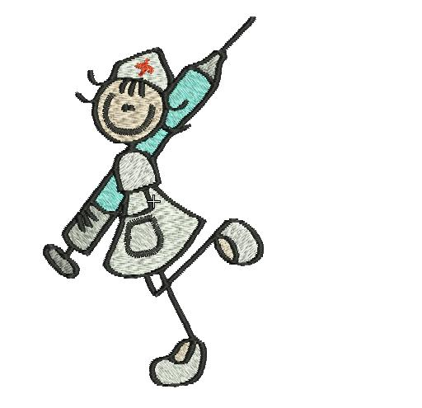

Revised/ A.Whalley/ Jan 2019

Contents

- Orientation
- Placement Philosophy
- Our Expectations
- What you can expect of us
- Uniform Policy
- Sickness/Absence Policy
- On your first day
- Multi-disciplinary team roles within the eye unit
- Spoke placements
- Opportunity to develop clinical skills within ophthalmology
- Anatomy and physiology of the eye
- Common eye conditions/diseases
- Ophthalmic terminology
- Common abbreviations used
- References
- Evaluation of placement feedback

WELCOME TO THE EYE UNIT!

We welcome you to the eye unit, and we hope your time with us is enjoyable and that you gain many valuable learning experiences assisting in your personal and professional development. We are aware that each student will be at different levels of training, therefore we endeavour to meet your learning objectives accordingly. The eye unit is a specialised area of nursing, providing opportunities to gain specialised knowledge and skills. The information that follows will assist your understanding of how the unit is managed, and will introduce you to Ophthalmology, so please take time to familiarise yourself with this booklet, which will be beneficial for your time spent with us.

The eye unit comprises of three areas: - Ward
Theatre
Clinic, including pre-assessment

Each of these areas have been selected as hub areas, however, you will have the opportunity to spoke out to the other areas of the department, maintaining your supernumerary status.

The eye unit is open Monday- Friday.
The ward is open from 07-30-19.00. When working on the ward, we expect you to work at least two late shifts as part of your 37.5 hour working week.
The pre-assessment area, clinic and theatre are open from 08.00-18.00. When working in these areas, you will usually work 4- 4 ½ days of your 37.5 hour working week.

Please ensure you familiarise yourself with the off-duty frequently so you are aware of your shift patterns.

When working on the ward, you will participate in the care for patients undergoing elective surgery for various eye conditions, for example, cataract, squint, oculoplastic and many other conditions. The patients we care for are commonly day-case patients, although you may care for emergency patients with varying eye conditions or trauma.

Within the theatre environment, you will observe and participate in the care of patients undergoing various ophthalmic procedures, and will become familiar with scrub, recovery and anaesthetics. The theatre environment can be daunting, but do not worry, as the nursing staff will orientate you to the environment and ensure you get the most out of your learning experience.

Within the clinic, you will participate in the running of numerous clinics where you will gain valuable ophthalmic knowledge and skills in relation to many ophthalmic conditions that you will encounter. These clinics include acute referral clinics (emergency eye patients), glaucoma clinic, retinal clinics, Consultant follow-up clinics, orthoptist clinics, and laser clinics. You will also spend time in the pre-assessment clinic area, where you will participate in the care of patients who are being assessed prior to undergoing surgery.

All staff on the eye unit are keen to ensure your learning needs are facilitated. If you have any queries about anything, please feel welcome to ask any member of staff, as your learning experiences are valued.
There are numerous resources accessible to assist in your professional development, for example, evidence-based practice resource file, patient information leaflets, so ensure you make the best use out of what is available. Student notice boards are located within the ward, pre-assessment and within the theatre setting, where information regarding study days and other useful information is accessible.

Once again, we hope you make the most out of your time with us, and we will assist in any way possible to maintain an optimum learning environment for yourselves.

Placement Philosophy

Here on the Ophthalmic Unit we consider teaching and learning to be of great importance. We strive to create an environment where learning can take place. This is a practice area where all learners are welcomed to ask questions. Where no one will feel unable to admit a lack of knowledge or skill for fear of feeling inadequate. Where we maintain an environment in which no one is afraid to question practice. We feel that learning can only flourish when a safe environment exists.
We feel staff professional development and education is a priority and the notion of life-long learning is supported. We aim to support and encourage all staff to maintain and enhance their knowledge and skills. All nursing staff are encouraged to identify learning needs and assisted to meet these goals. We strive to provide our staff with the resources they need to achieve their potential. We feel that we cannot hope to teach others if we maintain a state of personal ignorance.
We hold that knowledge and expertise should be shared with others. There is a wealth of knowledge within the Eye Unit. Therefore, we feel that it is important for us to provide a range of teaching possibilities, where information and ideas may be exchanged. Any situation can provide an opportunity to teach and learn and we aim to take advantage of these chances. We also feel that all disciplines can learn from each other. All members of the MDT are valued and we acknowledge the contribution that they make to the learning environment.
We recognise that students are significant members of the MDT and we value the contribution they make to the Eye Unit. Whilst we believe that everyone is ultimately responsible for his or her learning, we appreciate that it is important to support and assist students during their placement. To this end we feel it is essential that students’ supernumerary status is maintained. That learning resources are provided and supervised clinical experience can be obtained. Students’ time on the unit will be
co-ordinated by the Practice Education Lead and the students’ allocated mentor. We believe that it is of paramount importance that we listen to what students have to say about us to continuously improve the quality of the learning environment.

Revised/ F. Walsh/Jan 2018

Our Expectations

As a practice placement, we expect you;

To be punctual for your shift

- In the event of sickness/absence, to abide by the Trust’s and University’s sickness and absence policy

- To adhere to Uniform policy

- To maintain flexibility with your shift patterns, and arrange any part-time work or appointments around your allocated shifts

- To maintain professionalism, adhering the ‘The Code: standards of professional conduct, performance and ethics for nurses and midwives’ (NMC 2008)

- To demonstrate enthusiasm and a willingness to learn, in order to get the most out of your learning experiences

- To demonstrate good team-working, demonstrating respect for your colleagues

- To utilise the library facilities in your own time, unless it is specifically related to patient care and is agreed with your mentor. As previously stated, we do encourage you to utilise the unit’s learning resources within work time.

- To complete and hand in your assignment in your own time, although we are aware that on occasion, you are able to attend University for feedback from assignments within work time. This will be agreed on an individual basis

What you can expect from us

As a student nurse, you can expect;

- To be supported by a named mentor with a recognised mentorship qualification, and will also be supported by an associate mentor, both who are experienced registered nurses.

- To work at least two shifts per week with your mentor

- To have at least three formal meetings with your mentor to complete you summative assessment document, however, if you wish to meet with your mentor on other occasions, we will do our best to facilitate this

- To be provided with regular feedback on your progress, which will be honest and constructive, in order to achieve your development goals

- Your supernumerary status will be maintained

- To be provided with various learning opportunities to assist in your achievement of learning objectives according to your level of training (Benner 1984), adhering to the University’s expectations

- To have your individual learning needs respected

- To be supported and facilitated by highly motivated, knowledgeable professionals

Uniform Policy

During your time in clinic and the ward, you must adhere to the University’s and Trust’s uniform policy, which includes:-

- Hair should be tidy and long hair should be tied back off the shoulder

- Fingernails should be clean, short and free from polish. Acrylic nails are prohibited

- Make-up should be discreet

- Jewellery must be kept to a minimum. Plain gold studs are allowed, and you may wear a plain wedding band. Wrist-watches, stone rings, and other styles of jewellery are not allowed

- Identity badges must be worn at all times

- Plain black, closed shoes must be worn with uniform. Trainers, boots and heeled shoes are prohibited.

When working in theatre, it is not necessary for you to wear uniform, as you will be provided with theatre clothes, therefore, you can travel to work in your own clothes. However, ensure that you still wear your identity badge whilst in theatre.

Sickness/Absence Policy

It is a requirement of the University that we monitor and report your hours of practice. Therefore, it is essential that we record any periods of sickness and absence accurately. If you are unable to report for duty, please inform the unit at the earliest opportunity. The direct phone number is 01204 390736. You must speak to the person in charge of your area of work who will inform your mentor of your absence. You should indicate how long you intend to be absent. If this is not possible then you must contact the unit on a daily basis. Prior to returning to work, you must contact the unit to inform them of your last day of sickness.
You must also inform the university in accordance with the University’s sickness and absence policy.

On Your First Day
Please take time to complete the following to ensure you have orientated yourself to the placement setting effectively
ACHIEVED
Your mentor will be introduced to you

Other registrants will be introduced to you
Orientation around the unit

Have you been shown the fire exits, alarms and extinguishers and know what to do if the fire alarm is activated?
The emergency telephone number is 2222
Have you been show where the crash trolley and paediatric crash bag are?
Learn the telephone number of your hub placement and how you transfer calls
Learn how to use the bleep system
If you have not already done so, complete the initial self-assessment document in your assessment booklet
Have your induction checklist completed
Arrange to have your initial interview with your mentor within the first week of placement
Find out where the student notice boards are
Check your off-duty
Find out where the student resources are situated
Find out arrangements for breaks
Displayed evidence of moving and handling update
Supply us with a contact number
Familiarise yourself with this induction booklet

Any questions you may have feel free to ask any member of the team.

Multi-disciplinary team roles within the eye unit

During your time on the eye unit, you will have the opportunity to work alongside various member of the multi-disciplinary team. Each team member shares their clinical knowledge and expertise to work collaboratively to meet the individual needs of patients.
The following describes the roles of each professional who contribute to patient care within the eye unit.

Doctors

Doctors that work within the eye unit each share their professional knowledge and expertise to manage the care of ophthalmic patients. Eye doctors are acknowledged as ophthalmologists. On a daily basis, you will also work alongside anaesthetists and recognise their involvement in patient care. The same hierarchy within the medical profession exists across the Trust, i.e. specialist trainees, also known as ST1, ST2, ST3, and Consultants. We also facilitate learning for medical students.

Optometrist

Optometrists (also known as opticians) undertake comprehensive examinations of the eye. They assess patients’ visual acuity (central vision) and prescribe corrective lenses accordingly.

Orthoptists

Orthoptists assess eye muscles and teach exercise programmes which are designed to correct eye co-ordination defects, i.e. squints. Commonly, orthoptists deliver specialist care to paediatrics.

Nurses

The nurses within the eye unit are registered general nurses, many of which have undertaken specialist ophthalmic nurse training. They share their individual experiences and qualifications to deliver high-quality patient care. Some nurses undertake specialist roles, for example, glaucoma specialist nurse and oculoplastic specialist nurse, therefore, to maximise your learning, we will encourage you to spend time with these professionals.

Multi-disciplinary team roles

Auxiliary Nurses/Health Care Assistants (HCA’s)

These professionals share previous background experience and have undergone specialist training to meet the demands of their role. All HCA’s undergo NVQ level 2 training in health and social care, and they are encouraged to pursue NVQ level 3 in health care.

Ophthalmic Technicians

These professionals have had specialist training within the ophthalmic department and have undergone specialist training to be able to work around the department.

Assistant Practitioners

These professionals have predominantly worked as HCA’s, but have pursued further development in achieving a foundation degree in health and social care.

Operating Department Practitioners (ODP’s)

ODP’s work in the theatre setting. They assist the anaesthetist in delivering care for patients during anaesthesia and recovery.

Ward Clerk/Medical Secretaries/Clerical Staff

These individuals have specific responsibilities to manage clerical issues, for example, booking clinics, obtaining notes, preparation of theatre lists, writing letters, and much more.

Spoke Placements

We encourage students to spoke out to other areas of the department and Trust that are specific to their learning objectives. Some of the areas you will be able to visit are:-

- Bereavement and Donor Team
- Infection Control and Prevention Team (Third-year students only)
- Ward
- Clinic
- Pre-assessment
- Theatre
- Specialist Nurses
- Optometrists
- Orthoptists
- Eye Clinic Liaison Officer
- Retinal Service

Please discuss with your mentor the areas which you would like to visit, and your mentor will arrange time for you to spend in such areas to facilitate your learning. Upon completion of spoke placements, students must provide a reflective account as evidence of learning.

Clinical Skills within Ophthalmology

During your time within the unit, you will have the opportunity to gain knowledge and specialist skills significant to the care of ophthalmic patients. You will be able to carry out such skills whilst under supervision from nursing staff/mentor. The most common skills you will be able to observe are:-

The use of the Snellen chart

A chart of letter used to assess visual acuity (accuracy of distance vision when measured against the average vision). The person being tested stands 6m from the chart and reads as many of the symbols as they can from top to bottom

The use of the Slit Lamp

This instrument is used to examine the eye. An intense beam of light is projected through a narrow slit and a cross section of the illuminated part of the eye is examined through a magnifying lens
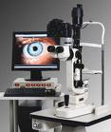

The use of a Tonometer

This instrument is used to measure intraocular pressure (pressure produced by fluid inside the eye)

The use of an Ophthalmoscope
This hand held instrument is fitted with a light and lens to view the inside of the eye



The use of a retinoscope

This hand held instrument is designed to assess refractive errors

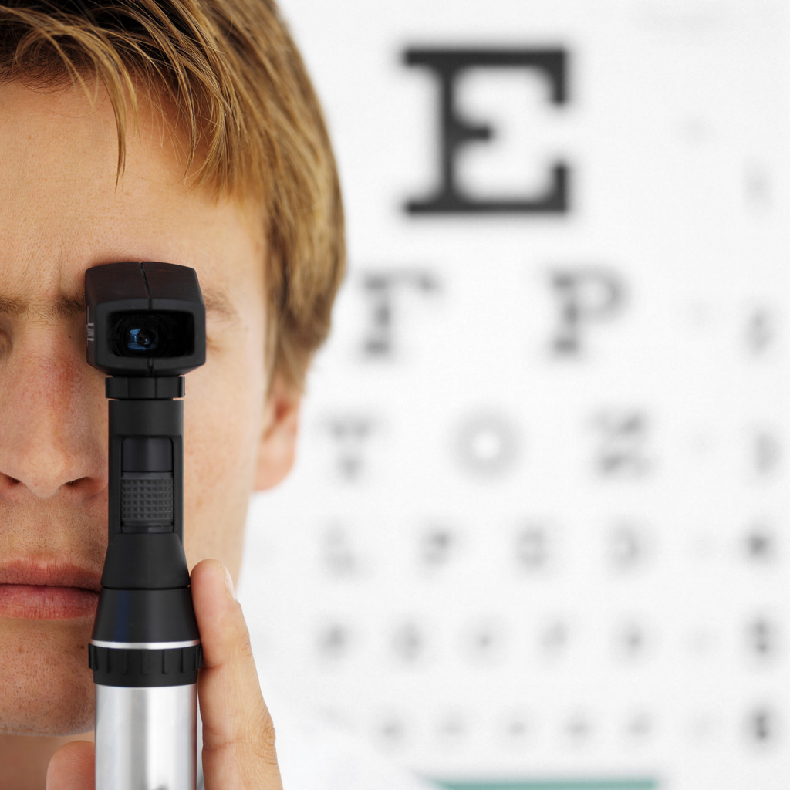

Anatomy and Physiology of the Eye

The eye or globe is situated in the bony socket or orbit. This contains nerves, muscles, blood vessels and fat which helps protect the eye. It is about 2.5cm (1 inch) in diameter and only one sixth of the anterior part is exposed. The rest is protected by the orbit.

Eyebrows

Via muscles (orbicularis oculi) the eyebrows help to protect the eyes from foreign objects, perspiration, and the direct rays of the sun.

Upper and Lower Eyelids

The eyelids are specialised folds of skin containing secretory glands that produce the tear film. The top lid is the largest and this closes over the globe to protect it. Blinking causes the tear film to spread over the anterior surface.

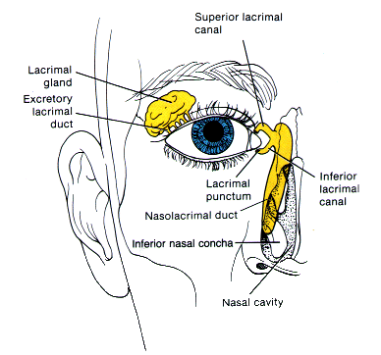
Lacrimal Apparatus

A group of structures that manufacture and drain tears (lacrimal fluid).
The lacrimal gland produces tears in response to a stimulus, for example, emotion, foreign body, peeling onions, etc. The tears are drained from the eye through the lacrimal drainage system. This consists of the puncta, canaliculi, lacrimal sac and naso-lacrimal duct.
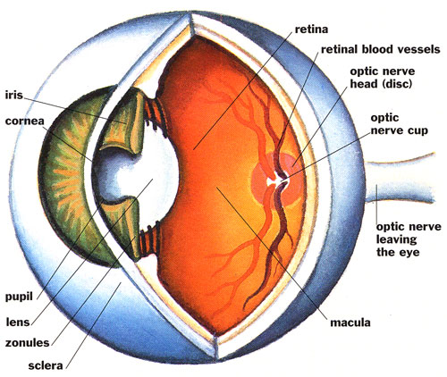

Conjunctiva

This is a thin, transparent mucous membrane lining the eyelids (palpebral conjunctiva) and covering the globe up to the cornea (bulbar conjunctiva). It has a rich blood supply and enables the eye to move freely.

Cornea

This is the transparent anterior part of the surface of the eye. It is convex and contains no blood vessels (avascular). It has a very rich nerve supply and is therefore highly sensitive. The main function of the cornea is to refract light onto the retina to allow us to see clearly.

Iris

This is the coloured part of the eye. The hole in the centre is called the pupil. The size of the pupil is controlled by two muscles- the sphincter muscle makes the pupil smaller and the dilator muscle makes it larger.

Lens

This is a biconvex, transparent avascular structure. It has no nerve supply. It lies behind the iris and is supported by the zonules or suspensory ligaments. The function of the lens is to focus light rays onto the retina by changing shape. This is called accommodation.

Sclera

This is the ‘white’ of the eye. It is dense, fibrous tissue and is continuous with the cornea anteriorly and the dural sheath of the optic nerve posteriorly. It has a protective function.

Choroid

This lies between the sclera and the retina and is continuous with the iris. It is pigmented and highly vascular. The function of the choroid is to provide nourishment to the retina.

Retina

This is the light sensitive layer that lines the interior of the eye. It is composed of light sensitive cells known as rods and cones. The human eye contains about 125 million rods, which are necessary for seeing in dim light. Cones on the other hand function best in bright light. There are between 6 and 7 million in the eye. They are essential for receiving a sharp accurate image. Cones can also distinguish colours.

Macula

This is a yellow spot on the retina at the back of the eye which surrounds
the fovea. This is the area with the greatest concentration of cone cells, and when the eye is directed at an object, the part of the image that is focused on the fovea is the image most accurately registered by the brain.

Fovea

This is a small indentation at the centre of the macula and is described as the area with the greatest concentration of cone cells.

Optic Disc

This is the visible (when the eye is examined) portion of the optic nerve found on the retina of the eye. The optic disc identifies the start of the optic nerve where messages from cone and rod cells leave the eye via nerve fibres to the optic centre of the brain. This area is also known as the blind spot.

Optic Nerve

The optic nerve leaves the eye at the optic disc and transfers all the visual information to the brain.

Aqueous

This clear fluid fills the anterior chamber, i.e. the area between the cornea and the front of the iris and the posterior chamber, i.e. the area between the back of the iris and the lens. The aqueous is being produced and drained away constantly in order to maintain intraocular pressure. It also provides nourishment to the lens and the cornea.

Vitreous

This transparent, jelly-like substance fills the area between the lens and the retina. It maintains the shape of the eye. It cannot be replaced naturally.

Muscles of the eye

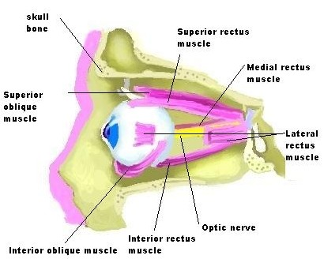

There are six extra ocular muscles which control the movement of the eyes and enable us to see all positions of gaze- straight ahead, to the right, upwards to the right, downwards to the right, to the left, upwards to the left, and downwards to the left

Common eye conditions/Diseases

Age- Related Macular Degeneration- A degeneration of the retina leading to a permanent loss of central vision. This is the most common loss of vision in people over the age of 50.

Blepharitis- Inflammation of the eyelid margins

Cataract- opacity of the crystalline lens often requiring surgical removal of the lens

Conjunctivitis- Inflammation of the conjunctiva, caused by allergy, bacterial or viral infection

Corneal Ulcer-Area of tissue loss from the corneal surface, usually caused by bacterial, fungal or viral infection

Cystoid Macular Oedema- Swelling of the retina in the area of the macula which is most often a temporary condition. This sometimes occurs after cataract surgery.

Diabetic retinopathy- Changes in the retina of patients suffering from diabetes mellitus

Dry Eye Syndrome- Corneal and conjunctival dryness due to deficient tear production

Endophthalmitis- an extensive eye infection, which requires urgent medical treatment

Floaters- Particles that float in the vitreous and cast shadows on the retina. Often seen by patients as spots. Occurs more frequently with age.

Giant Papillary Conjunctivits- Conjunctival inflammation forming a cobblestone pattern under the eyelids. Associated with the continuous wearing of soft contact lenses.

Glaucoma- A group of diseases characterised by an elevated pressure in the eye associated with damage to the retina and optic nerve leading to a progressive loss of vision. Both pharmaceutical and surgical procedures are available as treatment to help prevent the loss of vision.

Hyperopia- Long-sightedness due to eyeball being too short

Iritis- Inflammation of the iris

Itchy Eyes- A condition often found in patients suffering from ocular allergy.

Keratitis- inflammation of the cornea

Keratoconus- a degenerative disorder of the eye in which structural changes of the cornea cause it to thin and change to a more conical shape than its normal gradual curve. This condition can cause a substantial distortion in vision

Myopia- Short-sightedness due to eyeball being too long.

Ocular allergy- Commonly referred to as allergic conjunctivitis, a hypersensitivity of the conjunctiva

Presbyopia- Long-sightedness due to stiffening of the lens with age.

Pterygium- an abnormal wedge-shaped growth, which may be caused by exposure to the sun, occurring in the conjunctiva. It may be removed surgically.

Red Eye- A common term used to describe any condition in which the conjunctival or ciliary blood vessels are dilated. Numerous possible causes exist for this condition, the most common being allergy, infection or dry eyes.

Uveitis- Inflammation of the iris, the ciliary body or the choroid.

(Mary Shaw 2016)

Ophthalmic Terminology

Accommodation- the ability of the lens to change shape to allow near objects to be focused on the retina
Aphakia- absence of the lens
Astigmatism- Uneven curvature of the corn
Biometry- measurement of the axial length of the eye
Canthus- Outer and inner areas where the upper and lower lids meet
Cartella- protective plastic eye shield
Chemosis- Oedema of the conjunctiva
Dioptre- unit of measurement of the refractive power of the eye or lenses
Diplopia- Double vision
Ectropion- Turning out of eyelid
Emmetropia- Absence of a refractive error
Entropion- Turning in of the eyelid
Enucleation- Removal of the eye
Epiphoria- Watering eyes
Evisceration- Removal of the contents of the lens
Field of vision- The entire area that can be seen without moving the head
Fundus- The posterior portion of the eye visible through an ophthalmoscope
Guttae (G) - Eye Drops
Hypermetropia- Long sight
Hyphaema- Blood in the anterior chamber
Hypopynon- Pus in the anterior chamber
Injection- Degree of redness of the conjunctiva
Lacrimation- Production of tears
Miotic- Drug that constricts the pupil
Mydriatic- Drug that dilates the pupil
Myopia- Short sight
Oculentum (Occ) - Eye ointment
Photophobia- Sensitivity to light
Presbyopia- Inability to focus for near sight due to hardening of the lens after the age of 40
Ptosis- Drooping of the eyelid
Scotoma- An area of visual loss in the visual field
Strabismus- Squint
Synaechiae- Adhesion of the iris to the lens or cornea
Trichiasis- In growing and rubbing of eyelashes against the eye
Visual acuity- Detailed central vision
Visual Field- Area of vision
Xanthelasma- Fatty deposits on the eyelids
Other Common Abbreviations

Stat- once only
OD- once daily
BD- twice daily
TDS- three times daily
QDS- four times daily
SR- slow release
Prn- as required
I.V. - intravenous
I.M. - intra-muscular
SC- sub-cutaneous
Transdermal- absorbed through the dermis
Sublingual- absorbed through the sublingual gland
P.R. - per rectum

To enhance your professional development, please access the unit’s eye medication booklet and once you familiarise yourself with common medications used, you will be tested on your knowledge.

References

Benner, P (1984). ‘From Novice to Expert: Excellence and power in nursing practice.’ California, Addison Wesley

Nursing and Midwifery Council (2015). ‘The Code: standards for professional conduct, performance and ethics for nursing and midwifery.’ London, Nursing and Midwifery Council

Shaw, M Stollery,R, Lee,A Ophthalmic Nursing 4th Edition Wiley Blackwell.

Stollery, R. (1999) ‘Ophthalmic Nursing.’ 2nd Edition. London, Blackwell Science

Vaughan, D., Asbury, T., and Riordan-Eva, P. (1999) ‘General Ophthalmology.’ 15th Edition. London, Appleton and Lange

Vaughan, D. & Asbury, T., (2011) In Riordan-Eva, P. & Cunningham Jr., E.T. (eds), General Ophthalmolgoy 18th ed, Lange Medical Publications: London.

Websites

www.patient.co.uk

Student Evaluation- end of placement

It is important that students provide us with feedback so that we can maintain an optimum learning environment in order to facilitate students learning needs.

Thank you for your time and co-operation.



