

**Stroke Rehabilitation Ward (SRU)**

**Welcome Pack**

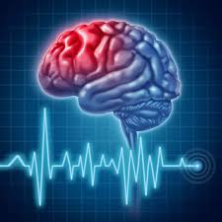

**SRU Mission Statement:**

**To provide high quality inpatient stroke rehabilitation for Salford residents and other stroke patients who need to stay at SRFT due to other health needs.**

Ward Manager: Janet Collins

Band 6/Sister: Joanne O’Meara

Mentors: Elizabeth Maudsley, Jane Barber, Joanne O’Meara, Janet Collins, Alexandra Hamilton.

Consultant specialist Nurse: Paula Beech

Ward Consultant: Dr Rebecca Grue

Practice Education Facilitator: Mike Hollinshead

PEL: Jane Barber

University link lecturer: Julia Cappleman

Ward Telephone Number: 0161 206-1901 / 0161 206 5768

**Placement philosophy**

A philosophy is a set of principles or beliefs, ideals and goals (Clodagh Gray, 2004).

The staff of the Stroke Rehabilitation Unit aim to:

* view patients, carers and relatives as individuals who have needs which require our help
* provide individualised assessment of the effects of each patient’s stroke and develop an individual goal driven rehabilitation plan
* promote, where possible , independence to the desired or achievable level of each patient by provision of an interdisciplinary rehabilitation environment
* preserve a patient’s dignity both in life and death
* protect an individual’s right to confidentiality
* care for patients and their families with courtesy and respect recognising and respecting their individual personal, cultural and religious beliefs treating all as we would want our families to be treated
* support patients and their families involving them in decisions about their treatment, rehabilitation care and discharge plan
* provide a high standard of specialist stroke rehabilitation as per evidence based guidelines (NICE/ICSWP)
* promote health education and health promotion to improve health and wellbeing and reduce the chance of recurrent stroke
* provide a work environment which is safe and supportive to students and all team members
* supervise and teach students, encouraging them to build upon their previous learning in order to meet the requirements for entry to the professional register
* encourage each staff member to contribute in their own unique way to this philosophy
* embrace lifelong learning principles in order to practice with a sound body of knowledge and competence

Staff on the Stroke Rehabilitation Unit would like to extend a welcome to you. All the staff will endeavour to ensure that your time with us is both pleasant and constructive. You will be given the opportunity to develop your nursing skills and knowledge, which will relate to generic nursing practice and to Stroke Rehabilitation.

**Introduction to the learning environment**

Welcome to Salford Royal Hospital and to the Stroke Rehab Unit (SRU). SRU is located on the ground floor in the blue area of the hospital, close to the inpatient pharmacy.

We are a sixteen bedded unit and accommodate patients of mixed gender and ages. The ward specialises in the rehabilitation of patients following a stroke, however, a large proportion of the patients, have multiple pathology associated with the ageing process. Usually prior to transfer for rehabilitation our patients will have been cared for on one of the acute stroke wards, ASU (Acute Stroke Unit) or HASU (Hyper Acute Stroke Unit).

The ward is divided into three bays and four side rooms and each patient is allocated a named nurse and support staff at the start of the shift. Patients are also allocated where appropriate a named therapist ie physiotherapist, occupational therapist, speech and language therapist, dietician, psychologist and social worker for their hospital stay. These allocations ensure that patients receive a high standard of individualised care, meeting not only physical, but social, emotional, psychological and spiritual needs.

**Ward Routine**

Monday am 09 30 – 12 30 Ward round

Tuesday am 09 30 – 12 00 Stroke MDT

Tuesday pm Family meetings 13 15 and 14 15

Wednesday am 11 00 Rehabilitation Goal Planning

Thursday am Ward round 09 30 – 12 -30

Thursday pm Family meetings 13 15 and 14 15

**Mentor Allocation**

Your mentor will be allocated to you prior to your arrival on the ward. The NMC requires that you work with your named mentor 40% of the time, and you will also be allocated a supporting mentor. You should meet your mentor on your first day and your shifts will be allocated to facilitate this. We will carry out your initial interview within your first 2 days on the ward and at this point will allocate dates for midpoint and final point paperwork.

**Shifts**

You will be expected to work a 37.5 hour week, which consists of 3 x 12.5 hour shifts ( 36 HRS), you will also be required to work an additional 12.5 hour shift once every 8 weeks to make your hours up to 37.5.

Shift times are:

Long day: 07:00 hrs – 19:30 hrs

Night Shift: 19:00 hrs – 07:30 hrs

The off duty is compiled up to 8 weeks in advance. There is flexibility built into the off duty and we appreciate that you may need to make specific requests, please speak to your mentor about this if needs be.

During a full working day you will be entitled to 60 minute break usually split into two 30 minute breaks, one in the morning and one in the afternoon. We have a staff room on the ward with a fridge to store food and drink you bring with you. This room has a microwave and hot water boiler.

Students are expected to be punctual and dressed as per university guidelines. We have male and female changing rooms and lockers to accommodate your personal belongings.

**Expectations of students**

* Students will arrive punctually on shift, and inform the nurse in charge as soon as possible if they are ill or delayed. Students are requested to provide a contact number on commencement of their placement.
* Students are expected to show initiative to learn and participate in care, whilst acknowledging any limitations in their knowledge and competence.
* Students are expected to develop competency in core clinical skills as identified by the University School Of Nursing. Students may be exposed to skills outside this framework, but these should not be considered essential.
* Should any personal or professional problems arise during placement, these must be raised as soon as possible with an appropriate member of staff, to prevent the problem escalating.
* Students must adhere to the uniform policy as set by the School of Nursing.
* Nursing students working bank shifts with NHS Professionals must wear the appropriate uniform.
* Students will whenever possible, work the same shifts as their mentor; this should be a minimum of two shifts a week. Weekends should be worked at a minimum of 1-in-4 and a maximum of 2-in-4 as recommended by the School of Nursing document ‘Changes to Pre-Registration Courses Commencing After September 1999’.
* Students must complete 4 weeks (150 hours) of night shifts over the course of their training; they are not expected to work nights in their first year of training (refer to the School of Nursing update document ‘Pre-Registration Students experiencing 24hr care’).
* Students should bring relevant documentation (assessment of practice documentation, action plans, profile) on a daily basis, for use at appropriate times.

**What you can expect from SRU staff:**

Following consultation with students; the following expectations of students towards staff are suggested:

* Students can be expected to be welcomed as ‘part of the team’ by the staff
* Students can expect an appropriately timed orientation to the placement including layout, routines, policies and procedures, and to receive a student handbook.
* Students will have a named mentor and be introduced as soon as possible.
* Students can expect to receive their off duty at least two weeks in advance
* Students will receive continuous feedback on their progress, and any problems / issues as perceived by staff will be raised with the student as soon as possible
* Students will not be regarded as an ‘extra pair of hands’ and their role of learners will be respected.
* Student will have the opportunity to learn and participate in new skills whilst acknowledging any limitations in their knowledge and competence.
* Students will be made aware of appropriate learning opportunities before/as they arise.
* Whenever possible, initial, midpoint, and final assessments will be carried out on time
* Students will be aware of their role during emergency procedures (fire, crash call)

**Uniform Guidelines**

* You are expected to wear the complete official uniform both whilst you are attending clinical placements and during clinical skills sessions within the university. Failure to do so may result in disciplinary action being taken. Uniforms should be clean and neat at all times.
* Cardigans if worn must be removed when in the clinical area. Tights or stockings should be of a plain neutral colour or black.
* Shoes should be supportive with a small heel only, quiet soled and black in colour; sandals and boots and trainers are not satisfactory footwear.
* When you are allocated to a placement where uniform is not required, you should check before attending what standard of dress is required.
* Pens, scissors and fob watches should be made secure.
* Hair must be tidy. Hair that is shoulder length should be tied back off the face and collar. For safety reasons, protruding hair decorations should not be used. If required, neutral coloured decorations should be used to secure hair. Beards and moustaches should be neatly trimmed.
* Finger nails must be clean and short. It is not acceptable to wear nail varnish or false nails.
* Make-up, if worn should be discrete. Perfumes and after-shaves should be used sparingly.
* Jewellery – only small, plain stud earrings (one pair) and wedding rings are permitted. Wristwatches must not be worn when attending to patients. No other jewellery is permitted.
* Identification badges must be worn when on duty.
* Outdoor Uniform – Dark coloured outdoor coats, which cover the length of the tunic, must be worn over uniforms when off hospital/university premises.

N.B Ethnic/religious customs concerning dress will be respected; clarification can be sought form the course team.

Failure to comply with the stated uniform policy will be regarded as unprofessional behaviour.

**Learning opportunities:**

* Nursing admission and discharge
* Clinical and neurological observations
* Record keeping and documentation
* Co-ordination and organisation of relevant investigations
* Nursing role in investigative procedures i.e. ECG, bloods, MR and CT scan
* Preparation and administration of subcutaneous and intramuscular injections
* Medication administration
* Insertion/removal of urinary catheter
* Interdisciplinary team working
* Health promotion and secondary prevention
* Assessment of psychological needs
* Evaluation of needs within the care plans
* Care of elimination
* Hygiene needs
* Oral hygiene care
* Care of nutrition and fluid intake
* Moving and handling
* Collection of specimens and urinalysis
* Management of diabetes
* Infection control policy and procedure
* Caring for patients from different cultural and religious backgrounds
* Serving meals and feeding patients
* Aseptic technique
* Wound care and evaluation
* Care of patients with intravenous infusions
* Care planning and evaluation
* Prioritising and planning care within a working shift
* Participation in ward rounds and case conferences
* Insertion of NG tubes and enteral feeding
* Maintenance of body weight
* Altered swallowing and observation of swallowing difficulties
* Completion of assessment forms for further care
* Involvement in Psychologist therapy sessions
* Liaison with Pharmacist at ward level

In addition to the immediate ward environment we can facilitate spoke placements in relevant placement areas; you will be expected to provide a reflective piece of work to support your learning and the relevance to the practice area.

**Spoke placements include:**

* CT/MRI scan
* Acute stroke Unit
* Hyper Acute Stroke - HASU
* Stroke research department
* Occupational therapists
* Physiotherapists
* Speech and language therapists
* Dieticians
* X ray
* Endoscopy
* Brain and spinal injury centre (BASIC)
* Patient flow team
* Stroke Consultant Nurse (Paula Beech)
* Community Rehabilitation
* Clinic – TIA / Follow up

Please speak to your mentor if you would like to arrange any spoke placements.

**Resources to support learning**

Some of the learning resources available to students are:

* The trust library – Students are able to access a wide range of books and journal articles and use the computer suite.
* Internet and Intranet Access – In addition to the internet students are able to access the trusts intranet site which provides information on a wide range of subjects including stroke specific policy.
* Student noticeboard – Located in the staff room and updated with relevant information, study days etc.
* Patients – Patients are our best sort of information and experts on their Stroke and symptoms. We actively encourage students to engage with patients during care delivery and at quieter times on the ward.

**Link Nurse Roles**

Each member of nursing and support staff has a designated link nurse role. Knowing these roles and staffs expertise may help you if you need specific help in a certain area. These are listed below:

Infection control – Janet Collins, Debra Norman, Oyeranti Ilesanmi

Palliative care – Joanne O’Meara

Dementia – Joanne Bonnar, Jackie Mcfadden

Nutrition – Alexandra Hamilton, Joanne Davies

Continence – Poppy Ashcroft, Zoe Elliot

Diabetes – Elizabeth Maudsley, Joanne Azzopardi

Tissue viability – Julie Lukose, Laura Webb

Falls- Diana Whendero, Lauren Catterall

Patient contact/ Manual handling – Jackie Mcfadden, Sallyann Gilbody

Alcohol – Leahanna Forrest

ANTT – Joanne O’Meara, Janet Collins

**Ideas to enhance learning**

The following information is intended to enhance your knowledge and give you a better understanding of stroke. Please take time when the ward is quiet to look at the following:

**About Stroke**

Strokes are the second single most common cause of death in the world causing 6.7 million deaths per year. They are the largest cause of complex disability worldwide (Stroke association, 2015).

There are two different types of stroke, ischaemic which account for 85%

of strokes and haemorrhagic which account for 15%. An ischaemic stroke or infarct is caused by a blockage, usually a blood clot, cutting off blood supply to the brain. Haemorrhagic strokes occur when a blood vessel within the brain bursts and bleeds into the brain tissue. (RCP, 2016)

There are numerous risk factors for stroke including high blood pressure, diabetes, atrial fibrillation, high cholesterol, smoking and alcohol excess amongst others.

The effects of stroke are varied and sometimes complex dependent on which area of the brain is affected.

**Recognising Stroke**

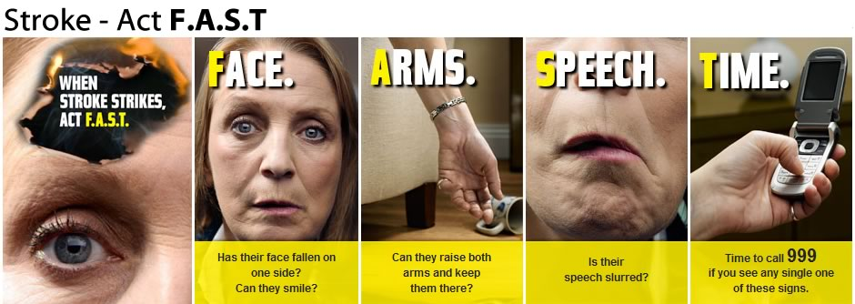

Stroke can strike anyone, any age at any time and every second counts. If you suspect a stroke even if symptoms pass do test and call 999. (www.stroke.org.uk)

**Anatomy of the brain**

Find out and label what each area of the brain is responsible for. Try and relate what you have found to the stroke patients we care for in terms of recognising what the after effects of their stroke are and therefore which area of their brain has been damaged. (More information on the next page if you struggle).

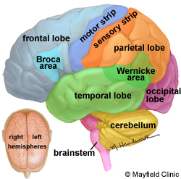

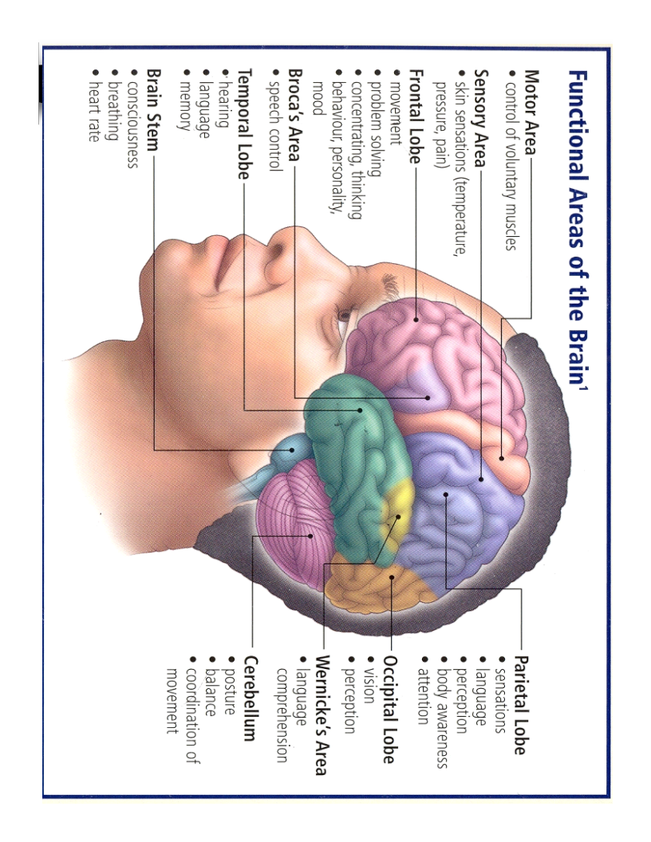

**Left Brain versus Right Brain**

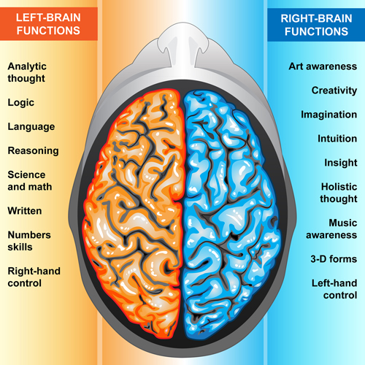

Stroke Terminology

Make yourself familiar with the commonly used terminology below and spend some time looking at what each means and how it affects patients.

* Aphasia
* Apraxia
* Ataxia
* Dysarthria
* Dysphasia
* Dysphagia
* Dyspraxia
* Hemiplegia
* Nystagmus
* Paresthesia
* Spasticity

Commonly used medications

It would be beneficial to your learning if you had an understanding of the following drugs commonly used within stroke. Use the BNF book which is available on the ward to look at usage, dose, and side effects of the following:

Amlodipine Movicol

Apixaban Omeprazole

Aspirin Paracetamol

Atenolol Perindopril

Atorvastatin Ramipril

Bisoprolol Rivroxaban

Clopidogrel Senna

Codeine Simvastatin

Dabigatran Sodium Valporate

Digoxin Thiamine

Ferrous sulphate Tinzaparin

Gabapentin Vitamin B Compound

Lansoprazole Warfarin

Lisinopril

**Secondary prevention**

If you observe the medics on the ward rounds you will hear them talking about a patients risk factors for stroke and what investigations they will need post stroke.

Spend some time looking at secondary prevention of stroke ie. What can be done to prevent patients from having a further stroke. Use any of the resources on the ward and try and follow a ward round to give you some ideas.

Things you may want to look at are anti-hypertensive medication, statin therapy, anti-platelet and anti-coagulant therapy.

**ABBREVIATIONS**

Approved list of abbreviations used in Stroke. This list is not exhaustive, so please ask your mentor/ any member of staff if there are any other abbreviations you do not understand.

NIHSS – National institute of health stroke severity scale

BI – Barthel Index

MRS – Modified Rankin Scale

MOCA – Montreal Objective Cognitive Assessment

TACS – Total anterior circulation stroke

PACS – Partial anterior circulation stroke

POCS – Posterior circulation stroke

LACS – Lacunar stroke

**GCS** – Glasgow coma scale

**SAH** – Sub-arachnoid Haemorrhage

**PICH –** Primary Intracerebral Haemorrhage

**PEARL** – Pupils Equal and Reacting to Light

**LOC** – Loss of Consciousness

**BP** – Blood Pressure

**HR** – Heart Rate

**BM** – Blood Measurement (Glucose)

**BO** – Bowels Opened

**BNO** – Bowels not opened

**PU** – Passed Urine

**CSU** – Catheter Specimen of Urine

**MSSU** – Mid-Stream Specimen of Urine

**ICP** – Intracranial Pressure

**AVM** – Arterio-venous Malformation

**LP** – Lumbar Puncture

**MR** – Magnetic Resonance Scan

**MRI** – Magnetic Resonance Imaging Scan

**CT** – Computerised Tomography

**USS** – Ultra Sound Scan

**NAD** – Nothing Abnormal Detected

**IV** – Intra-venous Infusion

**NBM** – Nil By Mouth

**ABX** – Antibiotics

**DN** – District Nurse

**TTO** – Tablets to Take out

**Placement Evaluations**

Students are requested to complete their placement evaluation on the P@RE website <http://onlinepare.net/>

Useful web links:

<http://www.nmc-uk.org/Students?Guidance-for-students/>

https://mail.srft.nhs.uk/owa/14.3.319.2/themes/resources/clear1x1.gifhttps://mail.srft.nhs.uk/owa/14.3.319.2/themes/resources/clear1x1.gif

Beech Paula

Hi Jane Sorry I can’t find Thom’ s document with the word search only the one attached you might have to email him or ask around. Useful web links: https://www.strokeaudit.org/Guideline/Full-Guideline.aspx https://www.nice.org.uk/guidance/cg162/evidence/full-guideline-190076509

https://mail.srft.nhs.uk/owa/14.3.319.2/themes/resources/clear1x1.gif

10:14

https://mail.srft.nhs.uk/owa/14.3.319.2/themes/resources/clear1x1.gif[https://www.strokeaudit.org/Guideline/Full-Guideline.aspx](https://mail.srft.nhs.uk/owa/redir.aspx?C=KPrwnASGrdj9lByx9sUqsO7kR7KsIuPQwA2wZLmXYFLkImrkmn3UCA..&URL=https%3a%2f%2fwww.strokeaudit.org%2fGuideline%2fFull-Guideline.aspx)

[https://www.nice.org.uk/guidance/cg162/evidence/full-guideline-190076509](https://mail.srft.nhs.uk/owa/redir.aspx?C=ULfqoVKw5wDRn5x1IS0XXFe9Tv2-D-Ha2jZB2hVVVGLkImrkmn3UCA..&URL=https%3a%2f%2fwww.nice.org.uk%2fguidance%2fcg162%2fevidence%2ffull-guideline-190076509)

[https://www.nice.org.uk/guidance/qs2/chapter/list-of-quality-statements](https://mail.srft.nhs.uk/owa/redir.aspx?C=L3_fo1yVk2ym9Nh5R6S7LKeNnWo-09ZkdKSPugQ2sYXkImrkmn3UCA..&URL=https%3a%2f%2fwww.nice.org.uk%2fguidance%2fqs2%2fchapter%2flist-of-quality-statements)

[http://www.strokecorecompetencies.org/node.asp?id=home](https://mail.srft.nhs.uk/owa/redir.aspx?C=4fC3xFsGlc3E4j4Uj_64HRTvud3TGRyE5v8BVOPeHJ3kImrkmn3UCA..&URL=http%3a%2f%2fwww.strokecorecompetencies.org%2fnode.asp%3fid%3dhome)

[https://www.stroke.org.uk/](https://mail.srft.nhs.uk/owa/redir.aspx?C=nBcHDP5dA3ucdQzOxD1j_j-66vB0dihm9mqtlfx03j_kImrkmn3UCA..&URL=https%3a%2f%2fwww.stroke.org.uk%2f)

[https://www.stroke.org.uk/sites/default/files/stroke_statistics_2015.pdf](https://mail.srft.nhs.uk/owa/redir.aspx?C=FuA4CROm_f3fLzDHbrlyNxqvVVlAmpHFouUxEpGSI5XkImrkmn3UCA..&URL=https%3a%2f%2fwww.stroke.org.uk%2fsites%2fdefault%2ffiles%2fstroke_statistics_2015.pdf)