**Children’s Unit**

**Student**

**Induction and Welcome Pack**



|  |  |
| --- | --- |
| **Name** |  |
| **Start date** |  |
| **Year** |  |
| **Assessors** |  |
| **Supervisors** |  |

**Welcome to the Team**

May we warmly welcome you to the Royal Oldham Hospital and in particular to the Children’s Unit. We are a 20 bedded general paediatric unit with 2 critical beds and a 6 bedded observation and assessment unit situated on the lower ground floor of the hospital. Our paediatric services are provided for children and young people 0-16 years. We receive referrals from Accident and Emergency, GPs, Community staff and Tertiary Centers for shared care. The children’s inpatient wards and Observation and Assessment Units are open 24 hours a day, seven days a week.

Referrals can be acute referrals for short stay assessment and observation, inpatient treatment or planned referrals for day case procedures/investigation or outpatient consultation.

Children’s services also provide assessments for children referred by Social Services for child protection (Section 47) medicals. This service is provided by Consultant Pediatricians Monday to Friday 0900-1700 hours and in the acute ward environment out of hours.

Children’s Outpatient services are based at Oldham and Rochdale Infirmary Hospital.

Opening hours are Monday to Friday, 0900-1700 hours.

Department contact details

Switchboard - 0161 764 6081.

Children’s Unit, Oldham – 0161 627 8866

Women’s and Children’s Division

**Divisional Managing Director** – Penny Martin

**Interim Assistant Director of Nursing (Paediatrics & Neonates)** – Simone Gorman

**Lead Nurse Inpatients** – Joanne Veichmanis

**Ward Manager** – Mark Smith

**O&A Unit Manger** Malcolm Wood

**Paediatric Clinical Governance Coordinator** – Paula Garlick

**Community Integration Lead -**  Lucy Lees

**Band 6 Staff**

Candy Cryer Karen Stanhope

Nicola Taylor Leah Bloy

Amanda Pollitt Bethany Booth

Rachel Crowther Naheed Mannan

Sarah Gee Jennifer Broadbent

Robert Baron Amelia Cowburn

Nicola Crowther Julie Barkley

**Staff Nurses**

Aysha Aktar Jennifer Kelly

Shahanaz Begum Heather Brooks

Shomitha Khatun Arwa Ghanem Saliha Shipa Emily Barnes

Nazma Begum Irsha Gul

Katie Bowler Holly Martin

Sharmeen Nawaz Nicole Walker

Jill Mundy Sanaa Yasin

Rebecca Walsh Rebecca Ainley

Katie Wright Lucy Hulson

Ikra Mahmood Antonia McGann  
Rabia Sultana Sanaa Yasin

Teresa Coimbra Rebecca Whitely

Paula Heap Michelle Diggle

**Nurse Associates**

Emily Johnson

Sara Mills

Sara Etchells

**Health Care Support Workers (HCSW) & Health Care Assistants (HCA)**

Adele Cumpsty Kath Grant

Joan Kurtz Kath Morris

Emma Ganley Carolyn Betherick

Zahira Shaheen Amanda Roberts

**Play Specialists**

Louise Gallagher, Sarah Ogden, Lisa McMahon

Ward Housekeeping

Handover

Handover is a crucial time for both the efficient running of the ward and for patient safety. This will take place at the PSAG board near the main Nurses station. Please do not hesitate to ask questions or seek further clarification on points raised in Handover. If it is not appropriate to do so then speak to the member of staff giving handover as soon as is possible following handover. You will work alongside your assessor / supervisor where possible.

Cleaning

It is everyone’s responsibility to ensure the ward environment is clean and tidy! Please ensure that you use the appropriate cleaning equipment for the task at hand

Equipment

It is everyone’s responsibility to look after equipment. Once it has been finished with, it is cleaned with Clinell wipes and put back in the appropriate area. Please ensure that all portable electrical equipment is left plugged into the mains when not in use. Any missing or faulty equipment should be reported immediately.

Daily Checks

Every shift the patient’s oxygen, suction and patient call bells should be checked to make sure they are working. Any faults or missing equipment should be reported

Ward Working Hours

Early 07.30 until 15.30 30 minute break

Late 12.30 until 20.30 30 minute break

Long Day 07.30 until 20.30 30 minute break x 2

Night 20.00 until 08.00 1.5 hour break

Uniforms

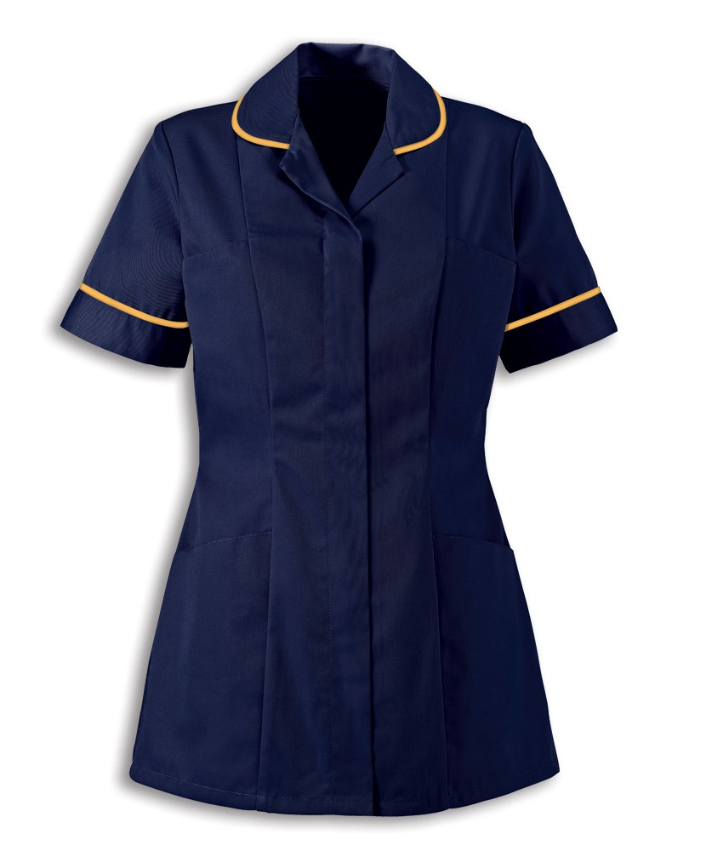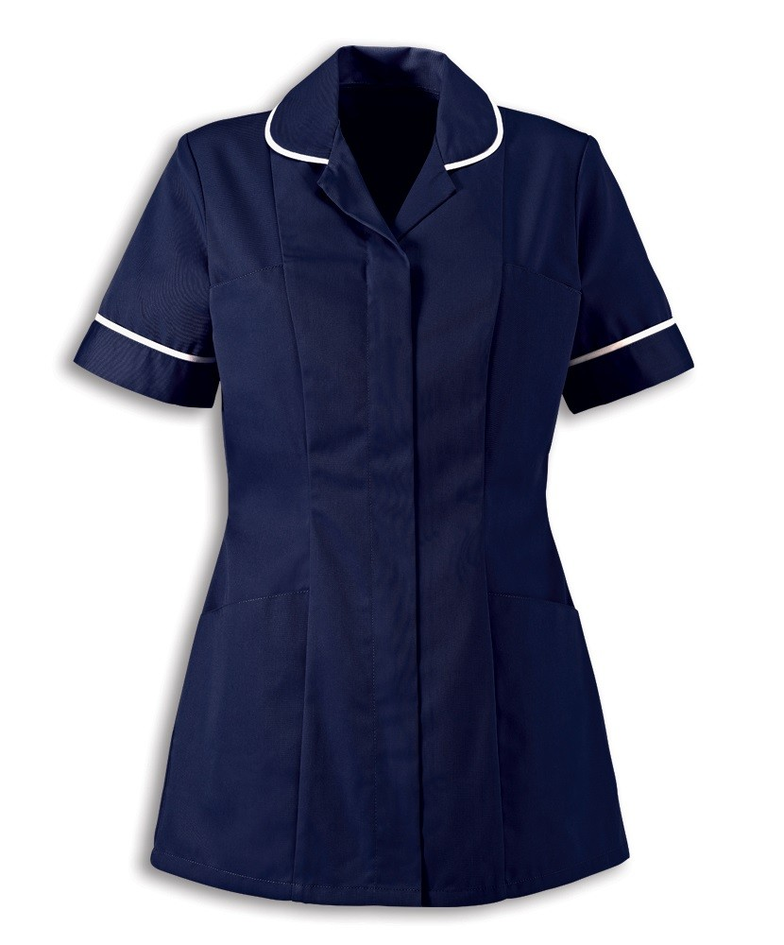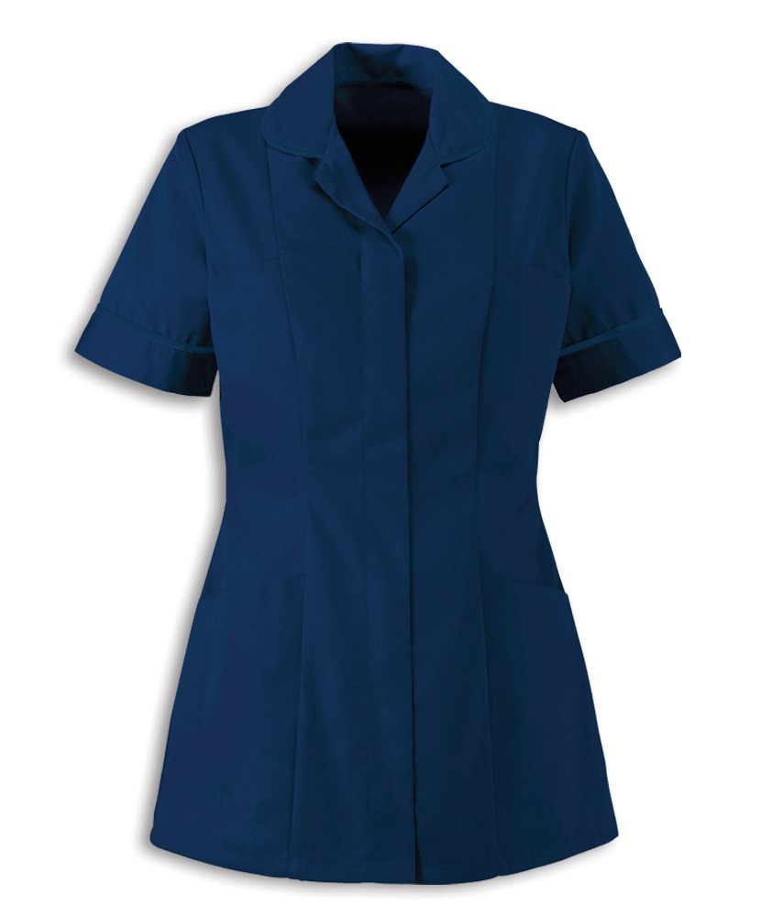

Lead Nurse Ward Manager Sister/Charge Nurse

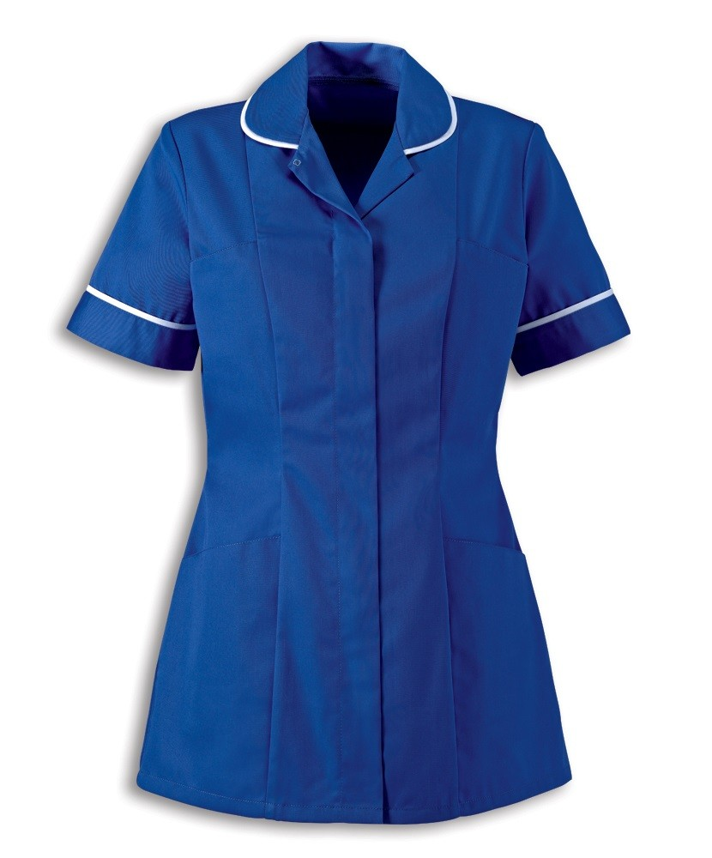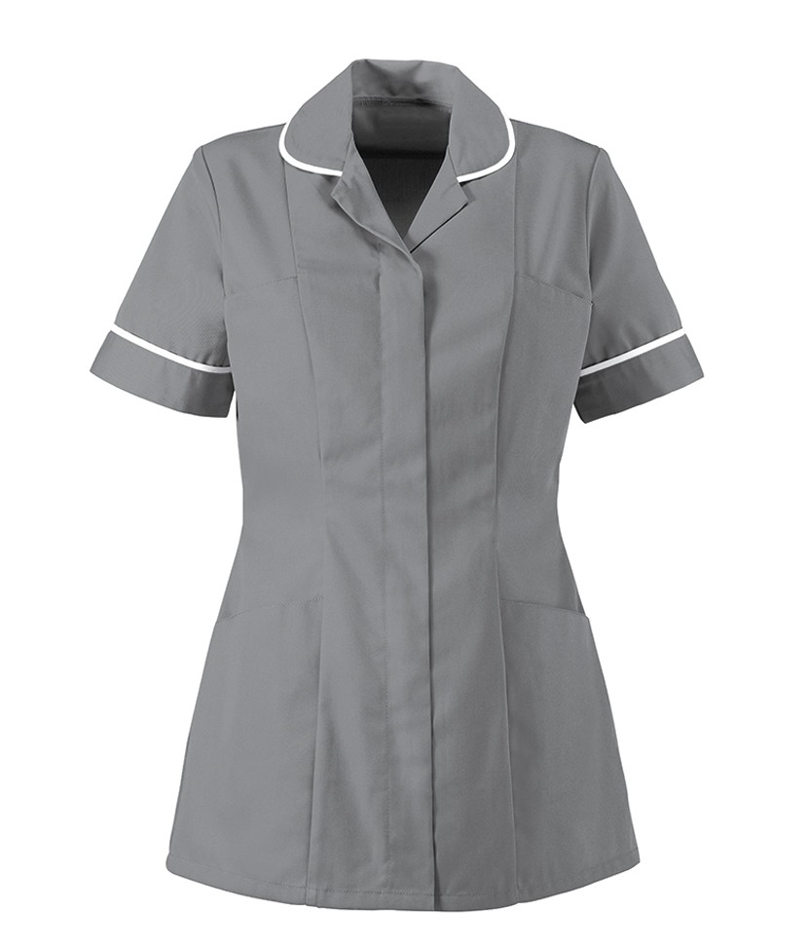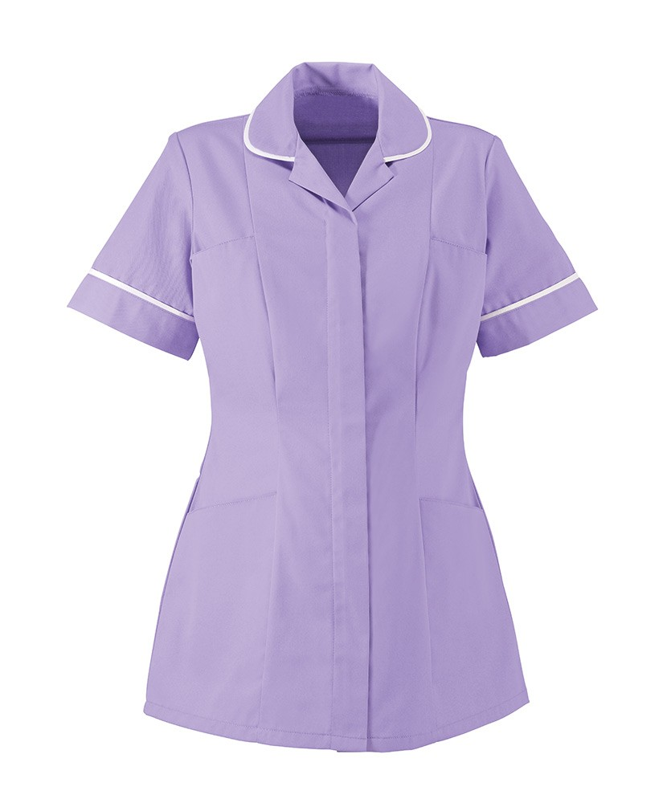

Staff Nurse Practice Educator Health Care Assistant

Uniform Policy

* Correct uniform must be worn at all times
* All employees must wear an ID badge with a picture
* Black or navy cardigans are permitted, but must not be worn whilst in the clinical area and attending to patients
* Plain studs only in pierced ears
* Hair should be neat, tidy and tied back off the collar if long
* Whilst in the clinical area all staff should be bare below the elbow
* No visible jewellery except for a plain wedding band or plain stud earrings
* Please challenge other members of the clinical team if they are not following the uniform policy
* For further information please see The Work Wear Policy EDG014

Phones and Bleeps

Telephones

Whenever you answer the telephone, remember you are the first point of contact for the person ringing. Please state:

* Ward/department
* Your name and position

Bleeps

If you are asked to bleep someone:-

* Press 11 followed by the bleep number
* Then press the extension number you are calling from
* Replace the handset

In an Emergency

Dial 2222 – state paediatric cardiac arrest or adult cardiac arrest and where you are

Dial 3333 – in the event of a Fire

Dial 4444 – if you need to fast bleep

Reporting Sickness

Please telephone the ward as soon as you feel you are too unwell to work. This should be before your shift commences. Please ensure you speak to the nurse in charge of the shift so the message is passed onto the ward manager. Keep in daily contact as to when you will be fit to return to work and ring the ward as soon as you are fit to work as staffing levels are reviewed regularly throughout the shift and that sickness is also reported to your university as per policy.

The Royal Oldham Hospital

The Royal Oldham Hospital is located close to Oldham town centre, 8 miles north east of Manchester.

Formerly known as Oldham District and General, the hospital lies within the Coldhurst area of Oldham on the boundary with Royton. It was the birthplace of Louise Brown, the world's first successful *in vitro* fertilised "test tube baby", on 25 July 1978.

The hospital has a full accident and emergency department and offers a comprehensive range of acute and general surgical services, including vascular surgery. The site also offers more specialist services including clinical haematology and provides all of the Trust's gynaecological services to patients in North Manchester.

In recent years, the hospital has benefited from a £44m investment to provide a new, purpose built Women and Children's development and maternity ward. This has allowed the hospital to become one of three specialist level three maternity units in Greater Manchester.

The hospital has also benefited from additional investment to create a specialist children’s accident and emergency department, which was launched in April 2014.

Oldham is one of four Care Organisations within Group. Each Care Organisation now consists of a Medical Director, a Director of Nursing, Managing Director, and a Finance Director. Together they will manage and be responsible for the day to day running of the hospital and community services.

Oldham’s management team are listed below.

[Dan Grimes - Managing Director](http://www.pat.nhs.uk/downloads/board/trust-profiles/oldham-care-organisation.htm)

[Medical Director – Dr Jawad Husain](http://www.pat.nhs.uk/downloads/board/trust-profiles/oldham-care-organisation.htm)

[Acting Chief Officer/Director of Nursing – Nicola Firth](http://www.pat.nhs.uk/downloads/board/trust-profiles/oldham-care-organisation.htm)

[Director of Finance – Carolyn Wood](http://www.pat.nhs.uk/downloads/board/trust-profiles/oldham-care-organisation.htm)

This new site-based operational management model is helping strengthen and improve senior leadership support and access at hospital-level, helping strengthen engagement with staff and clinical teams, strengthening relationships and joint working across health and social care with local care partners, and taking operational decisions for each site and services.

## Ward Philosophy

We aim to provide a high standard of care at all times which fulfil the needs of each individual patient and their families/carers, whilst taking into account their physical, psychological, spiritual, cultural and social needs. In doing so, we aim to provide care which is non-judgmental and respects the values, health beliefs and choices of each family.

We aim to provide care within the ethos of names nursing, understanding that each child needs to have an identified children’s nurse who is responsible for co-ordinating their care.

We are committed to caring for each child as a family unit and recognise the importance of family participation in planning and delivering care.

We recognise that health takes on many forms, and aim to promote good health and wellbeing for the children in our care.

We identify the need for the nurse to act as a patient advocate and in doing so support his/her best interest.

We recognise and understand the importance of communication with the child and their family/carer.

We recognise and understand the importance of play in children’s development and aim to provide an environment in which play is a vital part of every child’s care.

We recognise the need for professional development of staff within the children’s unit in order to provide optimal, evidenced based care, encompassing the ethos of shared governance. We aim to communicate effectively within the MDT and in doing so meet the child’s individual needs from admission to discharge.

The care we provide will be continues with the children’s community nursing team (CCNT). The aim is to reduce the amount of hospital admissions and the length of a child’s stay in hospital. It also ensures a smooth transition between hospital and home.

We endeavour to provide a warm and friendly environment in which children and their families can find support and reassurance which are appropriate to their needs.

We are committed to creating and promoting an optimum environment for learning:

* To support students in identifying both learning needs and experiences that is appropriate to their level of learning
* To provide a range of learning experiences
* To facilitate personal and professional development of all students and staff members.

As Pennine Acute Hospitals NHS Trust OUR VISION is to be:

'A leading provider of joined up healthcare that will support every person who needs our services, whether in or out of hospital to achieve their fullest health potential.'

Our Values

Our Values guide every action we take. They determine how we work and the promise we make to our patients, their families, the public and each other as colleagues.

WE ARE: Quality Driven, Responsible, Compassionate.

|  |  |  |  |
| --- | --- | --- | --- |
| **WELCOME, INDUCTION & ORIENTATION** | **Student Signature** | **Assessor supervisor** | **Date Completed** |
| Introduction to managers, colleagues & key individuals within the department |  |  |  |
| Orientation to the ward /department and any other areas within the organisation relevant to the post  Workstation and equipment locations |  |  |  |
| Ensure that arrangements are made for security pass, Access codes/swipes ID badge,, IT access etc. ( if not already got), Departmental security issues, Data protection |  |  |  |
| Car parking/transport |  |  |  |
| Uniform (if appropriate to role)  Expectations of standards of appearance to include hair, jewellery, appropriate footwear etc. |  |  |  |
| Orientation to rest room and departmental catering areas  ~~Smoking Areas~~ Smoke free environments / sites. |  |  |  |
| Explain terms & conditions:   * Hours of work * lunch and break arrangements * confidentiality rules * professional standards within the ward/department |  |  |  |
| Resuscitation procedures   * equipment/procedures * crash trolley location * emergency telephone numbers |  |  |  |
| Moving & handling procedures:   * equipment/procedures * beds and hoists * lifting and handling regulations |  |  |  |
| Fire safety procedures and assembly points:   * fire exits/alarms/equipment * emergency telephone numbers * evacuation procedures |  |  |  |

|  |  |  |  |
| --- | --- | --- | --- |
|  | **Student Signature** | **Assessor supervisor** | **Date Completed** |
| **PARE** |  |  |  |
| * Initial * Midpoint * Final |  |  |  |
| Infection prevention and control:   * waste disposal * procedures within the ward/department * Hand hygiene * Local assessment for support worker staff group |  |  |  |
|  |  |  |  |
| Explain the key equipment used within the ward/department and training requirements.  Complete the medical equipment competency assessment forms  Record electronically |  |  |  |
| **FIRST AID** | | | |
| Identify allocated first aid personnel  Identify position of first aid boxes within the ward/department |  |  |  |
| **POLICIES AND PROCEDURES** | | | |
| Explain how/where to access organisational/departmental policies  Identify policies currently applicable to the ward/department and the role.  Discuss the expectation of the staff member to read those policies |  |  |  |
| Check mandatory training assignment to role  Advice how/when staff member can complete all elements within 30 days of start date |  |  |  |
| **SICKNESS/ABSENCE** | | | |
| Explain the care organisation’s policy and procedures regarding sickness and absence:-   * What to do if off sick, who to notify * Other types of absence and requirements for special leave |  |  |  |
|  |  |  |  |
|  |  |  |  |
|  | **INITIAL**  **LINE**  **MANAGER** | **INITIAL**  **NEW**  **EMPLOYEE** | **DATE**  **COMPLETED** |
| **WORKING HOURS/HOLIDAY ENTITLEMENT/PROCEDURE** | | | |
| Start and finish times/shift patterns/holiday requests  Lateness procedure  Meal breaks |  |  |  |
| **COMMUNICATION AND INFORMATION** | | | |
| Use of telephones, mobile phones bleep/pager systems etc.  Use of internet |  |  |  |

|  |  |  |  |
| --- | --- | --- | --- |
|  | **INITIAL**  **LINE**  **MANAGER** | **INITIAL**  **NEW**  **EMPLOYEE** | **DATE**  **COMPLETED** |
| **SPECIALIST WARD/DEPARTMENT INDUCTION INFORMATION**  **(additional departmental information can be added here locally)** | | | |
|  |  |  |  |
| **ACTION ARISING FROM ISSUES OR QUERIES IDENTIFIED DURING INDUCTION** | | | |
|  |  |  |  |

**NORTHERN CARE ALLIANCE LOCAL INDUCTION CHECKLIST**

**STATEMENT OF COMPLETION**

**This form is to be completed with your line manager/ induction supervisor**

**The completed form is to be kept in the employee’s personal file**

|  |  |  |
| --- | --- | --- |
| **Name** |  | |
| **Start date** |  | |
| **Job title** |  | |
| **Division/Department** |  | |
| **Mentor/Supervisor/Manager** |  | |
| **Date checklist completed** |  | |
| **Date entered onto online system** |  | |
| **Employee’s signature** |  | **Date** |
|  |
| **Mentor/Supervisor/Manager signature** |  | **Date** |
|  |