Salford Urgent Response Team

Student Nurses Welcome Pack

|  |  |
| --- | --- |
| **Learners Name:** |  |
| **Learners Assessor:** |  |
| **Learners Supervisor:** |  |

Contents

|  |
| --- |
| **Introduction …………………………………………………………………………………………… 3 - 4** |
| **Urgent Response Team Services …………………………………………………………… 5 – 6** |
| **Placement Philosophy …………………………………………………………………………………… 7** |
| **Learning Opportunities ………………………………………………………………………………….. 8** |
| **Spoke Placements ………………………………………………………………………………………….. 9** |
| **Placement Expectations ……………………………………………………………………….. 10 – 11** |
| **Support on Placement ………………………………………………………………………… 12 – 13** |
| **Placement Feedback ……………………………………………………………………………. 14 – 15** |

Introduction

Welcome to Salford Royals Urgent Response Team, part of Salford Care Organisation within the Northern Care Alliance. We hope you find your placement with us to be educational, insightful, and enjoyable!

**Placement Address:**

3rd Floor, St James House, Pendleton Way, Salford, M6 5FW

**Placement Telephone Number:**

0161 206 6666

**Placement Email:**

[rapidresponse.admin@nhs.net](mailto:rapidresponse.admin@nhs.net)

**Placement PELs:**

|  |  |
| --- | --- |
| Rebecca Bates  [Rebecca.Bates2@nca.nhs.uk](mailto:Rebecca.Bates2@nca.nhs.uk)  0161 206 6666 | Samantha Lamb  [Samantha.Lamb2@nca.nhs.uk](mailto:Samantha.Lamb2@nca.nhs.uk)  0161 206 6666 |

Please note Rebecca and Sam work 3 shifts a week, therefore there may be a delay in replying to emails. If you need to speak with a member of Salford Urgent Response Team urgently regarding your placement, please ring the office telephone number and ask to speak with the shift lead.

**Hours of Service:**

Salford Urgent Response team operate between the hours of 08.00am – 22.00pm, 365 days a year, including bank holidays, however presently learners are not required to work bank holidays.

|  |  |
| --- | --- |
| **Early Shift**: 08.00am – 20.30pm | **Late Shift**: 09.30am – 22.00pm |

**Transport:**

Please note students on placement with Urgent Response are required to have their own vehicle to attend placement due to the hours of our service. This is to ensure students can get home without the use of public transport on late shifts.

**Parking:**

We have two gated car parks however this is only accessed with a fob. There is a car park across the road which entitles you to 3 hours parking for **free**. If you park in the car park across the road from St James House and come into the office someone in the office will lend you their pass to park in our main car park. Alternatively, you can obtain a temporary car parking fob, please note there is a £15 deposit, upon returning your fob you will get your deposit back.

Urgent Response Team Services

Salford Urgent Response team is an integrated team combining Urgent response and HOPT. We are a multidisciplinary team made up of nurses, physiotherapists, occupational therapist, clinical support workers (CSW), assistant practitioners (AP), advanced clinical practitioners (ACP), a pharmacist, and a general practitioner (GP). During your placement you will have an opportunity to work with all members of the multidisciplinary team.

Salford Urgent Response team covers all the Salford borough including the towns listed below.

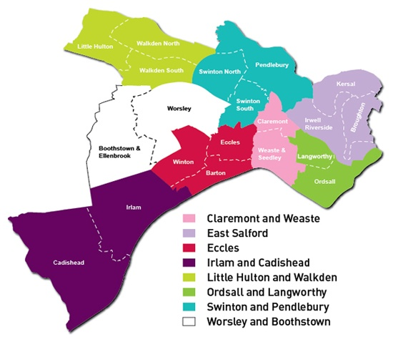

**Urgent Response:**

This service aims to prevent unnecessary hospital admissions by providing a multi-disciplinary team service for patients experiencing an acute episode of illness or injury and are in a health and/or social care crisis. Referrals are received from health and social care professionals including GPs, District nurses, social workers and North West Ambulance Service (NWAS). Referrals to the Urgent Response Team includes, but is not limited to: DVTs, cellulitis, UTIs, IV therapy, family crisis, falls, health deterioration. Referrals are received via telephone and a band 6 or band 7 nurse triages the referrals via the Manchester Triage System (MTS). Upon completion of a telephone triage an assessment team will attend the patient’s property and complete a holistic assessment to identify care needs. Assessments are completed in a timely manner depending on the outcome of the triage.

The Urgent Response team is an expanding service and is also exploring other pathways where we can support patients within their own homes and prevent hospital admission, these include mental health pathway and heart failure pathway.

**HOPT:**

The Home IV Team enables patients who are medically optimised for discharge from hospital or prevents hospital admission, requiring courses of IV antibiotic therapy, to return/remain at home whilst on IV therapy. The Salford IV service receives and oversees referrals from Salford Royal for patients who are not just living in Salford, but across the North West and even country-wide! Nurses oversee the IV service and will process referrals, administer IV antibiotics to patients in their own homes, take part in MDTs with the microbiologist-consultants and pharmacists, learn and gain awareness of blood results and readings, perform venepuncture and oversee the care of IV access devices e.g. CVCs, PICCs, Midlines, cannulas, PortaCaths. We work closely with the microbiology-consultants and pharmacists to ensure each patient is provided with safe, tailored care.

**Hospital at home:**

This service aims to support early discharge from hospital under several upcoming pathways. Members of the multidisciplinary team supporting patients in their own home through holistic assessment, providing nursing care and therapy support. Including the use of virtual technology allowing us to monitor patients clinical observations remotely.

Placement Philosophy

Urgent Response Team/HOPT is primarily concerned with the prevention of unnecessary hospital/social care admission and the support of people at discharge to reduce length of stay and reduce re-admission. This is achieved through programmes of rehabilitation and enablement following comprehensive person-centred assessment, in the patient’s usual place of residence.

The service aims to:

* view patients, carers and relatives as individuals who have needs which require intervention to promote independence and wellbeing
* provide individualised assessment of the effects of each patient’s injury or illness and develop an individual, goal driven, rehabilitation plan
* promote, where possible, independence to the desired or achievable level of each patient by provision of an interdisciplinary rehabilitation environment
* preserve a patient’s dignity both in life and death
* protect an individual’s right to confidentiality
* care for patients and their families with courtesy and respect recognising and respecting their individual personal, cultural and religious beliefs
* support patients and their families in making decisions about their treatment, rehabilitation care and discharge plan
* provide a high standard of specialist intervention as per evidence-based guidelines
* promote health education and health promotion to improve health and wellbeing and reduce risk of deterioration
* provide a work environment which is safe and supportive to team members and visitors/students
* supervise and teach learners, encouraging them to build upon their previous learning in order to meet the requirements for entry to their professional register

Learning Opportunities

Learners will be supported to achieve their placement summative competencies and gain exposure to a range of clinical skills. Learners will enhance their clinical skills, knowledge, and practical ability to complete some of the learning opportunities below. Please note learners will only be able to practice clinical skills in accordance with the clinical skills toolkit for pre-registration learners participating in invasive clinical skills within the NCA NHS Foundation Trust. Learners will be required to have the necessary knowledge, understanding and behaviour to underpin safe practice. This will be achieved by ensuring learners have attended the relevant skills / simulation sessions at university and have read the relevant trust policies.

**Nursing Skills**

* ANTT practice

* Wound care

* Diabetic care

* Medicines management

* Nursing assessments

* Clinical observations

**Invasive clinical skills**

* Peripheral venepuncuture and cannulation

* Administraion of injection

* Blood glucose monitoring

* Insertion, management, and removal of urinary catheters for all genders

**Therapy skills**

* Equipment assessments

* Falls assessments

* Cognition assessments

* Home exercise programmes

**Further learning opporuntities within the MDT**

* Board round

* Triage

* Shadowing ACP

* Daily saftey huddle

* HOPT

Learning opportunities

Spoke Placements

We encourage learners to take spokes available throughout the community to gain further insight and learning into services provided throughout Salford. Learners are responsible for organising their own spokes placements and must inform their supervisor/assessor of any spokes they have scheduled.

Please see below for spokes available but are not limited to:

Macmillan Nurses

Bevan Unit

District Nurses

Community SALT team

Spoke opportunities

Cardiac Rehab

District Nursing Evening Service

Tissue Viability

CAST (COPD Assessment & Support Team)

Health Visitors

Bladder and Bowel Team

Placement Expectations

**What to expect from the Urgent Response Team:**

To be welcomed and introduced to the team and provided with a local induction to your workplace to enable you to be familiarized with the office workspace environment e.g. fire exits, stock room, staff kitchen, toilet facilities, office space and car parking.

To discuss and address any health or learning needs you may have on your initial meeting.

Provide a safe and supportive environment to enable learners to achieve competencies, practice and learn new skills.

Ensuring your PARE documentation e.g. initial, midpoint, end points are completed in a timely manner.

You will be a valued member of our multi-disciplinary team and will be provided with opportunities to work with colleagues of varying professions throughout our team.

**What the Urgent Response Team expect of learners:**

Please ensure you arrive on time to placement. In the event you are going to be late please ensure you contact the office to notify the staff members you are due to be working with.

Follow the university/hospital uniform policy. Please note community staff can travel to and from work in uniform, however if you wish, you are welcome to change at base in the toilets.

Follow the sickness/absence policy, ensuring both university and placement staff are aware of your absence. Additionally, upon return to placement please ensure your supervisor and assessor are aware of any reasonable adjustments required upon your return from absence.

Ensure you inform your supervisor and assessor of learning competencies and objectives you will be required to complete during placement.

We encourage you to raise any concerns you may have with your supervisor/assessor. Alternatively, if you are not comfortable raising concerns to your mentors, please do liaise with the placement PELS (Rebecca Bates and/or Samantha Lamb) or our team managers. Alternatively, you can liaise with the hospital PEF team.

**Salford Royal PEF team contacts:**

|  |  |
| --- | --- |
| Luke Corcoran  [Luke.Corcoran@nca.nhs.uk](mailto:Luke.Corcoran@nca.nhs.uk)  Working days: Monday – Friday  0161 206 3210 | Generic Email:  [PEFTEAM@nca.nhs.uk](mailto:PEFTEAM@nca.nhs.uk) |
| Mike Hollinshead  [Michael.Hollinshead@nca.nhs.uk](mailto:Michael.Hollinshead@nca.nhs.uk)  Working days: Monday – Wednesday | Elaine Carter  [Elaine.Carter@nca.nhs.uk](mailto:Elaine.Carter@nca.nhs.uk)  Working days: Tuesday – Friday |
| Andi Surtees  [Andrea.Surtees@nca.nhs.uk](mailto:Andrea.Surtees@nca.nhs.uk)  Working days: Monday – Friday | Julianah Oluwasasakin  [Julianah.Oluwasakin@nca.nhs.uk](mailto:Julianah.Oluwasakin@nca.nhs.uk)  Working days: Monday – Friday |

We expect learners to be respectful and professional and to maintain confidentiality, privacy, and dignity at all times.

We value your feedback!

Support on Placement

Please see below for a list of commonly used terminology to help and support you during your placement.

* OD –once a day
* BD – Twice a day
* TDS – Three times a day
* QDS – Four times a day
* UTI – Urinary tract infection
* DVT – Deep vein thrombosis
* NBM – Nil by mouth
* DNAR– Do not attempt resuscitation
* SOI – Statement of Intent (in cases where death is expected, a GP who has reviewed a patient within the last 28 days may issue a SOI, meaning a death can be registered without automatically referring the death to the coroner or the police. SOIs are valid for 28 days and the patient must have a GP review before a further SOI can be applied)
* DoLS – Deprivation of liberty and safeguarding – a procedure which protects an individual’s rights if they are deprived of liberty in a hospital or care setting within England and Wales and lack mental capacity when consenting to being there.
* PMH –Past Medical History
* PEARL – Pupils Equal And Reactive to Light
* IV – intra-venous
* Bolus – a dose of a drug or substance given over a short period of time
* PO – medication taken orally
* TD- medication administered as Trans-dermal (e.g. pain patches)
* Topical – e.g. creams applied to skin
* SC – Subcutaneous – medication administered via subcutaneous injection (injected into the subcutaneous fat under the skin)
* IM- Intramuscular – an injection technique administered deep into the muscle
* Bradycardia – a slower than normal heart rate
* Tachycardia – a faster than normal heart rate
* Apyrexial – having a normal body temperature
* Pyrexia – higher than normal body temperature
* Hypothermia – lower than normal body temperature
* Hypoxia – having low oxygen levels in your tissues/organs
* Hyperoxia – excess supply of oxygen within tissues/organs
* Hypertension – higher than normal blood pressure
* Hypotension – lower than normal blood pressure
* Tachypnea – faster than normal breathing
* Bradypnea – slower than normal breathing
* SOB – Shortness of breath
* Hypoglycaemia – below normal levels of glucose in the bloodstream (often referred to as a ‘hypo’)
* Hyperglycaemia – higher than normal level of glucose in the bloodstream
* Acute – an abrupt onset of a condition (e.g. asthma attack)
* Chronic - a condition or disease persistent or long lasting in its effects that come with time (e.g. Chronic obstructive pulmonary disease)
* Asymptomatic – NO symptoms
* Symptomatic – showing symptoms of a condition or a disease

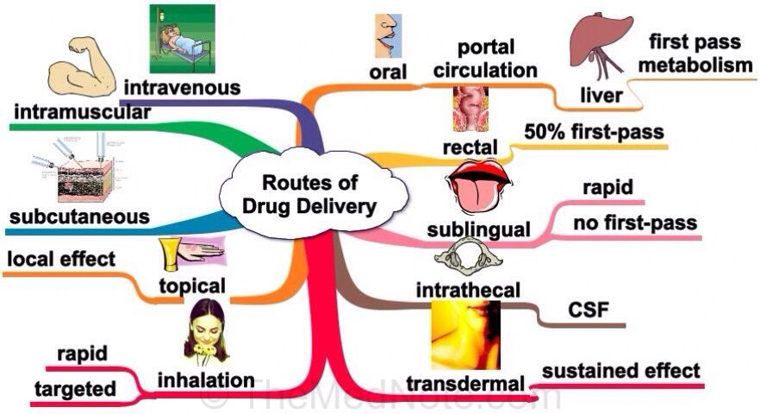

Placement Feedback

This placement was an enjoyable experience.

|  |  |  |  |
| --- | --- | --- | --- |
| Strongly agree | Agree | Disagree | Strongly disagree |

The staff were friendly and welcoming.

|  |  |  |  |
| --- | --- | --- | --- |
| Strongly agree | Agree | Disagree | Strongly disagree |

This placement was a valuable learning opportunity.

|  |  |  |  |
| --- | --- | --- | --- |
| Strongly agree | Agree | Disagree | Strongly disagree |

My learning needs were met on this placement.

|  |  |  |  |
| --- | --- | --- | --- |
| Strongly agree | Agree | Disagree | Strongly disagree |

The level of support received was appropriate to my level of training.

|  |  |  |  |
| --- | --- | --- | --- |
| Strongly agree | Agree | Disagree | Strongly disagree |

Please describe the best aspects about this placement experience.

Did you experience any difficulties as a learner during this placement?

Additional comments:

Thank you for taking time to complete the urgent response placement evaluation, your feedback and comments will help us to continue to provide quality learning experiences for learners.