**Welcome to**

**Ward 85**

**Information pack for student nurses**



Updated 2017

**Ward 85 – Tertiary Medical Ward**

Welcome to Ward 85, situated on the third floor of Royal Manchester Children’s Hospital. We hope that you will enjoy your placement with us, and find it an exciting learning experience. This student introduction pack aims to provide you with some further information in addition to the ‘Standardised Trust Welcome booklet for Nursing and Midwifery Students’ (Central Manchester University Hospitals NHS Foundation Trust, 2014).

Ward 85 is a tertiary medical ward that admits patients under the care of respiratory, cystic fibrosis, cardiology, rheumatology, metabolic, endocrine and immunology teams. It is a very intense and diverse ward with many sick children aged from birth to eighteen or nineteen years old, and their families.

Within Ward 85 there are ensuite cubicles available for infectious patients or immunocompromised patients. For example, patients admitted with Cystic Fibrosis need to remain in isolated cubicles due to the high risk of cross infection. There are also three, four bedded bays all of which have monitoring equipment for children and babies that are unwell and may require a high level of care.

There are fantastic facilities on Ward 85 that have been put in place to ensure children receive optimal care with minimal disruption. There is an ECHO and ECG room to enable sick cardiology patients to be assessed on the ward. We also have a therapy room used by allied health professionals such as physiotherapists and occupational therapists, which contains equipment such as a treadmill and an Xbox Kinect used for physiotherapy sessions.

There are facilities available to aid your learning located in the interview room on the ward, where you will have access to resource books and files. There are also teaching boards located around the ward, and you can gain access to policies etc via the computers. We also have an onsite library which you are welcome to use; you need a Trust ID badge to register.

**Ward Map**

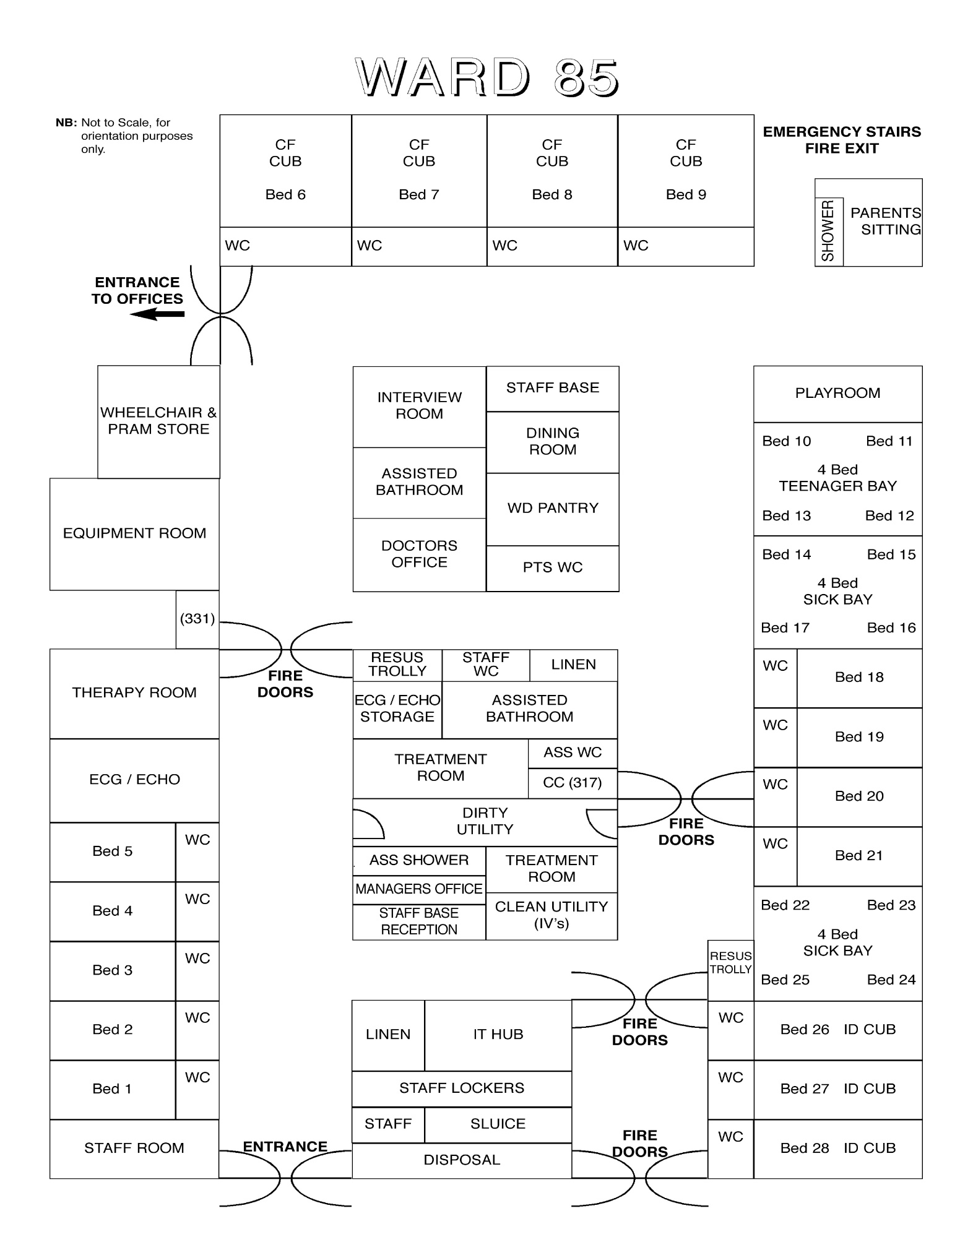

Stationary Cupboard

Oral Meds Room

Computer Room

**Our Ward Philosophy**

On Ward 85 we aim to ensure that all learners are welcomed and provided with a safe and supportive learning environment. Each student will be provided with two named mentors to support their learning and development. Achievable and relevant goals will be identified, specific to each student’s needs. Support will be provided to ensure that these are achieved.

**Shift Times and Handovers**

Our current shift times on Ward 85 are as follows:

* Early Shift: 0730 till 1530 with 30 minute break
* Late Shift 1200 till 2000 with 30 minute break
* Long Day 0730 till 2000 with one hour break
* Night Shift 1930 till 0800 with one hour break

Our handovers are facilitated by the nurse in charge who does a verbal handover. This usually takes between 20 to 30 minutes. We also have a printed handover sheet from the system ‘Bedman’ which provides basic information regarding the patients on the ward.

For information regarding university recommendations of shift patterns, required hours, and supernumerary status, please refer to the ‘Standardised Trust Welcome booklet for Nursing and Midwifery Students’ (Central Manchester University Hospitals NHS Foundation Trust, 2014). We will provide you with the opportunity to experience 24 hour care and work alongside your mentor at least two shifts a week. Further information can also be found in the off duty folder located at the nursing station and the student notice board.

**Student Off Duty Requests**

We now have a diary where you can request days off or particular shifts you want to work. We will do our very best to accommodate your requests however please remember that we do have a limit of three students per shift, and you have to work at least 40% or your time with your mentor.

**Staff Facilities**

On the ward we have an allocated staff locker room where you can safely secure your belongings. We also have a staff room where handover takes place. The staff room contains facilities such as a fridge and a microwave which you are welcome to use. Please ensure your food is labelled with your name and expiry date to save your food being thrown out by accident. The hospital also has several canteens available as well as an onsite Subway and Marks and Spencer. There is also a television available in the staff room which you are welcome to use during your break times.

**Common Terms and Abbreviations**

Working day to day on the ward you may come across some of these common abbreviations. Staff will be more than willing to help if you do not understand any of the abbreviations we use.

TPR – Temperature, Pulse and Respiration rate

BP – Blood Pressure

RR – Respiratory Rate

HR – Heart Rate

Pyrexial – Raised Temperature

Apyrexial – Normal Temperature (36.0 – 37.4)

Tachycardic – Raised Heart rate

Bradycardic – Low heart rate

Tachypnoeic – Increased respiratory rate

Apnoeic – Pauses in breathing

CF – Cystic Fibrosis

CFRD – CF related Diabetes

IV – Intravenous

IM – Intramuscular

Sub-cut - Subcutaneous

Port – an implanted device that allows IV access

IVI – Intravenous infusion

VSD – Venticular Septal Defect

ASD – Atrial Septal Defect

AVSD – Atrioventricular Septal Defect

JIA – Juvenile Idiopathic Arthritis

ICP – Integrated Care Pathway

MMA - Methylmalonic acidemia

PFO – Patent Foramen Ovale

PDA – Patent Ductus Arteriosus

SVT – Supraventricular Tachycardia

Echo – Echocardiogram – scan of the heart

ECG - Electrocardiogram

EEG - Electroencephalogram

CT – Computerised Tomography scan

MRI – magnetic Resonance Imaging

FBC – Full Blood Count

U and E – urea and Electrolytes

LFT – Liver Function Tests

OGTT – Oral Glucose Tolerance Test

NPA – Naso Pharyngeal Aspirate

RSV – Respiratory Syncitial Virus

CPE – Carbapenamase Producing Enterococci

MRSA – Methycillin Resistant Staph Aureous

TB - Tuberculosis

FTT – Failure to thrive

CHI – Congenital Hyperinsulinism

JIA – Juvenile Idiopathic Arthritis

NG – Nasogastric

NJ – Nasojejunal

URTI – Upper Respiratory tract Infection

**Spoke Placements Available**

|  |  |  |  |  |
| --- | --- | --- | --- | --- |
| **Spoke** | **Learning opportunities it provides** | **Specific to which year of programme** | **Placement contact details** | **Suitable length to spend in spoke** |
| Diabetes Service | Ward Management of Diabetes and CFRD, carb counting and blood glucose monitoring | 2nd and 3rd year | **Specialist Nurses**  Jude Campbell  Sue Ainsworth  Marie Marshall | 1 day usually Thursdays |
| Rheumatology Service | * To gain knowledge of the specialist nurse role. * To gain an awareness of rheumatology conditions. * To gain an awareness of the drug therapies used. * Participate in the weekly ward round. * Observe joint injections with Entonox. | 2nd and 3rd year | **Specialist Nurses**  Nicola East  Jodie Corbett  Ext 10618  Bleep 6588 | ½ to one full day Monday to Friday |
| Congenital hyperinsulism (CHI) | * Gain knowledge and understanding of specialist practitioner role * Develop skills and knowledge appropriate to level of learning related to the needs of patients and families with CHI. * Assessment and care planning. * Fluid and nutrition. * Hypoglycaemia management. * Medicines management. * PET CT scan. * Use of continuous glucose monitoring systems * Participate in MDT meeting/ ward rounds/ discharge planning * NORCHI clinics and video conferencing | 1st, 2nd and 3rd year opportunities dependant on availability and number of inpatients | Lindsey Rigby bleep 2460 and Louise Caine 10518 | ½ to one full day Monday to Friday |
| Professional play day with play leader | * Understand role of play leader and how play supports children and young people and their families * Gain an understanding of therapeutic play for preparation and distraction and appropriate age equipment to use | All years | Play centre 7010698 and play leader and specialist on the ward | 1 full shift |
| CF team | * Role of CF specialist nurses * An understanding of CF conditions and related conditions such as liver disease and diabetes * How chronic illness impacts on the child and family * Current treatment and latest research re CF * Family support through Cf trust guidelines and implications on practice and how this impacts on their live and specialist centre * Participate on grand round with MDHT * Physio techniques and implications of noncompliance with treatment * Annual review of therapies and monitoring such as USS * Medicines management including inhaler and nebuliser techniques * Lung function testing * Use of BIPAP and reasons for this * Palliative care pathway * Lung transplant assessments * Use of home oxygen | All years | Janet Edgar 10662 | 1 full shift |
| Cardiac service | * Understand specialist nurse role * Basic understanding of echo and ECG * Understand normal A & P and relate this to congenital heart conditions * Understand physiology of heart failure * Use of home oxygen therapy * Base knowledge of tilt testing and reasons why this is done * Base knowledge of EP studies including arrhythmias and how to recognise these * Cardiac catheterisation and defibrillator implantation | All years | Clair Noctor 10665 bleep 3328 | 1 full shift |
| RICH | * Introduction to research in children within the Trust * Observation recordings and patient observation/ monitoring | All years |  | 1 shift up to a full week |
| Physiotherapy | * Understand the role of physiotherapist * Anatomy and physiology * Techniques for chest physio used for conditions such as CF and bronchiectasis * Other situations where physio may be needed * Hydrotherapy | All years | Numbers available on ward contact board | 1 shift |
| Dieticians | * Role of the dieticians * Conditions in which a dietician referral may be needed * Stamp assessment * Types of feeds used * Creating feed regimes and liaising with the special feed unit | All years | Numbers available on ward contact board | 1 shift |
| Pharmacy | * Medication management * Role of the Pharmacist * Process in both the inpatient and outpatient pharmacy | All years | Please speak to the ward pharmacist | ½ to one full shift |

**Examples of Conditions You Will See**

**Cystic Fibrosis** This is a genetic condition which requires two sets of genes from both the mother and father. It results in thick sticky secretions being formed, which clogs up the person’s lungs and their digestive system. Children usually present with a persistent cough, poor gaining of weight and frequent chest infections (National Health Service, 2014).

**Respiratory**

Bronchiectasis – This is a condition which causes the airways to become wider resulting in the individual becoming more susceptible to infection due to collections of secretions (National Health Service, 2013).

Primary ciliary dyskinesia (PCD) – This is a condition that effects the cilia cells in the airway, ears and sinuses. The cilia do not work effectively, which leads to a build-up of bacteria causing frequent infections (U.S. Department of Health and Human Sciences, 2011).

**Cardiology**

Atrioventricular Septal Defect – This is a condition which refers to a hole being present between the walls of two atrium and the two ventricles in the heart (Children’s Heart Federation, 2013a).

Ventricular Septal Defect – This is a condition which refers to a hole being between present between the walls between the ventricles in the heart (Children’s Heart Federation, 2013b).

**Metabolic**

Wolmans Disease – This is a rare condition which is inherited. It results in the body having problems in breaking down fats and cholesterol (U.S. National Library of Medicine, 2014). This is a condition that usually results in the child not living past early childhood, however RMCH is trialing an enzyme replacement treatment to treat the condition.

**Rheumatology**

Juvenile idiopathic arthritis (JIA) – This is a condition that results in inflammation of the joints which lasts over 6 weeks (BUPA, 2012). This causes pain for the patient and may result in limited movement.

**Endocrinology**

Congenital Hyperinsulism – This is a condition which affects the pancreas, resulting in the body overproducing insulin. This causes dangerous episodes of hypoglycemia (National Health Service, 2011).

**Immunology**

Lupus – This is a condition where too many antibodies in the blood stream begin to attack the body. This results in damage to the bodies’ muscles, joints and organs (Lupus UK, 2014).

**Teaching available during this placement**

* Nasogastric feeding and passing of NG tubes
* Gastrostomy feeding
* Medication Management
* Clinical Observations
* Admission assessments
* Complex and routine discharges
* Fluid balance

**Contact Information**

Practice Education Facilitator for RMCH - Kirsty Walsh: 0161 901 1854 [kirsty.walsh@cmft.nhs.uk](mailto:kirsty.walsh@cmft.nhs.uk)

University Link Lecturer – Debbie Fallon - 0161 306 7774 [debbie.fallon@manchester.ac.uk](mailto:debbie.fallon@manchester.ac.uk)  
Ward 85 Ward Manager - Deborah Smith - 0161 701 8505  
Student Link Nurses - Lauren Rayner – [lauren.rayner@mft.nhs.uk](mailto:lauren.rayner@mft.nhs.uk)

Annie Tavendale – [annie.tavendale@mft.nhs.uk](mailto:annie.tavendale@mft.nhs.uk)

Rebekah Hutton – [rebekah.hutton@mft.nhs.uk](mailto:rebekah.hutton@mft.nhs.uk)

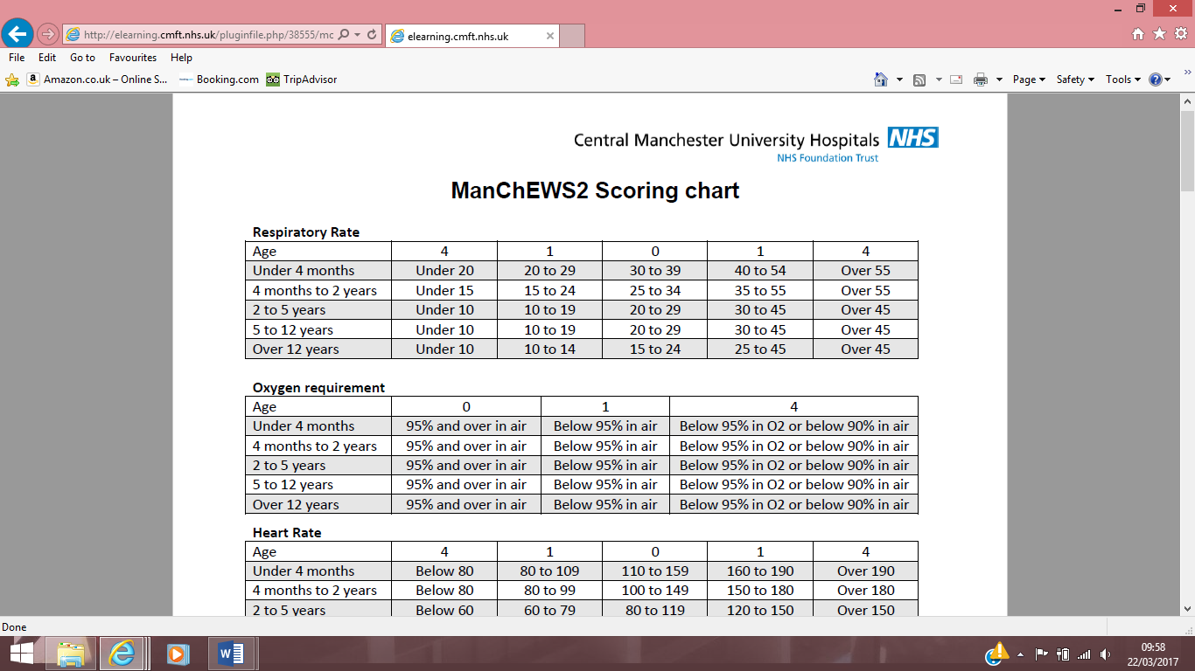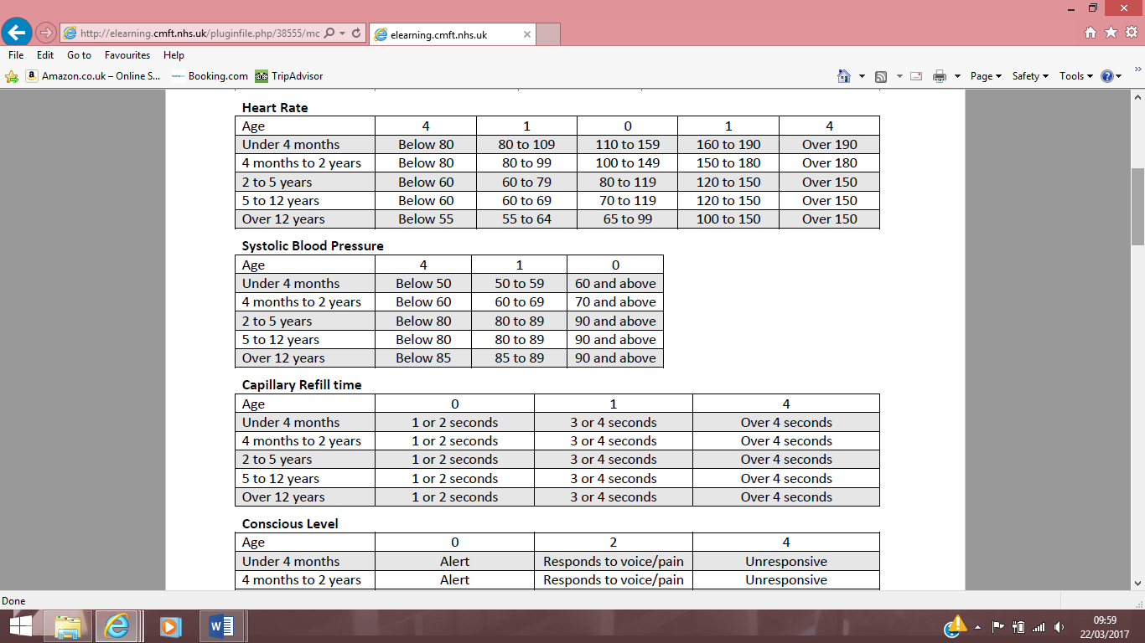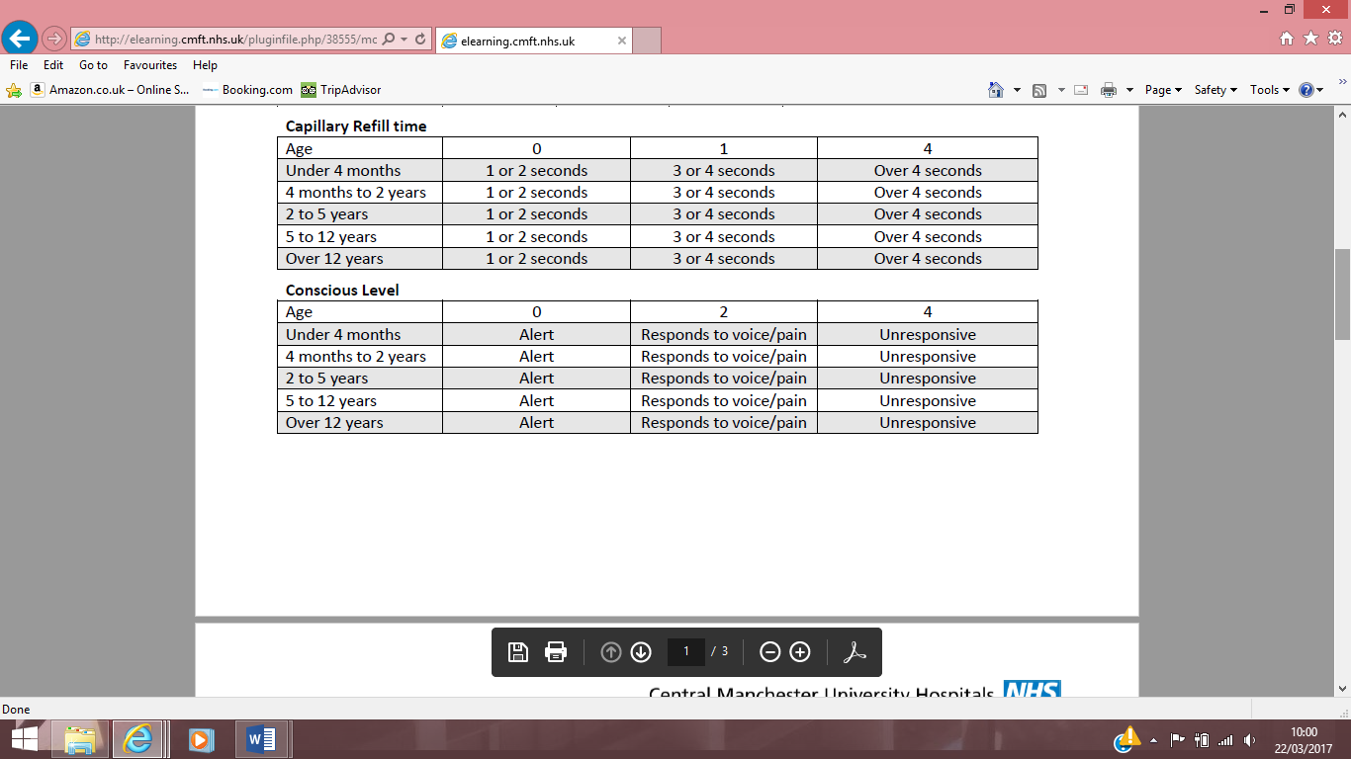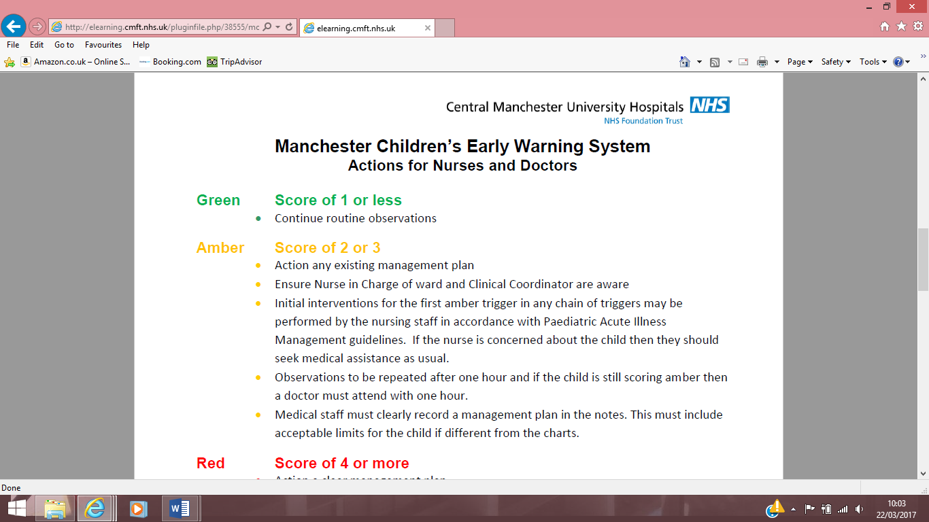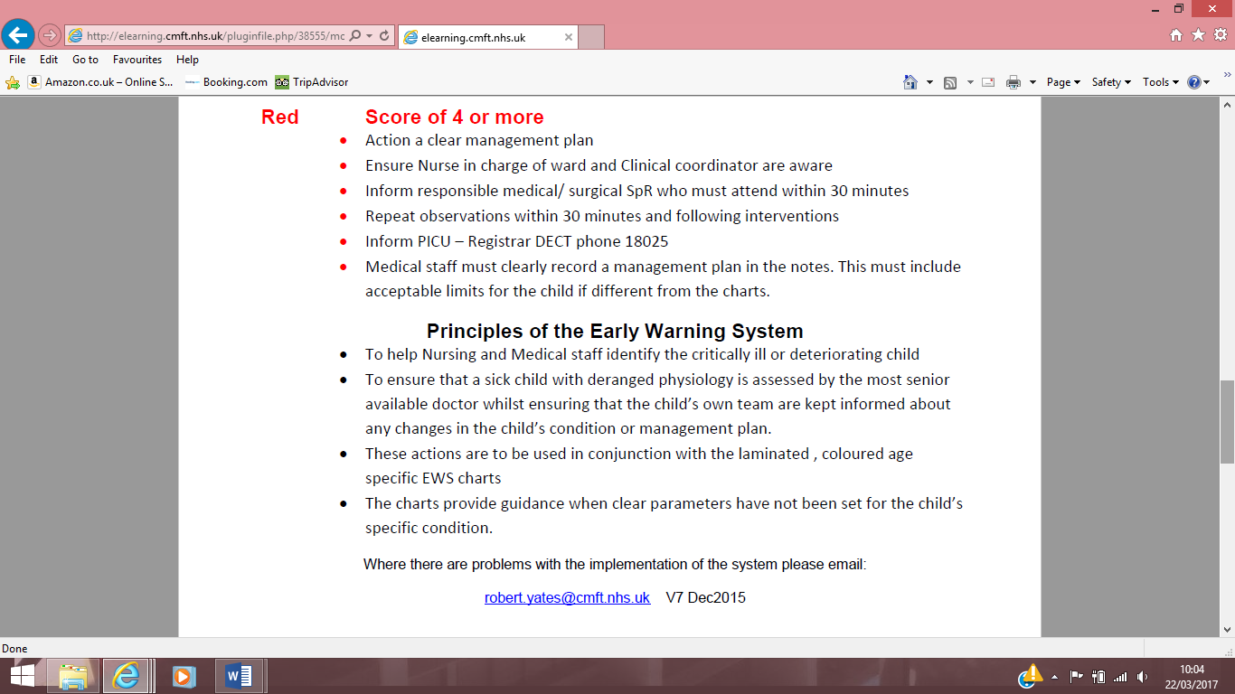

**Personal Notes:**