**WELCOME TO RESPIRATORY MEDICINE**

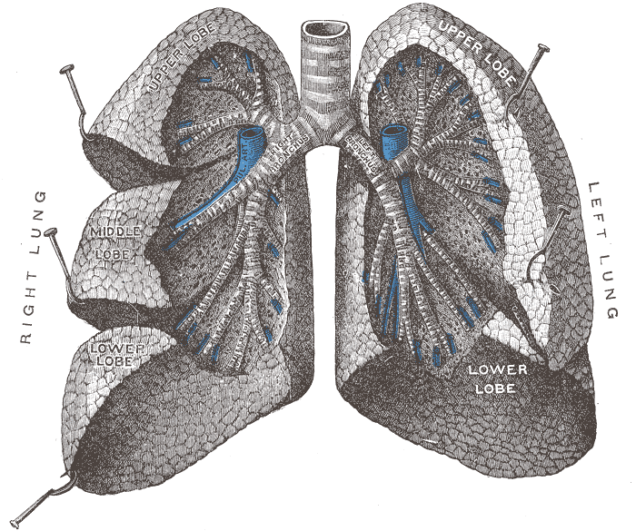

**STUDENT ORIENTATION PACK**

**Compiled by Practice Educational Leads:**

**Mariya Musa (SR) Rebecca Ruler (SR)**

*Updated August 2021*

**WELCOME TO D3**

**RESPIRATORY MEDICINE**

**CONSULTANTS:**

Dr Ibrahim

Dr Webster

Dr Ahmed

Dr Yadavilli

Dr Rafique

**WARD MANAGER**

**Vicky Brady**

**EDUCATIONAL LEADS**

**Mariya Musa, Rebecca Ruler**

D3 ward is a 27 bedded male ward caring for patients suffering from respiratory diseases which are acute and acute-on-chronic, and currently a covid ward. The ward is supported by members of the multidisciplinary team. Each of the consultants rotates onto the ward every two weeks during which time they are supported by a registrar, and a team of junior doctors. During weeks away from the ward Consultants operate daily out-patient clinics, twice weekly bronchoscopy sessions and relevant teaching of medical students.

**PRACTICE WORKING HOURS**:

D3 staff now predominantly work long shifts, (07.30am — 20.00pm, 19.30pm — 08.00am). If for any reason you are unable to work these shift patterns, please inform the Practice education leads on the ward to discuss off duty. Students are required to work a 37.5 hour week. Once shifts have been allocated these cannot be changed unless authorised by the mentor, ward manager and practice educational lead. Hours cannot be carried over to consecutive weeks.

**EXPECTATIONS OF PRACTICE ASSESSORS**

**Your assessor will:**

* Be a registered nurse who has a recognised mentorship qualification and is trained in the assessment process to university standard.
* Be supported by an associate mentor who has more than 6 months experience.
* Arrange a minimum of three formal meetings with you to complete your assessments, objectives and to discuss your learning outcomes.
* Respect your individual learning needs and capabilities. Provide learning opportunities to accomplish the clinical skills outlined by university guidelines.
* Help to facilitate additional learning experiences with different members of the multidisciplinary team.
* Assist in securing relevant objectives for spoke placements.
* Be open and honest regarding your progress both clinically and professionally. Ensure supernumerary status of student is adhered to at all times.

**EXPECTATIONS OF STUDENTS**

**As a student you will:**

* Treat all patients with dignity and respect.
* Work as a team member and demonstrate respect for your colleagues.
* Work within your limitations and always ask if in doubt.
* Take responsibility for your own learning, making use of teaching material available, attend teaching sessions and always question practice.
* Be punctual for shifts.
* Consider your personal appearance and adhere to the Trust uniform policy.
* Arrange any part time employment you may have around your allocated shifts on the ward.
* Retain a sense of self awareness and consider the problems that surround self-disclosure with patients
* To complete the workbook provided by practice education lead.
* Adhere to the correct PPE on the ward as per Trust policy since the start of covid.