The Pain Team

Learning Pack

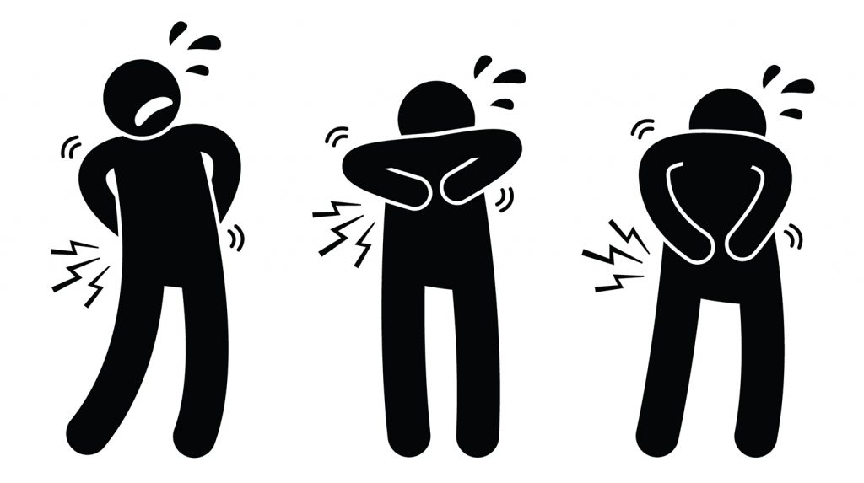

Name: ……………………………………………………

Placement Area: ………………………………………..

Contact email: ……………………………………………….

**Contents:**

Page 3: Acute Pain Team and contact details

Page 5: Defining Pain

Page 10: Anatomy and physiology of pain

Page 14: Pain assessment

Page 19: Balanced analgesia

Page 21: Common analgesia used

Page 23: Spoke Placement objectives

Page 24: Questions

Page 25: Further reading and information

Page 26: References

Please work through this learning pack and complete the questions and reflections.

Once fully completed, the pack can be returned to the Acute Pain Team (2nd Floor, G Block).

A certificate of completion and your completed learning pack will then be returned to you to put in your portfolio.

**Who is in the team?:**

Sr Janet Roberts. Lead Acute Pain Specialist Nurse

Sr Trudy Hadcroft. Acute Pain Specialist Nurse

Sr Alison Harris. Acute Pain Specialist Nurse

**Where are we based?**

Acute Pain Office

2nd Floor, G Block

**How can we be contacted?**

Ext 4628 (message can be left on answer phone)

Bleep 4866 or 3070 (8am-5.30pm) or

Via E mail: [janet.roberts@boltonft.nhs.uk](mailto:janet.roberts@boltonft.nhs.uk) [trudy.hadcroft@boltonft.nhs.uk](mailto:trudy.hadcroft@boltonft.nhs.uk) [alison.harris@boltonft.nhs.uk](mailto:alison.harris@boltonft.nhs.uk)

Each clinical area has a Pain Link Nurse and a Pain Resource File. Find out who the link nurse is for your current ward/area and where the resource file is kept.

**Area:**

**Name of Pain Link Nurse:**

**What is pain and how is it described in the literature?**

“Pain is an unpleasant sensory and emotional experience associated with actual or potential tissue damage or described in terms of such damage”

(International Association for Study of Pain 1992).

Pain can be difficult to explain and is unique to the individual. It has physical and emotional consequences which can lead to the inability to carry out normal daily activities.

Physical pain signals danger to the body and once the pain stimulus has been removed, pain will start to resolve.

(Swift, 2015)

Pain is categorised into Acute Pain - less than twelve weeks duration and Chronic Pain - of more than twelve weeks.  
Pain can be perceived as a warning of potential damage, but can also be present when no actual harm is being done to the body. (British Pain Society, 2017)

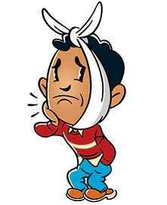 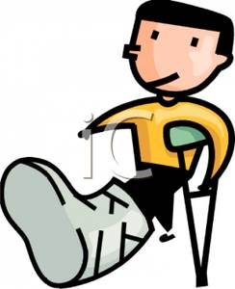

**Acute Pain:**

A symptom of injury or disease – A sign that something is wrong.

It has adverse effects on

* Breathing
* Circulation
* Mobility
* Psychological well being

It is an individual, subjective experience which is difficult to define and describe.

* Factors affecting acute pain include:
  + Nature and site of injury / surgery.
  + Personality.
  + Age, gender, social and cultural factors.
  + Information giving
  + Attitudes of medical and nursing staff.

It varies widely between individuals and depends on:

* Persons mood
* Memory of previous experience
* Cause of pain and what it signifies
* How person brought up to view pain
* Time of day and what is going on around

**Reflect on caring for a patient who had Acute Pain**

What was the cause of their pain? Did it affect their breathing, circulation, mobility? Were they upset, angry or distressed? What helped? Did anything make it worse? What could have been done differently?



**Chronic pain**:

* Ongoing pain for more than 3 months duration
* No longer a symptom
* Causes may be unknown
* Impacts on Activities of Daily Living
* Reduces function
* May lead to depression/suicidal thoughts

 

**Chronic Pain Team:**

* Patients referred by their own GP
* Out patient service only
* Contact number extension 5763

**Reflect on caring for a patient who has Chronic Pain**

What was the cause of their pain? What impact did it have on their daily life? Did anything help relieve their pain?

Find out about the Chronic Pain Service and what treatment do they offer patients?



**Anatomy and Physiology of Pain**

Pain mechanisms are usually described in terms of nociceptive pain or neuropathic pain. However, occasionally it could be a mixture of the two. Determining the type of pain is crucial as this affects the appropriate selection of analgesia or treatment plan.

Nociceptive pain

Nociceptive pain is the ‘normal’ pain pathway that occurs in response to tissue injury or damage. It is a protective function of the body that alerts the patient to the damage.

It is pain associated with and in proportion to trauma, injury or a pathological process such as inflammation. It is usually localized to the affected area.

It consists of four components: **transduction, transmission, perception and modulation**.

Free nerve endings (nociceptors) at the end of pain neurones are found in skin and subcutaneous tissue, muscle, visceral organs, tendons, fascia, joint capsules and arterial walls. These receptors then transmit signals to the nervous system.

These nerve endings detect and respond to a range of stimuli including heat and cold (noxious thermal stimuli) and stretching, compression, infiltration (mechanical stimuli) and to the chemical mediators released as part of the inflammatory response to tissue injury.

(Royal Marsdens, 2015)

Write down the meaning of:

* Transduction
* Transmission
* Perception
* Modulation

**Neuropathic pain**

Neuropathic pain is not pain that originates as part of ‘normal’ pain pathways. Patients may report ‘shooting, burning or stabbing pain’. It is caused by damage to the nervous system preventing signals from being transmitted to the brain. This injury or damage can be caused by a range of conditions such as infection, trauma, metabolic disorder, chemotherapy, radiation, neurotoxins, nerve compression, joint degeneration, tumour infiltration and malnutrition.

The mechanisms by which neuropathic pain develops are not fully understood but the following are thought to contribute:

* Damage in the nerves changing the way that they communicate with each other.
* Pain receptors require less stimulation to initiate pain signals.
* Pain transmission is altered from its normal sequence.
* There may be an increase in the release of chemical neurotransmitters.
* There can be increased and chaotic firing of nerves.
* Damaged nerves spontaneously generate impulses in the absence of any stimulation.

Pain can be spontaneous, may be triggered by non‐painful stimuli such as touch (allodynia), may be an exaggerated pain response (hyperalgesia) and patients may also experience non‐painful sensations such as pins and needles and tingling (paraesthesias). (Royal Marsdens, 2015)

**Reflect on patients you have looked after who have had neuropathic pain.**

How do they describe their pain? What analgesia were they prescribed?



**Pain Assessment**

“Pain is what the experiencing person says it is”

McCaffery 1968

* Pain assessment is crucial to ascertain the most appropriate treatment and monitor the underlying cause or condition.
* It can help detect and describe the type of pain and determine if analgesia given has helped.
* Pain assessment can be complicated, especially if there is no obvious cause.
* Patients may vary in their ability to explain or express their pain.

(Swift, 2015)

Successful and appropriate pain management is essential to aid patient’s quick recovery and decrease length of stay in hospital. (Huang et al, 2017)

Patients often struggle to have adequate pain management, as their pain assessments are often unreliable or inaccurately completed. (Gregory, 2015)

**How do we assess pain?**

* Ask the patient
* Believe what the patient says
* Use behaviour and body language as indicators
* Use a pain assessment tool: A separate tool is available at Bolton NHS Trust for patients who have Dementia or communication problems

Pain can only be measured indirectly.

There are no instruments available to measure pain such as a thermometer for temperature recording or a Dinamap to measure blood pressure but there are pain assessment tools.

**Pain scores used in Bolton:**

Verbal descriptor scale

No Pain = 0

Mild Pain = 1

Moderate Pain = 2

Severe Pain = 3

Pain assessments must be carried out at each set of observations. The patient should be asked “Do you have any pain? Is it mild, moderate or severe?” The number ‘0-3’ must be documented on the ‘early warning score’ chart or in the patient notes if in community.

**Bolton Pain Assessment Tool**

* To be used for all patients with Dementia or communication problems.
* Any comments from relatives/carers must be included on the tool.

|  |  |  |  |  |
| --- | --- | --- | --- | --- |
| **SCORE** | **NO PAIN** | **M ILD** | **Description: C:\Documents and Settings\thadcroft\Local Settings\Temp\Temporary Internet Files\Content.IE5\6R6AZF00\MC900423165[1].wmfC:\Documents and Settings\thadcroft\Local Settings\Temp\Temporary Internet Files\Content.IE5\6R6AZF00\MC900423165[1].wmfC:\Documents and Settings\thadcroft\Local Settings\Temp\Temporary Internet Files\Content.IE5\6R6AZF00\MC900423165[1].wmfC:\Documents and Settings\thadcroft\Local Settings\Temp\Temporary Internet Files\Content.IE5\6R6AZF00\MC900423165[1].wmfMODERATE**  **C:\Users\THadcroft\AppData\Local\Microsoft\Windows\Temporary Internet Files\Content.IE5\K3XS97I6\1024px-Oxygen480-emotes-face-sad.svg[1].png** | **SEVERE** |
| **VOCALISATION** | **none** | **Occasional moan or groan** | **Intermittent shouting/moaning** | **Repeatedly crying out, loud moaning or crying** |
| **FACIAL EXPRESSION** | **Smiling or relaxed** | **Looking tense,** | **Sad**  **Frowning,** | **Grimacing and looks frightened** |
| **CHANGE IN BODY LANGUAGE** | **None** | **Tense, fidgeting** | **Guarding.** | **Withdrawn, rigid, fists clenched. Knees pulled up** |
| **BEHAVIOURAL CHANGE** | **None** | **Slight/intermittent confusion or agitation** | **Increased confusion or agitation** | **Severe agitation/aggression** |
| **PHYSIOLOGICAL CHANGE** | **Normal** | **Mild increase in heart or respiratory rate** | **Increased heart rate, respiratory rate and Bp** | **Continued changes in vital signs.**  **Perspiring flushed or change in pallor.** |
| **PHYSICAL CHANGES** | **None** | **Mild trauma, ie skin tears etc** | **Pressure ulcers, moisture lesions etc** | **Post surgery, trauma,** |
| **PAIN SCORE** | **Predominantly**  **WHITE**  **= NO PAIN 0** | **Predominantly GREEN**  **= MILD PAIN 1** | **Predominantly AMBER**  **=MODERATE PAIN 2** | **Predominantly**  **RED**  **= SEVERE PAIN 3** |

**Pain Assessment Tools**

Look at other Pain Assessment Tools that are available. What did you find? Do you feel they are better or worse for assessing patients in acute pain?



A good assessment consists of more than one question. Think what else you may want to consider when carrying out your pain assessment?



**Balanced Analgesia**



In Acute Pain our aim is to manage the pain, achieving comfort and function with minimal side effects. Acute pain is of a short duration and the cause of the pain will usually be removed i.e. appendix, gallbladder, fracture. We use the World Health Organisation (WHO, 1996) analgesic ladder as a guide to the analgesia we prescribe or recommend. The analgesic ladder also reflects the assessment tool that we use at the Trust.

|  |
| --- |
| Trust assessment tool |
| 3= Severe Pain |
| 2= Moderate Pain |
| 1= Mild Pain |
| 0= No Pain |

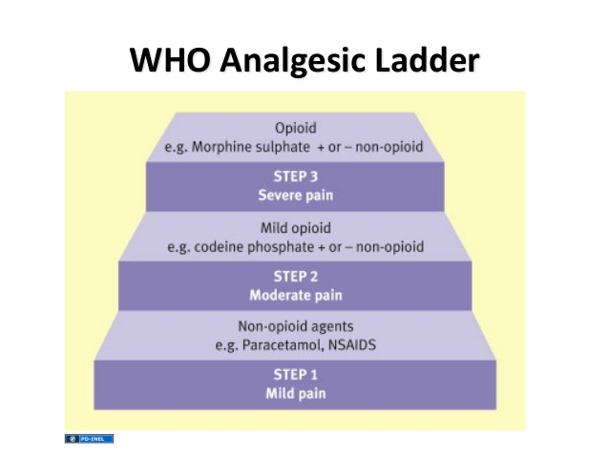

(WHO, 1996)

Read the Trust Acute Pain Management Guidelines on the hospital intranet (under ‘A’ for Acute Pain). What analgesia is recommended for mild pain, moderate pain and severe pain?



**Common Analgesia used at Bolton:**

Please complete the following table.

|  |  |  |  |
| --- | --- | --- | --- |
| **Drug name** | **List routes of administration** | **Dose and Frequency? (**List dose for all routes) | **Common side effects** |
| Paracetamol |  |  |  |
| Ibuprofen |  |  |  |
| Diclofenac |  |  |  |

|  |  |  |  |
| --- | --- | --- | --- |
| **Drug name** | **List routes of administration** | **Dose and Frequency? (**List dose for all routes) | **Common side effects** |
| Codeine Phosphate |  |  |  |
| Morphine |  |  |  |
| Oxycodone |  |  |  |
| Fentanyl |  |  |  |

**Spoke Placement for students:**

Do you know Student Nurses and Trainee Nurse Associates in their final year of training can shadow the Acute Pain Team on a daily ward round? This can be arranged this by ringing extension 4628.

**Student Nurse Spoke Placement objectives:**

The learner will be able to demonstrate an increased awareness and knowledge of pain management

**Expected outcomes:**

Increased understanding of the types of pain

Increased awareness of the importance of accurate pain assessment

Increased awareness of the Pain Assessment Tools used in the Trust and be aware how to use them and document appropriately

Demonstrate knowledge of frequently used analgesia including potential side effects

Be aware of when to seek further review and who to contact if patient is still in pain

Be aware where Trust guidelines are and how to access them

**Questions:**

1. What is the difference between Acute and Chronic Pain?

2. How do you contact the Acute Pain Team?

3. What Pain Assessment Tools are used at Bolton NHS FT?

4. How frequently should a Pain Assessment be carried out?

5. Where can you find up to date guidelines on the management of pain in the trust?

6. What is the World Health Organisation analgesic ladder and how does it influence analgesia selection?

7. List all the different routes analgesia can be administered

**Further Reading:**

Up to date Trust guidelines on pain management can be found on the hospital intranet ‘**BOB’** page under ‘**A’** for ‘Acute Pain’ and cover:

Acute Pain Management

Post Op Nausea and Vomiting

PCA

Epidural

Entonox

Bolton Pain Assessment Score charts

**Useful Websites:**

British Pain Society: useful source of up to date publications and news.

<http://www.britishpainsociety.org>

NHS Evidence: [www.evidence.nhs.uk](http://www.evidence.nhs.uk)

The RCN website also have ‘easy to read’ leaflets which can be down loaded free of charge and printed off for patients who may have learning difficulties or difficulties understanding information. Leaflets include ‘Pain’, ‘PCA’ and ‘Epidurals’. <https://www.rcn.org.uk/>

**References:**

British Pain Society (2017) [online] <http://www.britishpainsociety.org>

Gregory J (2015) [The complexity of pain assessment in older people](https://www.research.manchester.ac.uk/portal/en/publications/the-complexity-of-pain-assessment-in-older-people(e2242ea4-0aa9-483d-bce3-ed615b063bab).html). Nursing Older People; 27: 8

Huang E, Phillips S, and Owen B (2017) Post-operative pain management. Pharmacy Times; September 30

International Association for the Study of Pain (1992) [online] <https://www.iasp-pain.org>

McCaffery M (1968*)*Nursing practice theories related to cognition, bodily pain, and man-environment interactions*.* Los Angeles: University of California.

Royal Marsden (2015) The Royal Marsden manual of clinical nursing procedures. [online] [http://www.rmmonline.co.uk](http://www.rmmonline.co.uk/)

Swift A (2015) Pain management 3: The importance of assessing pain in adults. Nursing Times; 11: 41 pp12-17.

World Health Organisation (1996) Cancer pain relief. 2nd ed. Geneva: WHO.