

**Welcome to**

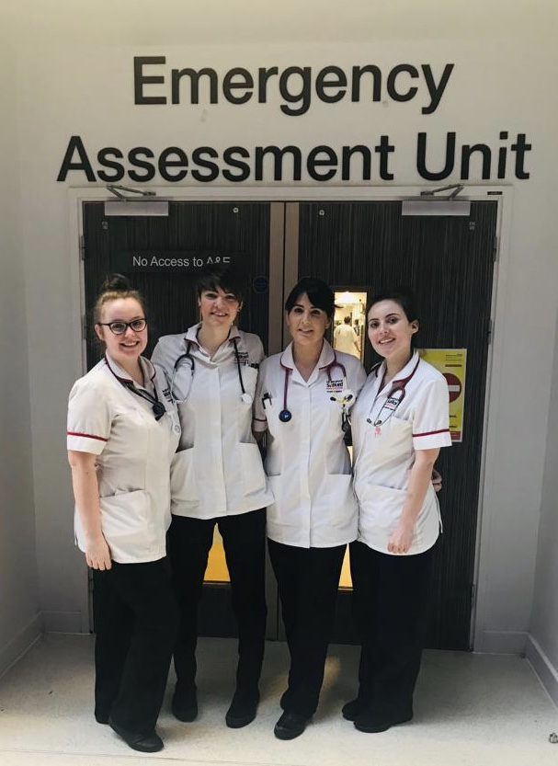

**Student nurse: Assessor/Supervisors:**

**Year: Semester: Start/End Date:**

**Ward Information:**

EAU is a 55 bedded unit consisting of 4 different areas:

**Ambulatory Assessment Unit**, AAA (Zone 1) – 16 beds and 2 side rooms

**Comprehensive Older Person Evaluation**, COPE (Zone 2) – 12 beds and 6 side rooms

**High Intensity Treatment**, HIT (Zone 3) – 12 beds and 7 side rooms

**Ambulatory Emergency Care**, AEC – 30 seats divided into 2 rooms and 5 treatment rooms

*We aim for a rotation between the different areas, meaning you will be exposed to different learning opportunities depending on which area you are working in.*

**Management:**

Lead Nurse: Lisa Coleby

Matrons: Debra Fletcher-Collins, Vicky Daye, Laura Malone and Lauren Hynes

**Practice assessor and supervisor:**

Upon initially contacting the ward for off duty you will have been assigned a Practice Assessor (PA) and one or more Practice Supervisors (PS). You will have gotten the initial 4 weeks of off duty by the PEL working shifts with your PS. Please ensure that you do work with the Practice Supervisor during your shifts as they are responsible for recording your attendance and reporting back to the PA. For remaining off duty, please discuss this during your initial meeting with the PS or with the PA.

The PA will be responsible to complete your midpoint and final assessment. They will receive feedback from your PS regarding your attendance and professional manner, but may also work with you to make their own assessments, or observe you for a period of time or during procedures connected to your competencies.

Your PA/PS are there to support you during your placement and work towards your individual learning needs . If you have any concerns, please discuss this with your PA, or PEL.

**Useful information:**

**Where to find us:**  EAU is located in the Hope building on the ground floor between Lloyds pharmacy and WHSmith.

**EAU Practice Education Link (PEL)**

Sister Jade Teeling [jade.teeling@nca.nhs.uk](mailto:jade.teeling@nca.nhs.uk)

Sister Emily Cook Emily.cook@nca.nhs.uk

**EAU Practice Education Facilitator (PEF)**

Julianah Oluwasakin [Julianah.Oluwasakin@srft.nhs.uk](mailto:Julianah.Oluwasakin@srft.nhs.uk)

**University Link Lecturer:**

Melanie Stephens & Sue Walker

**Sickness:**

If you are ill, please contact EAU nurse in charge (***0161 206 8765***) as soon as possible, informing us the nature of your illness and how long you are expecting to be off. Please also provide us with a date for contact with your Assessor, Supervisor or one of the PELs so that we know when to expect your return to the unit. ***Please be advised that it is not acceptable to text staff members that you are ill, as any sickness needs to be officially reported, and registered for auditing purposes.***

**Phone numbers:**

EAU front desk: 0161 206 4908

EAU Nurse in charge: 0161 206 8765

**Health and Safety:**

**Fire:** Please familiarise yourself with the emergency exits and alarms during your first day. If needed, please be aware that the phone number in case of a fire is 3333.

**Manual Handing:** It is your responsibility that your Mandatory Training has been completed, and be sure that you can show evidence of this to your practice assessor/supervisor.

**Infection control:** While you are on placement, please ensure that you adhere to the ANTT policy regarding PPE and handwashing. ***You, as students, can highlight any staff members not following the policy to a manager, PA, PS or nurse in charge on the day – it is everyone’s responsibility.***

**Needle stick injury:** In the event you sustain a needle stick injury; make it bleed, wash thoroughly and attend either Occupational Health (09.00-16.00) or A&E (16.00 – 09.00). Please also report it to nurse in charge on the day and complete an adverse incident report (DATIX). You will be supported through this by your practice supervisor on shift.

**Personal items:** Please label any food or drink with name and date before leaving in the fridge. There are currently no lockers available on EAU, so personal items can be left in the staff room; please ensure that you do not bring any valuables into work – it is your responsibility to look after your own belongings.

**Code of conduct:** You are, as students, expected to know your limitations while working. Do not hesitate to ask for help with any equipment or procedures you are unfamiliar with.

During your placement you need to wear the correct uniform, according to the uniform policy. This means, among other things, that you are expected to keep your hair above the collar of your uniform, no jewellery apart from a single pair of stud earrings and a plain wedding band. You are expected to not wear watches, or sleeves are allowed below the elbows, and no false nails or nail polish in accordance to trust policies.

**Spoke placements**

*You can, during your placement, do spokes in areas interesting to yourself. These spokes are available while you are on EAU, but please ensure that the spoke is suitable to your level of studies and that you complete a reflection piece after each of them and submit this to your PEL or Practice Assessor. The person you are completing the spoke with (nurses, specialists, bedmanagers etc.) will soon get access to PARE enabling them to give you written feedback.*

|  |  |  |  |  |
| --- | --- | --- | --- | --- |
| ***Spoke*** | ***Learning opportunities*** | ***Recommended year of studies*** | ***Placement contact detail*** | ***Suitable length of spoke*** |
| Accident & Emergency | Various |  | 206 2877 | 1-2 shifts |
| Substance misuse team | Substance withdrawal and safe management |  | Ruth Brown  206 4206  (bleep 2130) | 1 full shift |
| Bed manager | Patient flow, working with bed allocations | 3rd years only | Medical bleep 3095  Surgical bleep 2369 | 1 full shift |
| CAST | Airway management, long term condition care |  | 206 3165 | 1 full shift |
| Frailty | Care of dementia patients, management and strategies |  | Available on EAU | 1 Full shift |
| Diabetes specialist nurse | Manage diabetes  Different insulin/medication and how they work |  | Louise Wong  206 0203 | ½ Shift |
| Medical High Dependency Unit | Various (seriously ill, severe organ failure patients) |  | Ruth Mangaoang  206 5783 | 1 Full shift |
| Radiology | Different scans and differences |  | Elaine McKnight  206 2206 | 1 Full shift |
| Home First | Mobility, safe discharges, follow up. MDT teams |  | 206 6666 | 1 Full shift |
| Pharmacy | Medications, formulations and common issues |  | Alison – contact in EAU pharmacy office | ½ Shift |

**Evaluations:**

Please complete the evaluation on PARE, as well as hand in a copy of your reflections and the learning pack at the end of your placement. This will enable us to continue to improve our practice and get better at teaching your future colleagues.

If you, at the end of the placement (no matter what year), are interested in joining our team of nurses, please see one of the managers for information on how to proceed with recruitment and applications.

**Last words:**

We hope you enjoy your placement with us, and that you seize the opportunity to learn as much as possible. If you have any ideas to improve the learning experience with us, please contact one of the PELs with suggestions.