Welcome pack
Urology Outpatient Department



Introduction.

The Urology Outpatient Department is located in the Hope Building on Level 2, directly above WH Smith. The Urology department is the only unit that has been awarded the Macmillan Quality Environment Mark nationally. This provides quality assurance for both patients and their relatives with a cancer diagnosis.

Throughout your placement you will have the opportunity to observe and participate in a patient’s pathway, from initial presentation, diagnosis and management of their care and treatment. We will endeavour to arrange some SPOKE opportunities as part of your rostered off duty however there is scope for you to review and add into to meet your individual learning needs.

Throughout your placement we will make every effort to make your placement educational and enjoyable. We will help you to develop your knowledge and skills and challenge you to rationalise your actions and decision-making using evidence based, best practice guidance. This pack has been developed to give you an idea of what to expect from our department and what possible learning opportunities may be available to you.

Your first day.

You will be orientated to the clinic environment, introduced to the staff on duty and to the assessor and/or supervisor assigned to support you. There will also be time for you to read this pack and familiarise yourself with the resources available to you. It would be helpful if you review your outstanding proficiencies, current knowledge within urology & note down some goals & objectives you would like to obtain whilst on placement with us. This way when you meet with your Assessor/Supervisor you can tailor your placement exposure to meet your individual needs.

Contact Details.

Specialist Nurse Office – 0161 206 5380
Urology Hub – 0161 206 5239
Urology Base – 0161 206 5566

Generic Urology Nursing Email : urologycns@nca.nhs.uk

Shift Patterns.

Monday - Friday 8am – 6pm over three days and one day 8am -5.30pm a week (37.5 hours per week). We are closed weekends and bank holidays. There is the option to work shorter hours over 5x days. Any adjustments to the standard working hours can be discussed with your assessor/supervisor and your off duty reviewed.

What Learners can expect from staff.

You should expect to be welcomed as part of the team by all members of the multi-disciplinary team.

You can expect an appropriately timed orientation to the placement area, including departmental layout, clinic routine, emergency procedures and have opportunity to ask any initial outstanding queries. It will be made clear what your role is within any given clinic / emergency situation.

You will have a named assessor and supervisor as allocated on PARE and advised of on your welcome email. We will endeavour to ensure you meet them both at the earliest opportunity and complete your initial meeting together. It would be worth noting, however, that within the Urology department you will be supported by all members of the multi-disciplinary team. This may include doctors, nurses, support workers and other allied health professionals.

You will be included in end of clinic debriefs & should feel encouraged to participate any thoughts/ideas. You should expect to receive contemporaneous feedback throughout your supported practice. You will be encouraged to celebrate successes. We will address any areas of concern with you at the earliest opportunity and ensure the local PEF team, Personal Tutor and Academic Assessor are involved as appropriate. All feedback should be collated as part of placement meetings +/-additional feedback documents on PARE. We would encourage you to record reflective pieces to discuss with your assessor / supervisor which can form part of your continuing professional development. We hope that you feel that we provide a safe space for you to be curious and ask questions.

Your role as a learner will be respected at all times. You will always remain supernumerary. You will, however, be actively encouraged to participate in all aspects of care delivery as appropriate.

What staff can expect from learners.

You will be punctual for duty and be expected to be flexible in your working hours in order to gain true experience of the placement area.

You must adhere to uniform policy as set by the University and Local Policy. ID badge must be present and visible for all shifts.

If you are working bank shifts with agency companies such as NHS Professionals you should wear the appropriate uniform. Please ensure that your mobile phones are either kept with your belongings or in your pocket, we do not expect you to be using your phone when you are in the clinical area and/or the clinic hub.

The sickness and absence policy must be followed. If you are unfit for your shift you must inform the nurse in charge at the earliest opportunity, prior to the start of your shift. If you are unable to speak directly to a member of staff please leave a message on the specialist nurse answering machine – 0161 206 5380. Please advise of your reason for absence and some indication of when your intention to return to duty. It is your responsibility to inform the University of any sickness/absence.

You must gain consent from all patients to be involved in clinic consultations, diagnostic procedures and any other urological treatments. You will be expected to maintain patient dignity and confidentiality at all times.

Any personal/professional problems that arise during your placement must be raised as soon as possible with an appropriate member of staff; practice education lead (Sister Siobhan Allmark) or practice education facilitator (Andrea Surtees).

You are expected to take ownership of your PARE document. You should be proactive about your learning needs and discuss any potential learning opportunities with your assessor/supervisor.

Philosophy, of Care.

Our aim is promote and deliver high quality professional nursing care in partnership with individual patients, their families and the multi-disciplinary team. We aim to provide patient-centered care based on the unique physical, psychological, spiritual and emotional needs of each patient. We respect each patient's right to safe, timely, effective and coordinated care and are committed to protecting his/her dignity, privacy and confidentiality We hold ourselves accountable for the care we provide and for upholding NMC's standard of excellence at all times. We commit ourselves to continue professional growth through ongoing education and certification and to base our nursing practice on scientific evidence and the highest of professional standards.

The unit is organised within a multi-disciplinary team framework. This approach should foster collaborative, interdisciplinary relationships that promote mutual respect and teamwork, strengthen patient care and facilitate smooth care transitions for our patients. We challenge each other to achieve excellence through continuous quality improvement activities.

All team members are viewed as individuals bringing valuable attributes that contribute to the patents care. Individuals are encouraged to develop their own knowledge and skills, which will in turn promote safe, effective and competent care within the unit. The aim of the unit is to provide an environment that is conducive to learning for all disciplines.

Patients will receive care that is based on current specialist knowledge and evidence-based practice.

Patients will be viewed holistically considering their physical, emotional and spiritual needs.

Key Contacts.

Placement Education lead : Alice.Phillips@srft.nhs.uk 0161 206 5380 /
siobhan.allmark@nca.nhs.uk 0161 206 5380

Practice Educational Facilitator (PEFTeam@nca.nhs.uk )
Andrea.surtees@nca.nhs.uk - 07395799524

University link lecturer - N.Heaps1@salford.ac.uk

Medical Staff (Consultant Surgeons)

Professor N Clarke Mr L Clarke
Professor D Shackley Ms E Foster
Mr K O’Flynn Ms L Olson
Mr C Betts Mr J Broome
Mr M Lau Mr S Tolofari
Mr D Ross Mr A Hoyle
Mr S Maddineni Mr M Raslan
Mr E Green Mr R Mukherjee

Speciality Doctors.

Mrs K Burnett - Staff Grade in Urology
Mr J Tumman - Specialty Doctor in Urology

Visiting Doctors
Dr A Hudson - Consultant in Clinical Oncology
Dr M Serra - Consultant in Clinical Oncology
Mr V Modgil – Consultant in Andrology and Penile Health

Specialist Nurses

Consultant Nurse Julia Taylor

Advanced Nurse Practitioner Margaret Russell

Surgical Care Practitioners Nicholas Fletcher

Surgical Care Practitioners Helen D’Sa

Uro-Oncology CNS Team:
Sister Laura Jones
Sister Sally Botham
Sister Hannah Leather
Sister Siobhan Allmark

Benign CNS Team:
Sister Nicola Telford
Sister Alice Phillips
Staff Nurse Pamela Gantley

ERAS CNS : Sister Jane Kingham

Clinical Support Workers.

Joanne Norbury
Olive Mukarugwiza
Lok BajgaiSharma
Faye Greaves
Tracey Kilshaw
Amena Nashir
Kit Wai Tang
Martyna Kalupa
Janet Atkinson-Jones
Memory Keen

Housekeeping

There is a communal break room located on ward H4 with a microwave, fridge and tea making facilities. We ask that all food left in the fridge must be clearly dated and labelled. We provide tea and coffee facilities in the main clinic hub, which learners are welcome to use, we do not allow drinks in the main clinical areas. There is also the trust restaurant, coffee shop, WH Smith and M&S where food and beverages can be bought. We expect you to demonstrate effective time management & liaise with the clinic staff in terms of rotation of appropriate break times.

Any key code digits disclosed to you during your placement are expected to remain confidential.

Feedback
Within the Urology Department we strive to provide a culture where everyone is encouraged to both give & request feedback as a routine part of practice. The foundations of this really centre around providing a safe & confidential place for people to feel comfortable to share their ideas, thoughts or concerns. The benefits of this is that it creates an open & transparent environment which improves staff communication & encourages growth & development amongst the team.

Feedback & reflection of practice is an ongoing requirement of the Nursing & Midwifery Council (NMC) as part of your revalidation process once qualified. Therefore, it would be a benefit to you to find what models / processes work best for you. Throughout your time with us you should expect to receive contemporaneous feedback. This will obviously be collated formally at each of your placement meetings. If there is feedback from a particular member of staff you would like to record, please invite them to do so on your PARE & perhaps consider writing up a reflection on what it is about this particular feedback has been on benefit to you.

Below are examples of models for reflection & the link for the NMC will take you to the reflective templates which you may wish to utilise as part of this process.

Revalidation resources and templates - The Nursing and Midwifery Council (nmc.org.uk)

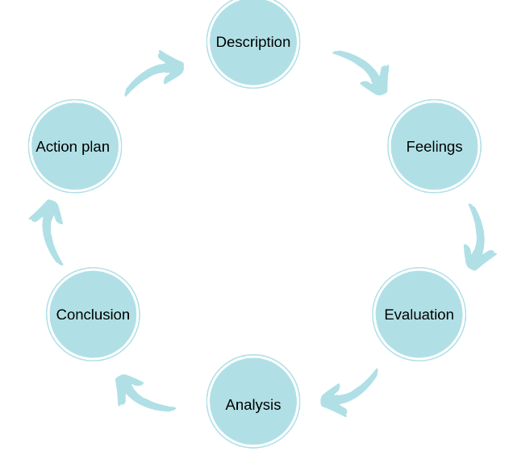
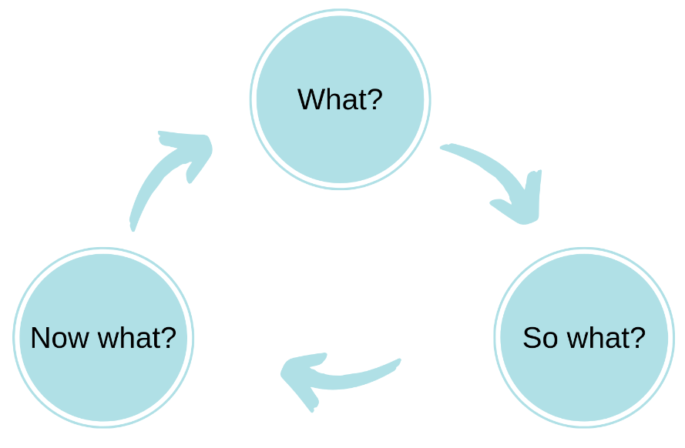

GIBBS
DRSICOLL

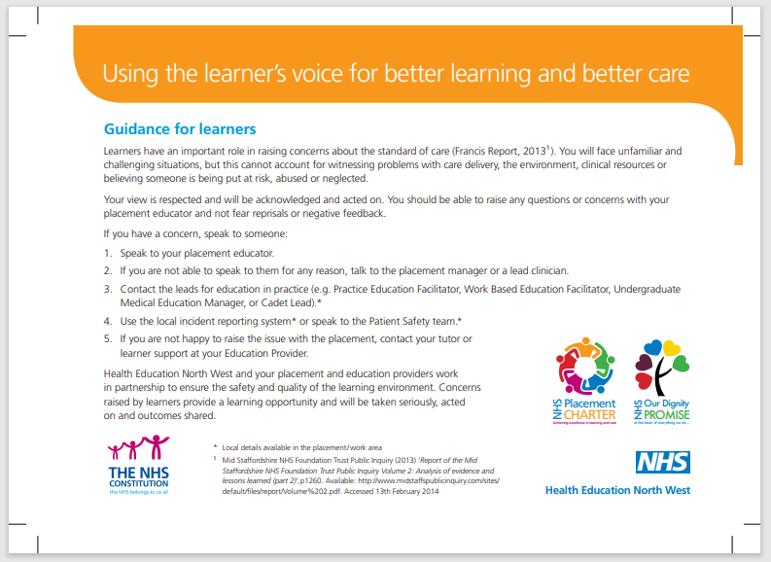

Learning Opportunities (Under Supervision) :

- Principle of ANTT – Observation, Practice & Assessment
- Infection Control – Hand washing & Rationalisation of PPE
- Clinical Observations including Height, Weight, Blood Pressure & Urinalysis
- Male (Currently unable due to Invasive Clinical Skill Update) and Female Catheterisation following completion of clinical skills workshop
- Catheter Care, including patient education
- Suprapubic Catheter Change
- Assessment of lower urinary tract symptoms including interpretation of urinalysis & uroflowmetry
- Assisting with Urological procedures (following ANTT assessment) : Flexible Cystoscopy, LATP Biopsy, Lithotripsy, Intravesical Treatments, Urodynamics
- Gain insight into urology referral process including patient pathways
- Experience & involvement of Multidisciplinary team working – understanding differing roles & responsibilities
- Experience of clinical systems including Electronic Patient Records
- Exposure and involvement of administration of medications
- Advanced Communication Skills including breaking bad news
- Holistic Needs Assessment
- Exposure to decision making skills & use of evidence-based guidance
- Time management & prioritisation of case load
- Post Surgical Care (with ERAS CNS)
- Clinic Coordination

We will endeavor to coordinate some SPOKE placements as part of your initial off duty however should there be a particular area of interest or something which you have identified as a knowledge gap you are more than welcome to discuss additional SPOKE placements with your assessor/supervisor. These must be related to Urology & we would ask that we are aware of your scheduled activity at all times. Below you will find a few suggestions of interprofessional teams we work closely with – this is also displayed on the learner notice board.

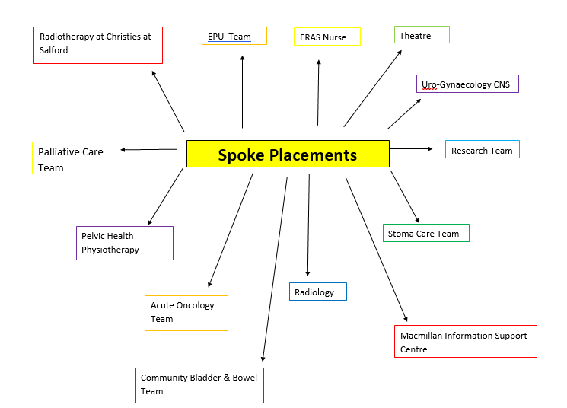

Common urological abbreviations and procedures.

- AUR – Acute urinary retention
- AUS – Artificial urinary sphincter
- BCG – Bacillus Calmette-Guerin (Intravesical Immunotherapy)
- BOO - Bladder outflow obstruction
- Botulinum Toxin Type A – Botox
- BPH - Benign prostatic hyperplasia
- CIS – Carcinoma in situ
- CT KUB – Computed tomography of the kidneys, ureters & bladder
- Cystoprostatectomy – Removal of bladder and formation of ileal conduit (Urostomy)
- DRE - Digital rectal examination
- ED - erectile dysfunction
- ESWL - Extracorporeal shockwave lithotripsy
- Flexible Cystoscopy – Cystoscope (camera) inserted into the bladder
- HPCR – High pressure chronic retention
- Intra-Detrusor – Into the bladder muscle
- Intravesical – Into the bladder
- IPSS - International prostate symptoms score
- ISC – Intermittent self-catheterisation
- ISD – Intermittent self-dilatation
- LUTS - Lower urinary tract symptoms
- Mitomycin C – Bladder Chemotherapy
- Nephrostomy – Percutaneous tube inserted into the kidney, to act as drainage system for the kidney
- PCNL – Percutaneous nephron-lithotomy
- PMS / PVR – Post-micturition scan / Post Void Residual
- PSA - Prostatic specific antigen
- Radical or Partial nephrectomy – removal of all or part of the kidney
- RCC – Renal cell carcinoma
- TCC bladder – Transitional cell carcinoma of the bladder
- TRUS - Trans-rectal ultrasound & biopsy of the prostate gland
- TURBT – Trans-urethral resection of bladder tumour
- TURP - Transurethral resection of prostate
- TWOC – Trial without catheter
- UDS – Urodynamic studies
- USS KUB – Ultrasound scan of kidneys, ureters & bladder
- VUDS – Video urodynamic studies

Useful Links:

- BAUN - www.baun.co.uk
- BAUS - www.baus.org.uk
- Prostate cancer - www.prostatecanceruk.org / Home - Prostate Cancer Research (prostate-cancer-research.org.uk)
- Kidney cancer - Home - Kidney Cancer UK (kcuk.org.uk)
- Continence - www.aca.uk.com
- Continence - www.bladderandbowelfoundation.org
- Infection control - www.ips.uk.net
- Stones - www.kidney-stones.org.uk
- Cancer support - www.Macmillan.org.uk
- Christie - www.Christie.nhs.uk
- Benign prostate disease - www.prostateaction.org.uk
- Bladder cancer - www.actiononbladdercancer.org / Fight Bladder Cancer |
- Guidelines - www.rcn.org.uk
- Catheterisation guidelines: http://www.uroweb.org/fileadmin/EAUN/guidelines/EAUN_Paris_Guideline_2012_LR_online_file.pdf
- Online training in catheter care - www.skillsforhealth.org.uk

For further information around learning opportunities within the Urology Department please read through the Learning Objectives Pack.

Urology OPD Placement Feedback

Name (Optional) :
Year / Placement : Placement Dates:

- Did you feel you receive adequate information via introductory email prior to starting this placement? (If No, what else would have been helpful)

- Did you feel welcomed into to department & receive appropriate introduction on your first day?

- Did you feel you had a variety of learning experiences during your time with us? What did you enjoy the most?

- Did you feel encouraged to 9please provide examples);
- take part in care delivery?

- Challenged to think about evidence-based best practice?

- Encouraged & comfortable to ask questions?

- What will be one thing you take away from this placement?

- What would have improved your experience with us?

- We recognise that Urology OPD provides a highly specialist service & we wonder whether you have any thoughts around when this would be best placed during your training? Or how long of a placement you feel would be most appropriate?

- Are you able to provide some feedback specifically for your;
- Supervisor ;

- Assessor ;

- Anyone other members of the Multi-Disciplinary Team who may have stood out during your time with us;

All feedback will be shared with the Urology Team & may also be used to celebrate departmental successes via trust communications. Your feedback will be put into our Learner File for others to review & may be used for display on the Learner Notice Board. Should you wish to remain anonymous please delete as appropriate below.

Happy for my feedback to be shared / Would like to remain anonymous

Many thanks for taking the time to complete this form. We hope you have enjoyed your time with us. Do not hesitate to reach out in the future should you feel we would be able to support your learning / development further. We wish you all the best in the remainder of our training & future career.

The Urology OPD Team.

