

Welcome to

Salford Diabetes Team

Learner Information pack

Name:

Assessor:

Supervisor:

Start date:

Contents

1. Welcome to Salford Diabetes team

2. Salford Diabetes team’s philosophy

3. Our Role in the Community

4. Our Role in the Hospital & Spoke opportunities

5. What we expect from you

6. Useful Information

7. What is Diabetes

8. Common types of Diabetes

9. Common medications used to treat type two diabetes

10. Common Insulins & their actions

11. How to administer insulin

12. Hypo management

13. Common abbreviations

14. Placement charter

Welcome to Salford Diabetes Team

Firstly, we would like to welcome you to the team. We hope you have a wonderful placement with us, and we will do everything we can to support you during your time with us and ensure you have the best learning opportunities possible. Our team supports patients and staff in managing diabetes both in both the acute and community setting.

Our very knowledgeable staff from all disciplines are here to support you and share their knowledge. Our team includes the following staff members: Diabetes specialist nurses, Advanced Nurse Practioners, Diabetes specialist dietitians, Diabetes health advisers, Admin team and Diabetes & Endocrine consultants.

Please feel free to ask questions and make use of the resources available to support you during your placement.

There are also wide range of spoke placements available to help to enhance your knowledge and understanding of diabetes and we hope during your time with us you take advantage of these learning opportunities available to you.

During your first week of placement, we will allocate you an experienced assessor who will be here to support you during your placement, ensure your learning requirements are met and be here for any issues and concerns you have.

Our Team is a busy but varied place to work with a lot to learn and we hope by the end of your placement you have a good knowledge base and understanding of diabetes care

Finally, we hope you enjoy your time with us 😊

**Diabetes Team Philosophy**

We believe that each patient is an individual and has the right to be treated as such incorporating their physical, psychological, social, and spiritual needs.

We aim to ensure our patients feel empowered and well informed of their care. We recognise the need to facilitate patient independence and always promote and respect their privacy and dignity.

We encourage patient participation and value both patients and their relatives or carers involvement alongside the consent of the patient

We believe that a high standard of care should be always maintained. To support this, we promote awareness & provide education on diabetes.

We keep on top of new developments in diabetes to ensure our practice remains evidenced based to uphold high standards.

We always aim to uphold Trust Values of

**Patient and Customer Focus, Continuous Improvement, Accountability & Respect**

Our Role - In the community

Our team’s role is to support patients and staff in managing diabetes both in secondary and primary care. In the community we provide the following clinics & education courses for our patients.

* Diabetes basics
* Diabetes x-pert
* Insulin group start
* GLP-1 starts
* DAFNE
* General, 1:1, Consultant & Virtual Clinics
* Foot clinic
* Libre start
* Pump clinic
* Carb counting
* New type one diabetes clinic
* Joint renal diabetes clinic
* Young person clinic
* Dietitian lead clinic
* Pre- pregnancy clinic

We also provide education sessions for community staff who work with patients who have diabetes.

On placement you will be given the opportunity to observe and learn from many of the above clinics. Your mentor will discuss which clinics will be most useful for your practice, please let them know if there is an area of particular interest to you.

Our Role - In the Hospital

You will also have to opportunity to be a part of our inpatient service. In hospital we review acutely unwell patients with diabetes who the wards refer via EPR. The patient you see will have been referred by the wards for one of the following reasons

* D – DKA /HSS (diabetes ketone acidosis& hyperosmolality syndrome)
* I - Insulin (Type 1 – new to / pumps or Type 2 and starting insulin)
* A - Admission due to Diabetes complication (includes hypo/hyper/Diabetic foot)
* B - Blood glucose monitoring and control
* E - Enteral feed/TPN
* T - Two hypos or more
* E - Education (insulin pen/ injection technique / staff)
* S - Sliding scale (VRII)

We also provide regular bite sized education sessions for hospital-based staff. 1:3 patients in hospital have a diagnosis of diabetes which is why staff need to feel confident caring for diabetes no matter the ward’s speciality. Education is key to keep our patients safe and ensure they receive a high standard of care.

Spoke Placement Opportunities

Our team is lucky enough to benefit from a wide range of MDT specialists who you will be encouraged to spend time with. You are also encouraged to organise spokes outside the team some of the other teams we work closely with include.

* Palliative care team -District nurses
* Endocrine specialist nurses -Diabetes ward (L7)
* Paediatric Diabetes Team -Podiatry Team
* Psychology -G. P practices

**What we expect from you**

* We expect you to arrive on time for planned shifts and any other activity identified by your assessor orsupervisor.
* We expect you to ensure your assessor or supervisor is aware of your learning outcomes for the placement and specific learning needs
* We expect you to always act in a professional manner in line with the NMC Code of Conduct
* We expect you to dress in accordance with your University uniform policy, and in accordance with the Trust dress code
* You should inform your assessor and supervisor if you are unwell and not able to attend your placement. The process for how to do this will be covered on your induction to the ward / initial interview with your assessor
* We expect you to always maintain and respect confidentiality. This applies to patients, their records and discussions between the student and the assessor
* We encourage you to raise any concerns regarding your placement with your assessor or our lead nurse. If this is not possible you should contact your link tutor / placement co-ordinator.
* Your assessor will be responsible for your assessment, co-ordination of learning and personal support. It is your responsibility to ensure this is done
* Make the most of your placement and enjoy this learning opportunity

**Useful information**

**Lead Nurse:**

Gemma Allen ([Gemma.Allen2@srft.nhs.uk](mailto:Gemma.Allen2@srft.nhs.uk))

**Lead educators**

Caroline Eden([Caroline.Eden@srft.nhs.uk](mailto:Caroline.Eden@srft.nhs.uk))

Rebecca Makin(Rebecca.makin@srft.nhs.uk)

**Contact information**

Community Diabetes Team Base: 0161 206 8802

Inpatient Diabetes Team Base: 07928658542

**Team locations**

Our inpatient service is based in the Diabetes & Endocrine offices. They are at Salford Royal in the Ladywell building. (opposite ward L1)

Our community service is based at **Swinton Gateway** -100 Chorley Road Swinton M27 6BP

To give patients choice and flexibility with their care we will also work from the following gateways:

**Pendleton Gateway**- 1 Broadwalk, Salford M6 5FX

**Walkden Gateway**- 2 Smith St, Worsley, Manchester M28 3EZ

**Eccles Gateway** -28 Barton Ln, Eccles, Manchester M30 0TU

**Irlam Gateway** -Liverpool Rd, Irlam, Eccles, Manchester M44 6FW

Please note you may be asked to start your day at one of the above clinic locations so you can take part in all the experiences our service has to offer.

**Shift patterns**

The majority of our team typically do 7.5-hour shifts Monday – Friday 0800-1700. These hours vary slightly depending on the needs of the service.

**In the event of sickness, it is your responsibility to notify your mentor as well as your university contact at the earliest possible convenience.**

**What is diabetes?**

Diabetes is an umbrella term it means that the patient is unable to lower their Blood Glucose levels back into normal range. We classify diabetes into types depending on the cause of the diabetes.

**What does insulin do?**

Insulin is produced by the beta cells on the pancreas. We all need insulin to live. It does an essential job. We like to say it is the Key that allows the glucose in our blood to enter our cells and fuel our bodies. If the glucose can’t get into our cells it stays in the blood which makes the blood glucose level rise. High Blood Glucose levels makes the blood “sticky” this will cause damage to the body leading to a range of complications with the Eyes, Feet, Heart and Kidneys.

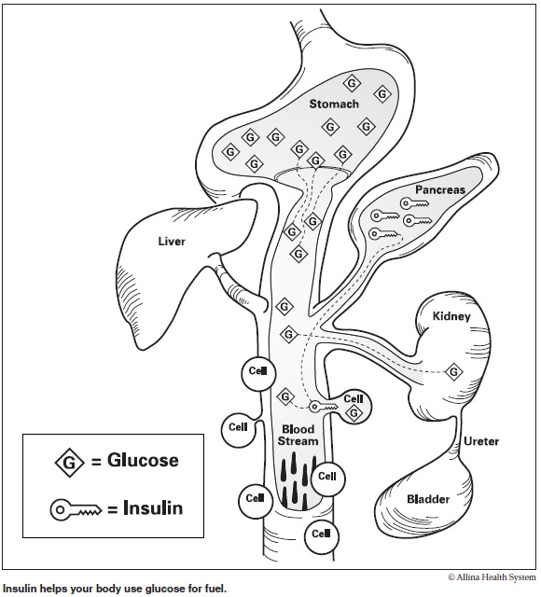

# Common types of Diabetes

**Type two diabetes** is a condition which affects 90% of patients with diabetes. The pancreas produces insulin, but the body’s cells don’t open sufficiently, therefore the glucose is unable to enter (Insulin resistance). The pancreas therefore produces extra insulin to overcome this resistance. This can eventually tire the pancreas out, meaning their body makes less and less insulin and Type 2 Diabetes develops.

There are factors which will increase the cell’s insulin resistance & reduce pancreas production. Factors include older age, increased weight, family history and ethnic background.

**Treatment:** There is no cure for type 2 diabetes, but for some patients it can be put into remission with extensive lifestyle changes, other treatments include oral medications, insulin and other injectable treatments.

**Type one diabetes** is a Lifelong autoimmune condition it affects 8% of people with diabetes. The immune system attacks the insulin producing cells (beta cells) in the pancreas. As a result, the pancreas does not produce any insulin.

We don’t yet know what causes type one diabetes you are slightly more likely to develop it if you have a family history. It can happen at any age from 6 months upwards.

**Treatment:** the only treatment for Type one diabetes is insulin via insulin pen / pump

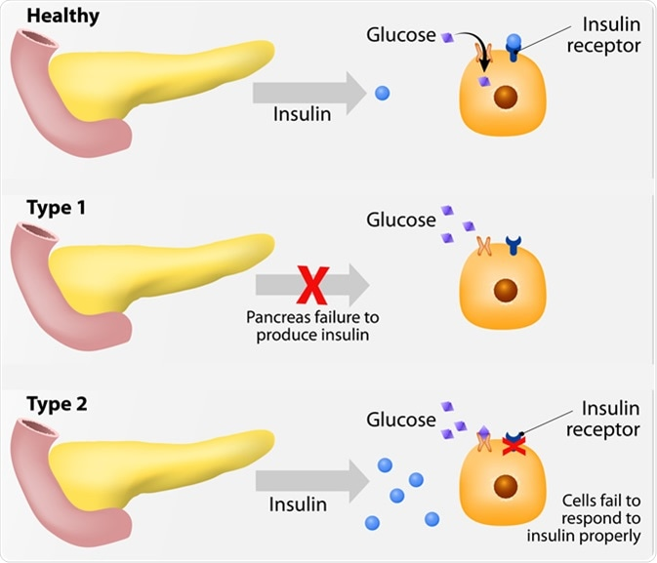

There are many other types of diabetes including Type 3c (secondary diabetes), Gestational, Steroid Induced, MODY (maturity onset diabetes of the young) and LADA (latent autoimmune diabetes of adulthood). You will have to opportunity to learn more about them and how we manage them on your placement.

**Common medications used to treat type two diabetes**

|  |  |  |
| --- | --- | --- |
| **Common name/class** | **When to take** | **Main Actions** |
| Metformin (Glucophage)  Biguanides* | With meals, usually breakfast and evening meal | Reduces the amount of glucose released by the liver and decreases insulin resistance in muscle cells and so helps the body to use its own insulin. |
| Pioglitazone (Actos)  Thiazolidinediones | Once daily | Increases insulin sensitivity, decreases liver glucose output.  (Takes 12 or more weeks to achieve maximal effectiveness.) |
| Sitagliptin (Januvia)  Vildagliptin (Galvus)  Saxagliptin (Onglyza)  Linagliptin (Trajenta)  Alogliptin (Vipidia)  Dipeptidyl peptidase-4 (DPP-4) inhibitors | Once daily | Reduces the breakdown of naturally occurring GLP-1 hormone in the gut. The GLP-1 hormone increases insulin secretion in the presence of elevated blood glucose levels and reduces the amount of glucose the body releases from the liver. |
| Canagliflozin (Invokana)  Dapagliflozin (Foxiga)  Empagliflozin (Jardiance)  Sodium glucose co-transporter-2 inhibitors (SGLT-2s)* | Once daily with breakfast | Reduces glucose reabsorption in the kidneys and increases glucose excretion in the urine. |
| Gliclazide (Diamicron)  Glipizide (Minodiab)  Glimepiride (Amaryl)  Sulphonylureas | Once or twice daily 20 minutes before breakfast and/or evening meal | Stimulates the beta cells of the pancreas to increase insulin production |
| Liraglutide (Victoza)  Dulaglutide (Trulicity)  Semaglutide (Ozempic)  Incretin mimetics  (injectable)  (GLP-1s) | Once daily (Victoza only) or once weekly injection | Mimics the effect of incretin hormones to increase insulin secretion in the presence of elevated blood glucose levels, reduces the amount of glucose the body releases from the liver, slows gastric emptying, and improves the body’s response to insulin. |
| Several insulins can be used in Type 2 Diabetes.  Two common examples are Humulin I and Insulatard  Insulin  (injectable) | Once or twice a day, usually before breakfast and evening meal | Increases the passage of glucose from the bloodstream into the cells and decreases the production of glucose by the liver |

**Common Insulins & their actions**

In a person without diabetes the pancreas is always producing insulin 24/7 this keeps energy moving into the cells. When we eat the pancreas will then produce extra insulin to deal with the glucose from food. The diabetes specialist will consider which kind of insulin the patient requires as well as the onset time, peak and length of action before deciding the most appropriate insulin for the patient. All patients with Type 1 diabetes are commenced on 2 different injections daily (long acting and rapid acting insulin).

Lantus, Levemir, Tresiba & Toujeo

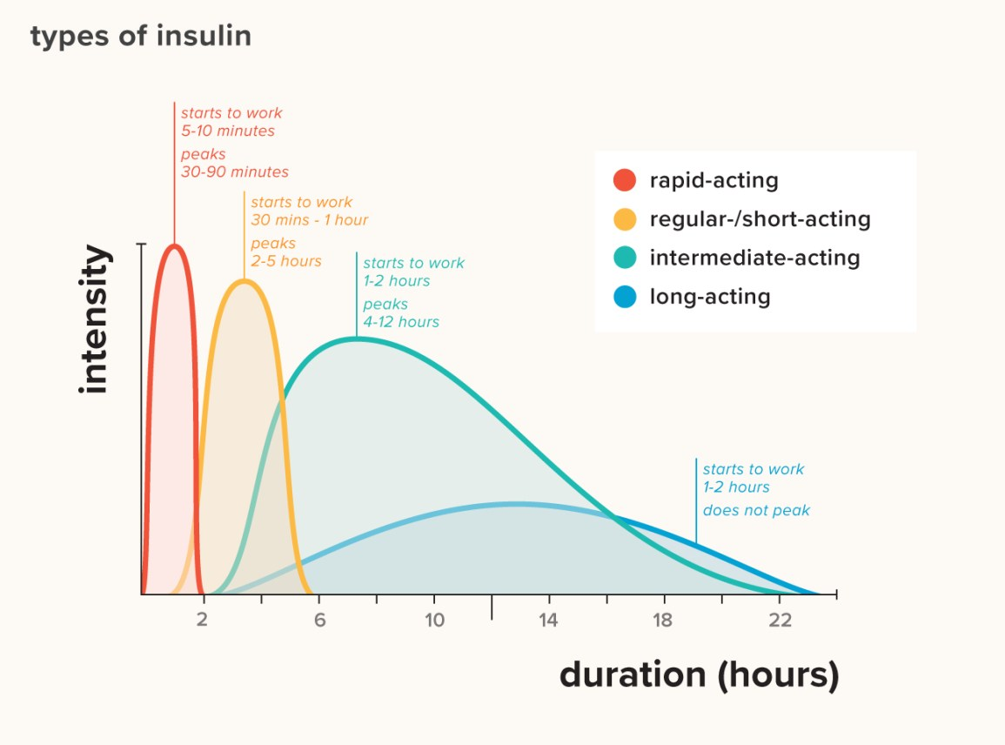

There is also NovoMix 30, Insuman combo 15, Insuman combo 25, Insuman combo 50, Humalog Mix 25 and Humalog Mix 50. Theses insulins are a mix of both rapid & intermediate acting insulins.

Insulatard, Humulin I, & Insuman basal

Actrapid, Humulin S & Insuman rapid

NovoRapid, Humalog & Apidra

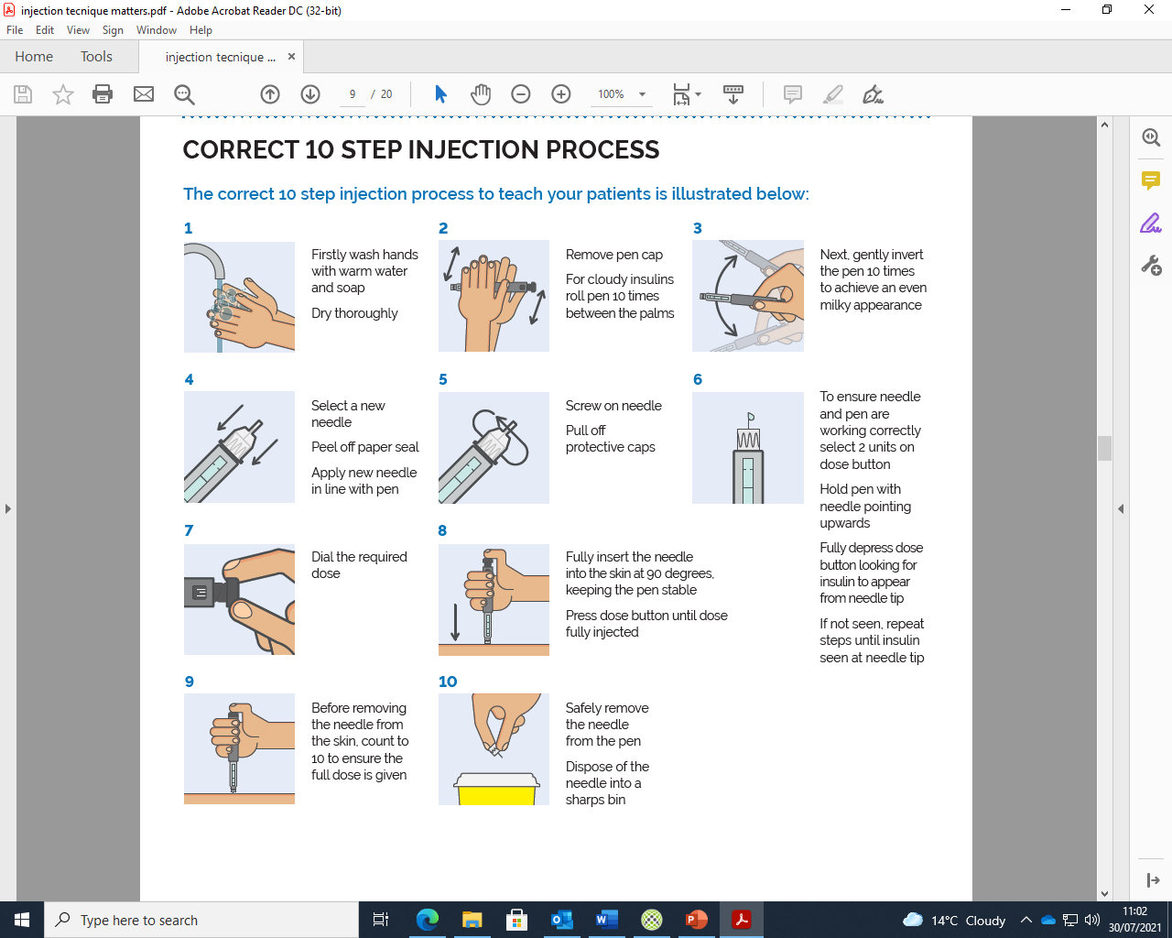 **How to administer insulin with the correct technique**

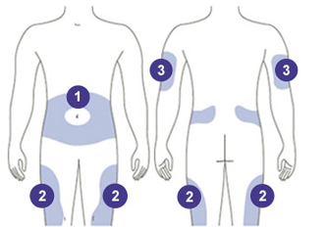

**Lipohypertrophy** is a lump under the skin caused by accumulation of extra fat at the site of many subcutaneous injections of insulin. It is caused by poor technique when administering insulin and not rotating the sites. Theses lumps are not always as visible as above sometimes they can just be felt under the skin.

*NOTE staff should only inject into sites 1 & 2 never in the arms

## How to treat a hypo in the conscious patient

If unconscious, please refer to the management pathway on the hypo box

Blood glucose < 4 give patient **fast acting** sugars first

 (examples below)



**2x 85ml pots 6 dextrose tablets 2 glucose gels**

(Other forms of foods are the wrong treatment and will not work ie sugary tea or chocolate)

15 minutes later it’s time to recheck the patient’s blood glucose

Blood glucose still below 4 repeat first step. If you have repeated this step x3 alert medics urgently

Blood glucose now above 4 don’t leave it! Treat as below

Blood Glucose >4 keep it up by giving the patient a meal if it is due. If there isn’t a meal due they need a **slower acting** carbohydrate (examples below)



**2 pieces of toast 2 Weetabix 2 biscuits**

*Remember if your patient has had one hypo, they are more likely to have another one! Always inform the medical team if the patient has a Hypo*

**Common abbreviations you might come across**

|  |  |
| --- | --- |
| **ABG** – Arterial Blood Gas  **ACR** – Albumin Creatinine Ratio    **AKI** – Acute Kidney Injury  **ABX**- Antibiotics  **AXR** – Abdominal X-Ray  **BG** – Blood Glucose  **BMI** – Body Mass Index    **BNO** – Bowels Not Opened    **BP** – Blood Pressure  **Ca** –calcium    **CKD** – Chronic Kidney Disease    **Cr** – Creatinine    **CRP** – C - reactive protein  **CXR** – Chest X-Ray  **DHA**- Diabetes health adviser  **DKA**  - Diabetes Ketone Acidosis  **DN** – District nurses    **DSN-** Diabetes Specialist nurse  **DSD-** Diabetes Specialist dietitian  **ECG** - Electrocardiogram  **EOL** – End of Life  **ECHO** - Echocardiogram    **eGFR** – Estimated Glomerular Filtration Rate  **EOL** – End of Life  **ESKD** – End Stage Kidney Disease  **ESKD** – End Stage Kidney Disease  **FBC** – Full Blood Count  **GLP-1**- Glucagon-like peptide-1 | **Hb** – Haemoglobin    **HSS**- Hyper Osmolality Syndrome  **Ig** - Immunoglobulin  **IHD** – Ischemic Heart Disease  **IM** – Intramuscular  **IV-** Intravenous  **K+** - Potassium  **MI** – Myocardial Infarction  **Na / NaCl** – Sodium / Sodium Chloride    **NBM** – Nil By Mouth    **NGT** – Nasogastric Tube  **NSAIDs** – Non-Steroidal Anti-inflammatory    **PCR** – Protein Creatinine Ratio    **PD** – Peritoneal Dialysis    P**MH** – Past Medical History  **PRN** – Pro Re Nata; as required  **PVD** – Peripheral Vascular Disease  **RBC** – Red Blood Cells  **SOB** – Shortness of Breath  **SGLT-2**- Sodium glucose co-transporter-2 inhibitors  **T2DM**- type two diabetes  **T1DM**- type one diabetes  **T3c** – secondary diabetes  **U&Es** – Urea and Electrolytes  **VBG** – Venous blood gas  **VRII**- variable rate insulin infusion  **WBC** – White Blood Cells |

