**Ward NSSU**

**Neuro Short Stay Unit**

**Welcome Pack**

**What is NSSU?**

NSSU (Neuro Short Stay Unit) is part of the Greater Manchester Neuroscience Department which is made up of 18 spinal beds. The ward caters for a variety of patients with lots of different spinal problems/ conditions.

NSSU Spinal Unit looks after a wide range of patients from acute elective spinal patients to oncology patients and trauma patients. We also accept patients from other hospital areas ranging from Greater Manchester, Mid Cheshire, and the Northwest and beyond.

This ward prides itself in providing patient centred care whilst having productive hands-on approach to both teaching and learning.

**Key Contacts**

**PEL (Personal Educational Link)**

Hannah Lawless

NSSU

Salford Royal Foundation Trust

Stott Lane

M6 8HD

Tel: 01612067209

Email: Hannah.lawless@srft.nhs.uk

**PEF (Personal Educational Facilitator**

Julianah Oluwasaki

Mayo Building – Learning & Development

Salford Royal Foundation Trust

Stott Lane

M6 8HD

Tel: 0161-2065218

Email: julianah.oluwasakin@nca.nhs.uk

**Learning Philosophy**

On NSSU teaching and learning is seen as paramount, in order to create an environment that is conducive to learning. The ward prides itself on using up to date evidence-based practice enabling staff to learn new skills as well as expanding and developing existing ones. Staff members are encouraged to attend study sessions to ensure that they gain new knowledge and skills.

Staff members are encouraged to take part in all aspects of care delivery and care management as well as taking part in practical skills working alongside all members of the MDT. New starters both staff nurses and care workers are supernumerary for the first 4 weeks.

**Ward Philosophy**

NSSU’s philosophy of care is an explicit statement of the values and beliefs of the nursing team in the provision of health care services within this unit.

We aim to provide the highest quality of care possible, administered by a knowledgeable and appropriately skilled nursing team, based on evidence-based practice.

We feel that it is fundamental to cultivate good relationships with our patients and their families/carers, maintaining privacy, dignity, and confidentiality at all times. We believe all our patients to be unique individuals with physical, psychological and spiritual needs. We aim to meet these needs as part of a multidisciplinary team through a collaborative approach incorporating all aspects of holistic care.

**House Keeping**

Breaks are 30 minutes long; one in the morning and one in the afternoon on a day shift.

On nights your break lasts for an hour, usually halfway through your shift.

Drinks are not provided on the ward but there is a water fountain and full use of tea and coffee making facilities.

Our kitchen provides the facilities to enable patients to be provided with sufficient diet and fluids and we do have a patients’ own fridge, if you are to place food in the patients fridge, please put a label on with their name otherwise it may be thrown away. There is also a staff fridge in the staff room which is based on the ward. Please place a sticker on all food and drink products with your name and date on them before placing them in the fridges. Food and drink with no stickers on will be removed and thrown away. There is also a microwave in the staff room if you wish to warm up any food that you bring in. All we ask is that you tidy up after yourself.

At this current time, we do not have enough lockers for all staff, so, staff are advised to only bring in essential belongings which they need and not have anything of value left in the staff room unattended. We cannot take responsibility for missing belongings.

**Shift Patterns**

**Day Shift:** 07:00 – 19:30

**Night Shift:** 19:00 – 07:30

**Early:** 07:00 – 13:30

**Late:** 13:00 – 19:30

**Ward NSSU Staff**

**Management**

Hannah Lawless – Ward Manager

Yasmin Mellish – Nurse Practitioner

Victoria Carruthers – Nurse Practitioner

**Registered Nurses**

Daniella Bedford

Patricia Chasi

Chinaza Okorie

Marzena Koszucka

Karen Corbett

Rani Kurian

Rebecca Field

Charis Iyrobinson

Anju Chacko

Deanna Sibbick

Mariana Castro Lopes

Alisha Roebuck

**Care Support Workers**

Donna Griffiths

Stephen Lisowski

Kit Yan Wong

Neethu Thomas

Peggy Maddran

Janet Kent

Phylis Ziswa

Cara Underwood

Leanne Tarrant

Bethany Officer

Eunice Thuku

**Spinal Anatomy & Physiology**

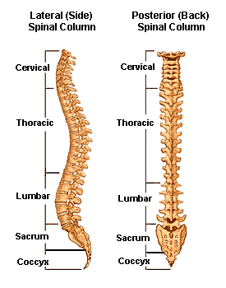**The Spinal Column**

The spinal column (or vertebral column) extends from the skull to the pelvis and is made up of 33 individual bones termed vertebrae. The vertebrae are stacked on top of each other and are grouped in to four regions.

**Cervical**

**Thoracic**

**Lumbar**

**Sacrum**

The vertebral bodies are the weight bearing structures of the spinal column. Upper body weight is distributed through the spine to the sacrum and the pelvis. The natural curve in the spine provides resistance and elasticity in distributing body weight and axial loads sustained during movement.

**Cervical Spine** – the cervical spine begins at the base of the skull and is made up of seven vertebrae (C1-C7) and eight pairs of cervical nerves. The cervical vertebrae are smaller in size when compared to other spinal vertebrae. Their purpose is to contain and protect the spinal cord, support the skull and enable diverse head movement.

**Thoracic Spine** – the thoracic spine is located in the chest area and contains twelve vertebrae. The ribs are connected to the thoracic spine and protect many vital organs.

**Lumbar Spine** – the lumbar spine is the third major region of the spine. Most people have five vertebrae n this region although it is not unusual to have six. The vertebrae in the lumbar spine bear much of the body's weight and related biochemical stress.

**Sacrum** – the sacrum is a large triangular bone at the base of the spine, where it is inserted like a wedge between the two hip bones. Its upper part connects with the last lumbar vertebra and the bottom part with the coccyx. In children it consists of usually five un- fused vertebrae which begin to fuse between the ages of 16-18 and are usually completely fused to become a single bone by the age of 26.

Between the vertebrae lie 'discs' which acts almost like a shock absorber between adjacent vertebrae. These discs also act as ligaments that hold the vertebrae of the spine together and as joints to allow for slight mobility in the spine. There are a total of 23 vertebral discs in the spinal column.

**Spinal Cord**

The spinal cord is a thin tubular structure that is an extension of the central nervous system from the brain. It is enclosed and protected by the bony vertebral column. The main function of the spinal cord is the transmission of neural inputs from the periphery to the brain and vice versa. It is a vital structure in our survival and functional capacity.

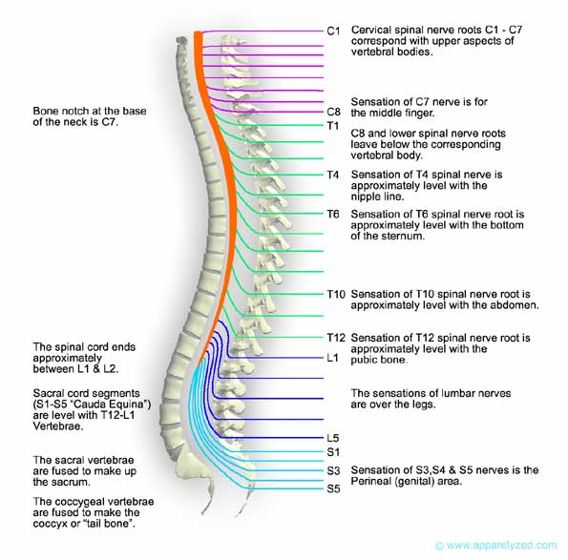The human spinal cord is divided into 31 bilaterally paired spinal nerves each communicating with different parts of the body.

8 pairs of nerves in cervical region.

12 pairs of nerves in the thoracic region.

5 pairs of nerves in the lumbar region.

5 pairs of nerves in the sacral region.

One pair of nerves in the coccygeal region.

All of the spinal nerves a part of the peripheral nervous system.

Cerebrospinal fluid is a clear fluid found in the bran chambers, spinal canal and spinal cord. The fluid acts as a shock absorber to protect against injury. The fluid contains different types of electrolytes, proteins and glucose. In an average adult the total volume of CSF is about 150 millilitres.

**Spinal Cord Injury**

Spinal cord injury (SCI) is the result of damage to the spinal cord that results in loss of function such as mobility or feeling. Frequent causes of SCI are trauma or disease. The spinal cord does not have to be severed for a loss of function to occur. In many cases the spinal cord remains intact but the damage to it results in loss of functioning. A person can 'break their back or neck' yet not sustain SCI as only the bones (vertebrae) around the spine may be damaged. In these situations, the bones can be stabilised and the individual may not experience paralysis.

|  |  |
| --- | --- |
| **Level of Injury** | **Effect** |
| Between C1 and C5 | Paralysis of some or all the muscles used for breathing and all arm and leg muscles. Usually fatal unless a ventilator is used. |
| Between C5 and C6 | Paralysis of legs trunk hand and wrist. Weakness of the muscles that move the shoulder and elbow. |
| Between C6 and C7 | Paralysis of the legs, trunk and part of the writs and hands. Normal movement of the shoulder and elbow. |
| Between C7 and C8 | Paralysis of the legs, trunk and hand. |
| C8 and T1 | Paralysis of the legs and trunk. Weakness of the muscle that move the fingers and hand. |
| T2 to T4 | Paralysis of the legs and the trunk. Loss of sensation below the nipples. Normal movement of the shoulders and elbows. |
| T5 to T8 | Paralysis of the legs and lower trunk. Loss of sensation below the rib cage. |
| T9 to T11 | Paralysis of the legs. Loss of sensation below the naval. |
| T11 to L1 | Paralysis and loss of sensation to the hips and legs. |
| L2 to S2 | Various patterns of leg weakness and numbness depending on the level of injury. |
| S3 to S5 | Numbness to the perineum. |

The effects of SCI depend on the type and level of injury which are split into two types – complete and incomplete. A complete injury means that there is no function below the level of injury; no sensation and no voluntary movement, with both sides of the body being equally affected. An incomplete injury means that there is some function below the primary level of the injury.

Management of patients with Spinal Fractures

Spinal fractures occur when one or more of the bones (vertebrae) in the spine fracture or collapse. The most common symptom of a spinal fracture is pain in the back or neck.

Stable fractures of the spine are often treated conservatively using a support brace or bed rest. Unstable fractures often require surgical stabilisation.

The correct manual handling of patients with confirmed or suspected spinal cord injury is extremely important. These patients are moved/ repositioned using a technique known as log rolling. The objective of log rolling is to maintain anatomical alignment's of the spine to prevent the possibility of further injury.

**Log Rolling Procedure**

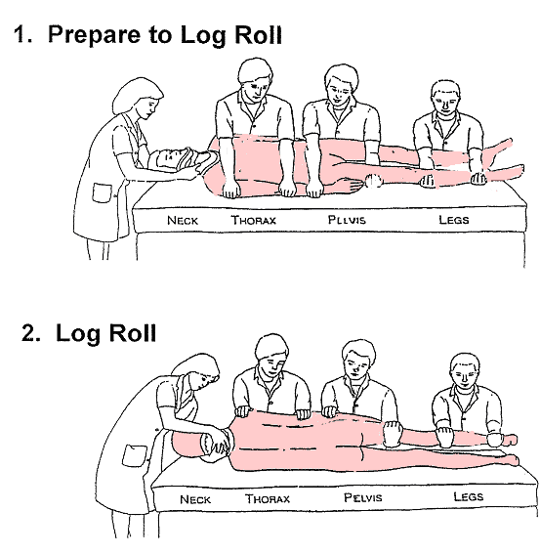

**Management of Patient's with Spinal Fractures**

Depending on the severity of the fracture and the location patient's with spinal fractures can be managed in a number of ways.

Surgically – if the fracture is unstable and requires fixation this is usually done as a surgical procedure. Metalwork is sometimes used to make the spine stable.

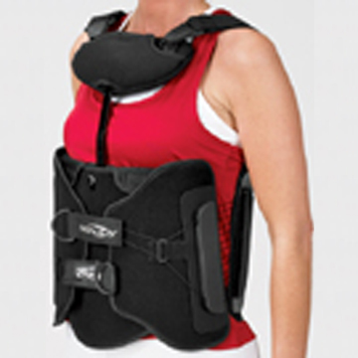Conservatively with a TLSO brace –TLSO braces are designed to provide support and stability for people with spinal fractures that do not require surgical intervention. The braces are designed to provide stability, support and to reduce the movement of the spine. The brace should be worn when the patient is upright. The patient should be log rolled onto the brace in order to maintain spinal alignment. Braces are custom fitted in order to fit the patient correctly. On occasions the TLSO brace is also used for people who have had surgical fixation of a fracture. This is to provide support and stability for a short period after the surgery.

HALO – The HALO is a metal piece of equipment attached to the patient’s head. HALO jackets are used in the management of people with odontoid peg fractures and in some instances fractures of the cervical spine. The halo is attached to a jacket worn around the patient. This provides complete immobilisation of the spine whilst allowing the patient to remain mobile. The purpose of this type of treatment is to immobilise the spine whilst allowing the fracture to fuse.

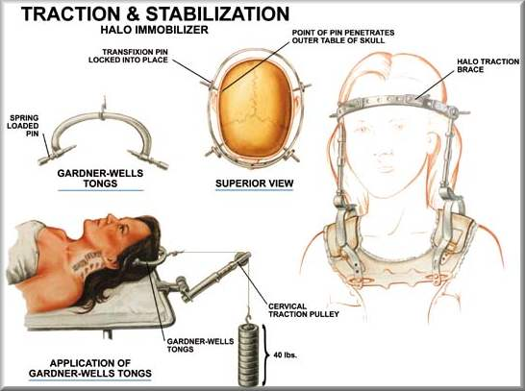Spinal bed traction is also used occasionally this involves attaching a halo ring to the head and attaching weights on a series of pulleys which hang over the edge of the bed. This is to stretch the neck and allow the bones to fuse and start the healing process. This procedure is used but is not as common as other procedures.

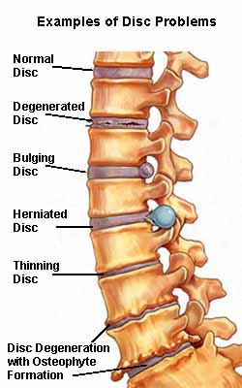

**Surgical Procedures**

**Discectomy-** surgical removal of part of all a disc that has bulged or prolapsed. Discectomy’s can be performed on any part of the spine from the cervical region right down to the lumbar. Depending on the problem one disc (single level) or more (multi- level) may be removed. The same procedure can also be performed with minimal invasion and is known as a microdiscectomy.

**Laminectomy-** surgical removal of the entire bony lamina, a portion of enlarged facet joints and the thickened ligaments overlying the spinal cord and nerves.

**Foraminotomy –** removal of the bone around the neural foramen, the space between vertebrae where the nerve root exits the spinal canal. This method is used when disc degeneration has caused the height of the foramen to collapse resulting in a pinched nerve. This procedure is sometimes performed with a laminectomy.

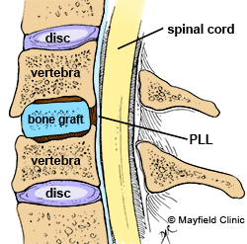

**Anterior Cervical Discectomy and Fusion –** surgical procedure to remove part or all of a herniated or degenerative disc in the cervical region. Once the disc has been removed the space between the vertebrae is empty. A graft is inserted into the space and acts as a bridge between the two vertebrae creating a fusion.

**Cauda Equina Syndrome –** the mass of spinal nerves which meet and branch off at the end of the spinal cord are known as the cauda equina (‘horse’s tail'). If these nerves are subjected to compression or a disturbed, then bladder and bowel function can be affected. Prompt surgical intervention to relieve the cause of the decompression is required to prevent permanent nerve damage.

Epidurals are also used in some cases and are designed to relieve back, leg and neck pain caused by inflamed spinal nerves.

**Scoliosis**

Scoliosis is condition that involves complex lateral and rotational curvature and deformity of the spine. It is typically classified as a congenital abnormality (present from birth), idiopathic (infantile, juvenile or adult according to when the onset occurred) or as having developed as a secondary symptom of another condition such as cerebral palsy.

The cause of scoliosis is poorly understood. Contrary to common belief scoliosis does not come from slouching or sitting in awkward positions. It is more prevalent in females.

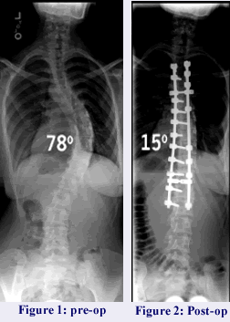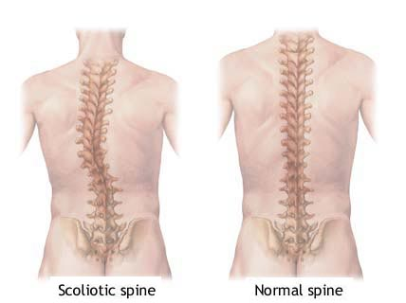

Spinal fusion is the most widely performed surgery for scoliosis. In this procedure bone grafts are grafted to the vertebrae so when it heals, they will become one solid bone mass and the vertebral column will become rigid. Originally this procedure was done without metal implants. Usually, a cast was applied and pulled under traction to straighten the spine and hold it straight until fusion took place. In 1962 a metal system of instrumentation was developed which helps straighten the spine as well as holding it ridged whilst fusion takes place. Modern procedures involving spinal fusion and instrumentation have good outcomes with high degrees of correction and low rates of infection.

**Metastatic Spinal Cord Compression**

Metastases are secondary tumours resulting from the spread of cancer cells from a primary site. The breast, lung and prostate are the three most common cancer sites with secondary spinal involvement.

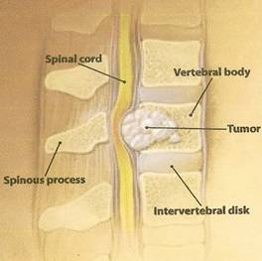

The initial management of patients with suspected metastatic spinal cord compressing is carried out by doctors and specialist spinal surgeons. Once a diagnosis is confirmed and a plan of surgical or medical management is established care is often taken over by nursing staff.

There is thought to be no definitive treatment for patients with spinal metastases. Options include medication, surgery, and radiotherapy with the surgical option often being palliative in order to maintain spinal stability, alleviate pain, and maintain function as able. In many instances the treatment of spinal metastases is often palliative with the main aim of treatment being to obtain adequate pain control and maintain or restore physical and neurological function. It is believed that the outcome of spinal metastases 'bleak' with the ultimate goals of nursing staff to maintain patient dignity and independence and ensure that they are comfortable. Nurses are also thought to hold a vital role in assessing and supporting patients' emotional and physical needs.

Patients with metastatic cord compression may be referred to Christie Hospital for further treatment and support.

**Pre-Operative Patients**

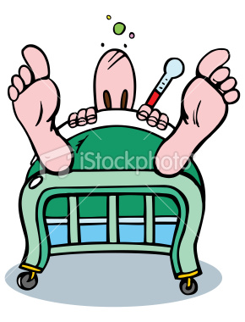

**Bloods**. All patients going to theatre must have bloods taken.

These bloods are:

* Urea & Creatinine
* Full Blood Count
* APTT clotting
* Group and save

The above 3 can be ordered on EPR and the group and save form must be handwritten and is in the draw in the office.

Eco cardiogram (**ECG**) every patient over the age of 40 needs to have a valid ECG. Also, if patient has a cardiac problem regardless of their age there must be an ECG done. Clinical support or some of the night staff can do these. You MUST be trained to do them.

Where possible **consent forms** must be signed by patient and doctor, if patient is going for emergency consent forms are not always used until they go down to theatre.

**On morning of patient’s surgery**

Patient **MUST** be washed and changed into a hospital gown. This needs to be done with assistance from the night staff in the early morning.

**TED** stockings must be worn by patient. (Patient should already be wearing TEDS since admission) Flowtron boots are used if patient immobile.

There should be 2 **name bands** on patient. One on patients arm and the other on patient’s opposite ankle. Don’t forget allergy band If needed.

8am morning **medications** should be given by night staff. Please only essential medications.

**Checklist** must be completed prior to patient leaving for theatre. This is suitably done after handover.

**MC900359059[1]Post-Operative Patients**

Patient arrives to ward.

Hand over given by recovery staff. Has patient passed urine?

Check lines, O2, drains and wounds.

If patient has PCA, is it prescribed? Check pump with recovery staff.

Is patient hungry? Do they want a drink?

Perform a full set of observations. **PLEASE** include limb observations.

Regular medications, do they need prescribing? Oxygen saturations prescribed?

PAS/Extramed patient onto our ward.

Name bands needed including Red/Blue/Orange/Yellow if required.

MRSA swabs

Pressure areas check **EVERY** patient, even if mobile.

Time for another set of observations? Remember every 1hour for the first 4 hours if condition stable.

Risk assessments to complete

Nursing admission needs to be completed in full.

Care plans also are they active? Please include 1-10 plus any other care plan relevant to patient.

**Please remember**

Post op observations are crucial in a patients care; the first 24hrs are the most important as patients can develop complications very quickly and with no warning. Limb observations should always be included.

When in any doubt speak to another member of staff if you think there is something not quite right with your patient.

**And…**

Don’t forget its 24hr care; Assessments need to be completed within the first 4 hours. Observations and caring for your patient are priority.

**JARGON**

**ACTION TREMOR** – [tremor](http://www.strokecenter.org/education/glossary.html#tremor#tremor) that appears during movement of the affected body part

**ACTION POTENTIAL** - rapid, transient, all-or-none nerve impulse initiated at the axon,

**AGNOSIA** - inability to recognize and interpret objects, people, sounds, or smells despite intact primary sense organs (e.g., inability to identify a sound despite intact hearing); typically results from damage to the occipital or parietal lobe

**AKINESIA** - inability to initiate movement due to difficulty selecting and/or activating [motor programs](http://en.wikipedia.org/w/index.php?title=Motor_program&action=edit&redlink=1) in the central nervous system.

**AFFERENT** - sensory pathway proceeding toward the [CNS](http://www.strokecenter.org/education/glossary.html#cns#cns) from the peripheral receptor organs - / **EFFERENT** - motor pathway proceeding from the [CNS](http://www.strokecenter.org/education/glossary.html#cns#cns) toward the peripheral end organs

**ANTERIOR HORN (VENTRAL HORN**) – Grey matter in the front of the spinal cord that contains motor neurons

**APHASIA** – syndrome of disordered expression or comprehension of spoken and/or written language caused by brain injury

**APRAXIA** – Impaired planning of sequencing of movement not caused by weakness, lack of co-ordination or sensory loss.

**ASSOCIATED REACTIONS** - movements of body parts other than the ones that are intended to move, often increased with increased effort

**ATAXIA** – incoordination of movement usually due to disease of [cerebellar](http://www.strokecenter.org/education/glossary.html#cerebellum#cerebellum) or sensory pathways

**BASE OF SUPPORT** – A reference point for movement within a posture and from one posture to another. Consists of the supporting surface, the body part in contact with it and the relationship of the whole body and the supporting surface.

**BABINSKI** – Extension of great toe which signifies a lesion of corticospinal tract. Upper motor neurone lesion.

**BRADYKINESIA** - slowed movement due to dysfunction of the [basal ganglia](http://www.strokecenter.org/education/glossary.html#basal#basal) and related structures

**CENTRAL PATTERN GENERATOR** - is a neural circuit that can produce a rhythmic motor pattern with no need for sensory feedback or descending control such as locomotion

**CLASP KNIFE** - spring-like resistance to passive extension at the elbow or flexion at the knee that increases up to a certain length and force before suddenly relaxing as the [Golgi tendon organ](http://www.strokecenter.org/education/glossary.html#Golgi_tendon_organs#Golgi_tendon_organs) is activated; sign of [spasticity](http://www.strokecenter.org/education/glossary.html#spasticity#spasticity)

**CLONUS** - rhythmic contraction relaxation [tremor](http://www.strokecenter.org/education/glossary.html#tremor#tremor) due to cyclic alternations of the spindle stretch reflex and the [Golgi tendon organ](http://www.strokecenter.org/education/glossary.html#golgi#golgi) reflex; indicative of exaggerated [stretch reflexes](http://www.strokecenter.org/education/glossary.html#muscle_stretch_reflex#muscle_stretch_reflex)

**DYSKINESIA** - blanket term for movement disorders characterized by increased motor activity

**DYSARTHRIA** - inability to pronounce or articulate words due to disorders of the vocal apparatus (e.g., lips, tongue, larynx)

**DYSPHASIA** - a [language disorder](http://en.wikipedia.org/wiki/Language_disorder) in which there is an impairment (but not loss) of speech and of comprehension of speech

**DYSPHAGIA** – the symptom of difficulty in swallowing

**DYSTONIA** - involuntary muscle spasms that produce peculiar postures of different body parts

**EXTRAPYRAMIDAL** - movement disorder not involving the [corticospinal tracts](http://www.strokecenter.org/education/glossary.html#tractc#tractc); typically refers to [basal ganglia](http://www.strokecenter.org/education/glossary.html#basal#basal) or [cerebellar](http://www.strokecenter.org/education/glossary.html#cerebellum#cerebellum) disorders

**EQUILIBRIUM REACTIONS** – Automatic adaptations of postural tone in response to gravity and displacement. Functionally they maintain a postural alignment. They can not be performed voluntary.

**FACILITATION** – Neural facilitation in neuroscience, is the increase in postsynaptic potential evoked by a 2nd impulse

**FLACIDITY** – Lacking firmness, resilience or muscle tone

**FUNCTIONAL** – not due to organic disease

**HEMIANOPIA** - loss of vision in one half of the visual field, indicating a pathological process posterior to the [optic chiasm](http://www.strokecenter.org/education/glossary.html#opticc#opticc)

**KEY POINTS OF CONTROL** – A body part through which we can use prorioceptive control to tap into the motor systems to change motor output.

**CENTRAL KEY POINT** - Position of maximal rotation in thorax T8. CKPs can be different between patients. Not an anatomic structure. Movement can be facilitated from CKP.

**DISTAL KEY POINTS** – hands & feet

**POSTERIOR HORN (DORSAL HORN)** – grey matter in the back of the spinal cord that receives sensory information from the body through the dorsal root ganglia

**PROXIMAL** – Shoulders & hips

**MYOCLONUS** - sudden, shock-like, jerking contraction of a group of muscles

**MYOPATHY** - muscle disease; manifested by [lower motor neurons](http://www.strokecenter.org/education/glossary.html#lowmotneuro#lowmotneuro) weakness that is usually proximal > distal

**NEGLECT** - failure to acknowledge stimuli toward the side of space opposite to a hemispheric (usually parietal) lesion

**NYSTAGMUS** - involuntary, rhythmic oscillation or trembling of the eyeballs

**PARAPLEGIA** - [paralysis](http://www.strokecenter.org/education/glossary.html#paralysis#paralysis) of both legs

**POSTURAL CONTROL:**

**POSTURAL STABILITY** – Ability to control body position in space for the dual purpose of stability and orientation

**POSTURAL ORIENTATION** – Maintains alignment between body and segments, between body and environment and involves establishing a vertical orientation.

**POSTURAL INSTABILITY** - loss of ability to make postural adjustments in response to perturbations, i.e., defect in righting reflex; common in [Parkinson disease](http://www.strokecenter.org/education/glossary.html#parkinsons#parkinsons)

**POSTURAL SET** – Alignment of key points to each other in relation to an accepted base of support. It provides an assessment of postural orientation.

**PROPRIOCEPTION** – Awareness of spatial and mechanical status of the musculoskeletal framework

**QUADRAPLEGIA** ([tetraplegia](http://www.strokecenter.org/education/glossary.html#tetraplegia#tetraplegia)) - [paralysis](http://www.strokecenter.org/education/glossary.html#paralysis#paralysis) of all four extremities

**RECIPROCAL INNERVATION** – Modulation of excitation and inhibition within CNS. The interplay of muscle activity in patterns of selective postural movement.

**RIGHTING REACTIONS** – Sequencing of selective movement in patterns in response to displacement.

Functionally they allow the loss and regaining of midline through – trunk righting, head righting, stepping reactions, protective extension of the upper limb.

Components can be performed voluntary.

**RIGIDITY** - increased resistance throughout the range of motion when passively moving a body part due to co-contraction of agonist and antagonist muscles ("lead pipe")

**SELECTIVE MOVEMENT** - Controlled movement

**SPASTICITY** - abnormal increase in muscle tone and reflexes, manifested as a velocity dependent spring-like resistance to moving or being moved; indicates an upper motor neuron lesion

**STEREOGNOSIS** - ability to recognize objects by touch