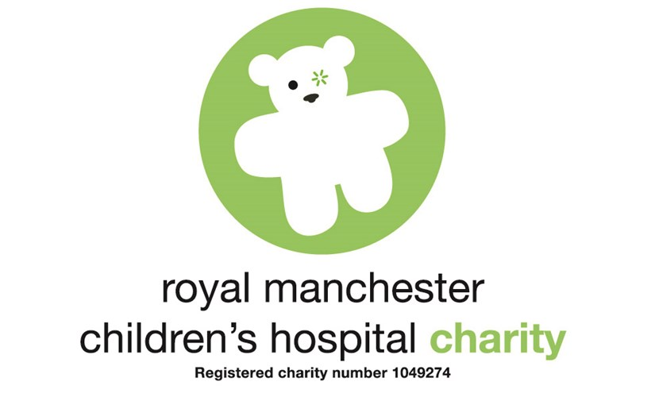Manchester

Children’s Hospital

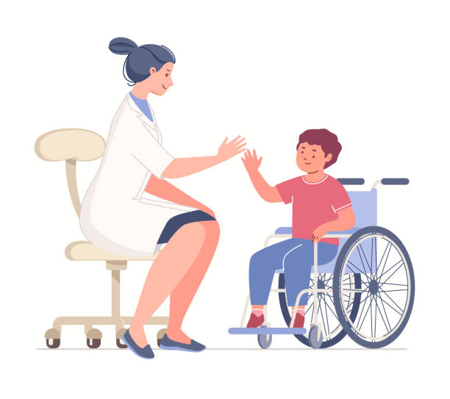

**Focus Support Team**

G

03/04 - General Questions about placement.

05 – What the Focus Support Team do.

06 – Mental Health Diagnosis to be aware of.

07- Teams you may work with.

08/09- Reflective Practice

10- Meet the team.

11- PEF Team

**Table Of Contents**

What will my hours be?

Emails:

[Andrew.Pope@mft.nhs.uk](mailto:Andrew.Pope@mft.nhs.uk)

[FSTMH@mft.nhs.uk](mailto:FSTMH@mft.nhs.uk)

[FSTLDA@mft.nhs.uk](mailto:FSTLDA@mft.nhs.uk)

Phone Number:

01617015504

Who do I contact before placement starts?

The team works 4 days a week. Starting at 8am-6pm. Days will be discussed when you arrive on your first day.

Where do I find the office?

Whilst on placement with the support team, you must wear uniform. Please adhere to the uniform policies. Bear below the elbow, hair up off your shoulders, appropriate shoes, no jewellery and clean uniform.

What will I wear on placement?

What do I do if im sick or can’t make it to Placement ?

The team is located in Manchester Children’s Hospital. The office is on Ward 77 which can be found on the first floor. To find the team you need to enter the Ward and either ask at the desk or continue on to the youth zone through the double doors where the office is located.

If you are unable to work, you must inform the team either by phone or email as well as letting your University know. Unreported sickness will be marked as absent leading to you missing out on hours.

RMCH Education Team: 0161 701 0726 [Alison.Butterworth@mft.nhs.uk](mailto:Alison.Butterworth@mft.nhs.uk)

Galaxy House: 0161 701 5197 [Edward.Corcoran@mft.nhs.uk](mailto:Edward.Corcoran@mft.nhs.uk)

Winnicott Centre: 0161 701 6880 [Joanne.Marshall@mft.nhs.uk](mailto:Joanne.Marshall@mft.nhs.uk)

MFT Community Eating Disorder: 0161 701 0447 [Molly.Caine@mft.nhs.uk](mailto:Molly.Caine@mft.nhs.uk)

Safeguarding Team: 0161 274 4981 [Leah.Meakins@mft.nhs.uk](mailto:Leah.Meakins@mft.nhs.uk)

What spoke Placements are available?

The team works alongside the multidisciplinary team to support children and young people with mental health needs, learning disabilities and or autism who are either admitted or planned to come into hospital.

Although based at Manchester Children’s Hospital, the Team supports children in other hospitals which you may visit. This includes : North Manchester Children’s Unit, Trafford Children’s Resource Centre and Wythenshawe Starlight Unit.

What is the Focused Support Team?

**How do we do this?**

* Ensuring the individual/family/carers voice is heard at every stage of their Journey.
* Advocating for the specific needs of individuals who we are involved with.
* Providing Training to Hospital staff.
* Highlight and challenge health inequalities.
* Work collaboratively with all teams involved in the individuals care.

What do the Focus Support Team do?



Psychosis

ADHD

Obsessive compulsive disorder

Bipolar Disorder.

Mania and Hypomania.

Depression

Suicidal ideation and Suicidal intent.

Self-harm

Non epileptic seizures :

* Organic NES
* Psychogenic NES

Pervasive arousal withdrawal syndrome

Eating Disorders:

* Anorexia Nervosa
* ARFID (avaoidant/restrictive Food intakte disorder)
* Binge eating
* Bulimia



Anxiety





Greater Manchester Assessment Centre

This team assess young people who attend PED for mental health reasons, this is an all age service.

School

Safeguarding Teams

Mental Health Liaison Team

Sees and assess young people who attend PED for mental health

Rapid Response Team

Provides intensive Community Support for young people at Risk of requiring implantiert admission due to mental health.

Early Intervention Service

Service for young people aged 14+ who experience psychosis

CAMHS LD Team

Work with young people with a primary learning disability who also requires mental health Support.

Psychosocial Team.

Work with young people who have a primary medical condition which impacts mental health.

Emerge

Provides mental health care for Young people aged 16-18

Mental Health Nurses

Learning Dissability Specialist Nurses.

**Reflective Practice**

What is reflective practice?

Reflective Practice is thinking about or reflecting on what you do. It is closely linked to the concept of learning from experience. You may want to complete reflections about your shift, these can be uploaded on to your additional evidence on PARE.

**Examples Of Reflective Practice**

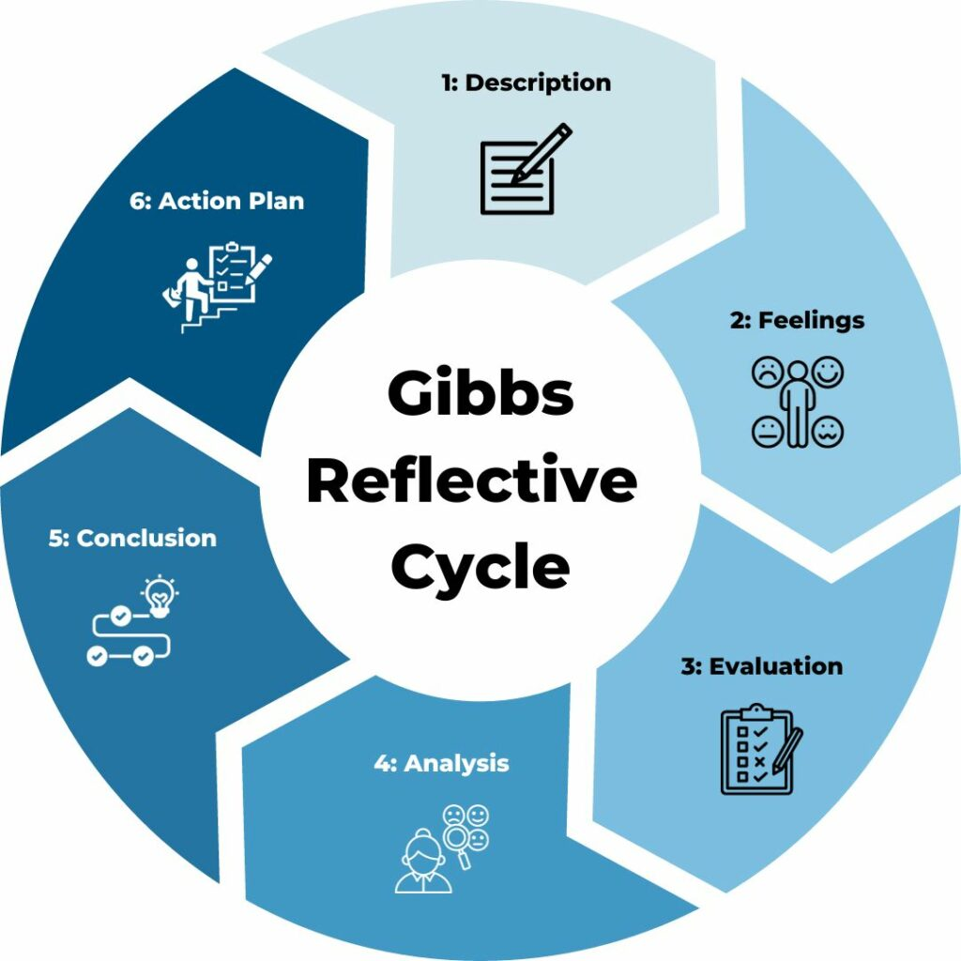Gibbs reflective cycle (1998)

If it happened again, what would you do?

What was good/bad about the experience?

What else could you have done?

What sense can you make of the situation?

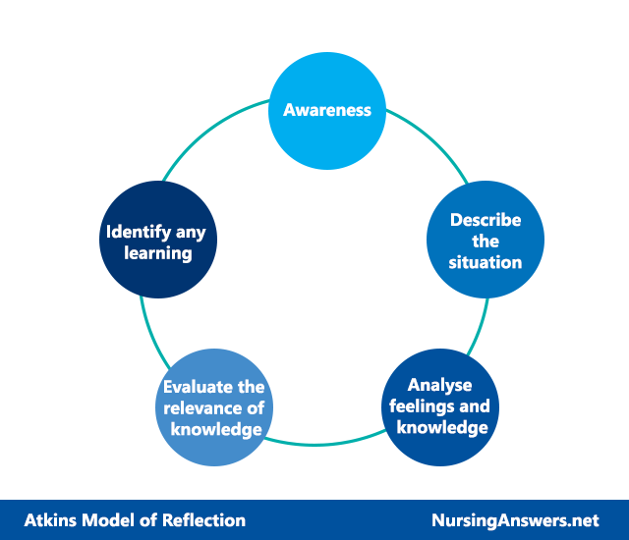Atkins and Murphy (1994)

Rolfe et al. Framework (2001)

What …. Is the problem? … was my role? …. Happened? …. Consequences?

So what …. Was going through my mind? … should I have done? Do I know about what happened now?

Now what … do I need to do? … broader issues? …. Might happen now?

**Meet The Team**

Jen Crane

(Matron of EDI & FST)

Rowena Wartkins

(Learning Disability Team Manager)

Andy Pope

(Specialised Paediatric Mental Health Advisor)

Carlton Dawston

(Specialised Paediatric Mental Health Advisor)

Elena Williams

(Specialist Learning Disability & Autism Nurse Advisor)

Naomi Yeboah

(Specialist Learning Disability & Autism Nurse Advisor)

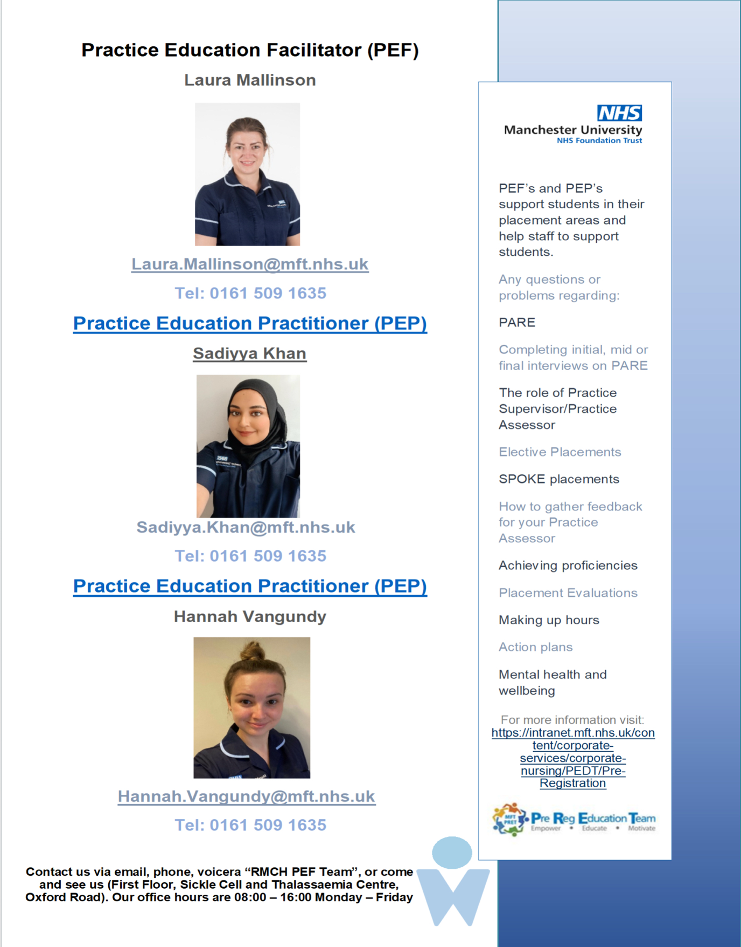

The PEF Team try to visit you on placement every week, depending on your shift patterns. If you have and questions or your struggling on placement you can email the PEF Team for Support. They also offer extra sessions which can help you with signing Proficiencies off.



We hope you enjoy your placement with the Focus Support Team. Remember to complete the end of placement Survey on PARE so we can make placement better for future students.

Booklet created by Tillie Fielding.