**SALFORD BEVAN INTERMEDIATE CARE UNIT**

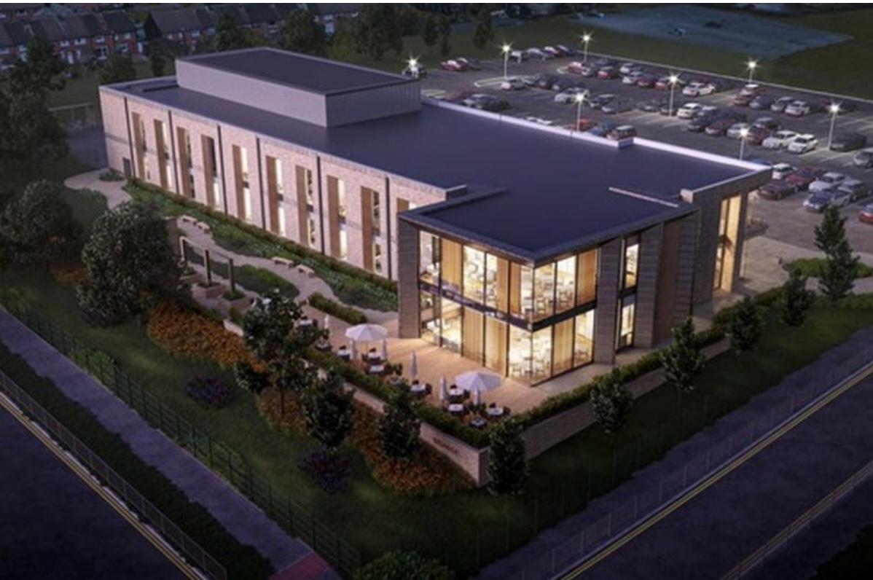**LEARNER WELCOME PACK😊😘**

**LEARNER NAME;**

**PRACTICE ASSESSOR:**

**PRACTICE SUPERVISOR:**

**PLACEMENT DATE:**



**WELCOME TO SALFORD BEVAN UNIT!**

SBU will provide you with learning opportunities both from experiences on the unit and through its SPOKE placements. You will be supported throughout your time on SBU by your practice assessor and practice supervisor and other highly skilled and experienced staff, who have plenty of knowledge to share with you. We know that this placement (SBU) is a very busy unit but don't worry! We are all friendly and you will be looked after in your time here with us. SBU is a team! and we all work together to make sure that all our patients are safe and well cared for. You will be expected to assist in all aspects of this care be involved delivering care for patients throughout their journey under the supervision of a band qualified nurse.

There is lots to learn on SBU to please ask many questions as you all the team are eager to help you learn and progress towards your nursing qualifications. Whilst we endeavor to complete your PARE document with you in a timely manner there may be times when service pressure and the needs to of patients impact on timely completion. Please continue to remind your educators to address this with you during quieter periods. If it is possible for you to stay a little longer to get this completed at the end of shift, this would be greatly appreciated. You must ensure all pages of you PARE are completed before you leave placement.

**REALISTIC EXPECTATIONS.**

You will follow your educator's Rota across the duration of placement which will set for a minimum of 1 8-week periods. Request can be made for consideration for exceptional circumstances or special occasions. We will try to accommodate these where possible

**HOW LEARNER FEEDBACK IS ACTED UPON.**

We appreciate any constructive feedback provided by learners that could help us to improve yours or future learner’ experiences. We endeavor to act on this in a timely manner. We also review PARE evaluations and where scores are below 75% these are discussed with the PEF team.

**TITLE OF PLACEMENT**: **SBU SALFORD BEVAN UNIT- INTERMEDIATE CARE**

**Our Philosophy is:**

The nursing care delivered will be evidence based and collaborative within multi-disciplinary Team. Have effective clinical care will be audited and evaluated to purse “best practice” Experience of patients will be at the heart of everything we do.

The Bevan unit provides openness, honesty and a supportive learning environment. Education is pivotal to improve staff performance and development.

Very good reputation partnership working. always respect dignity, privacy, confidentiality and cultural diversity for all patients, carers and families. Nursing will take responsibility for developing systems and processes that ensure resources are utilized effectively.

Ultimately, we rehabilitate our patients to their optimum baseline with a structured approach to future care needs. New ways of working, recruit and retain staff through providing a creative innovative stimulating environment and explore challenging.

Improve performance of staff through process of personal development plans and joint Development review, and yearly appraisals. This results in lower rate of hospital admissions and promoting an early discharge from hospital.

**Placement contact:**

**Manager's office: 0161 206 3048**

**Reception: 0161 206 3040**

**Placement Contact email address:**

[**Gemma.reamon@nca.nhs.uk**](mailto:Gemma.reamon@nca.nhs.uk)

[**Gaynor.logan@nca.nhs.uk**](mailto:Gaynor.logan@nca.nhs.uk)

[**Ann.bracken@nca.nhs.uk**](mailto:Ann.bracken@nca.nhs.uk)

[**Jayne.summerskill@nca.nhs.uk**](mailto:Jayne.summerskill@nca.nhs.uk)

**PEF Team:**

[**PEFTeam@nca.nhs.uk**](mailto:PEFTeam@nca.nhs.uk)

[**andrea.surtees@nca.nhs.uk**](mailto:andrea.surtees@nca.nhs.uk)

**WHAT IS AN INTERMEDEATE CARE FACILITY?**

Intermediate care provides specialist in-patient nursing bed rehabilitation and assessment to prevent an unnecessary hospital admission or to promote early discharge from hospital. They are also designed to prevent pre-mature admission to long term care. Bevan unit, provide intermediate care for Salford Royal Foundation Trust.

**HOW BIG IS BEVAN UNIT**

Bevan unit is based in the newly purpose-built unit. We have 60 beds, which are split up over 2 floors. During your placement you will work on the either floor depending on which assessor/supervisor. the unit is set out with bays and side rooms. The bays have 5 beds with one bathroom with walk in shower. The side rooms are all en-suite. There is a communal dining room and lounge facility on each floor, with therapy GYM and therapy kitchen for functional assessments.

**WHO IS BASED AT BEVAN UNIT?**

At any one time there is 6 registered nurses on unit. During the day there is also 2 nursing coordinators based on each floor. Our nurses are supported by 12 support workers over both floors.

We have **Advance nurse practitioner, Occupational therapist, a Physiotherapist**, assistant practitioner and therapy assistant.

**THERAPY AT BEVAN UNIT**

During your placement at Bevan unit, you will have the opportunity to work alongside therapy staff and assist in the rehabilitation of our patients. We aim for our rehabilitation patients to leave IMC with increased mobility and independence from when they first arrived. This is achieved through regular exercise and Physiotherapy carried out by therapy staff.

**WHAT SHIFT PATTERNS ARE LEARNERS ALLOCATED FOR LEARNING?**

**EARLY- 07:00-15:00**

**LATE - 13:00-19:00**

**LONG DAY- 07:00-19:00**

**NIGHT SHIFT- 19:00-07:30**

**WHAT ARE YHE ARRANGEMENTS FOR EDUCATORS**

Via Email or via phone

Learners to check PARE prior to start date.

Practice assessor/supervisor to be allocated on your PARE prior to:

Shifts (off duty) will be arranged during initial meeting.

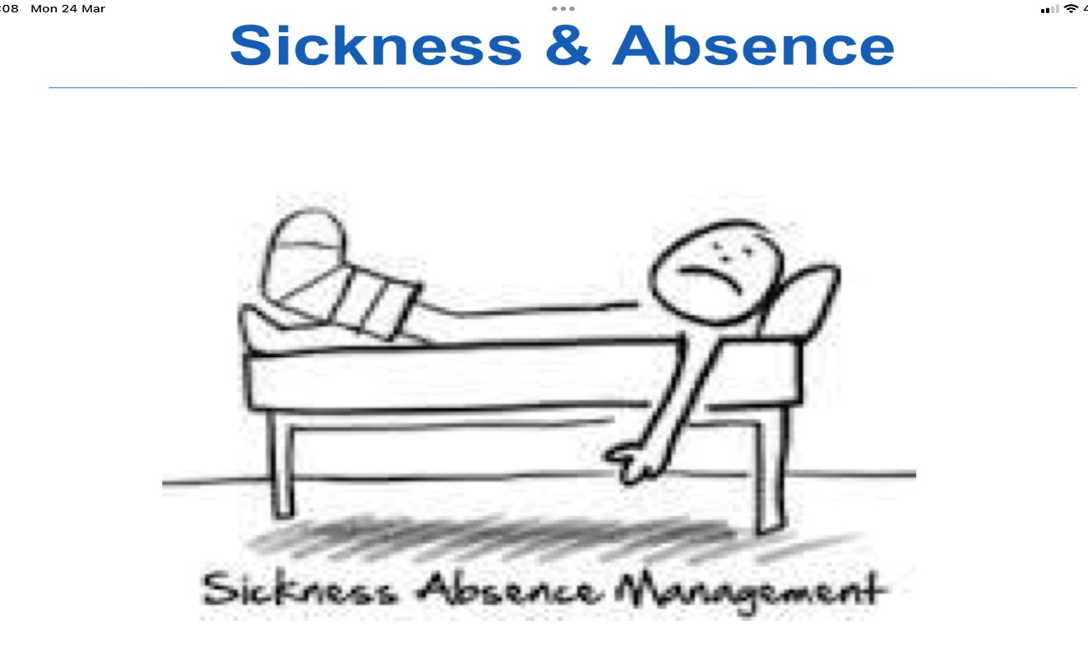

If you are ill or unable to come in to Bevan unit for any reason, then please call us prior to your shift commencement and ask to speak to the nurse in charge (take the name of the person you speak to). You need to make sure that you tell us when you are likely to be back in placement and keep us updated during your period of sickness.

**Please make sure that you also inform university.**

**DRESS CODE AND PROFESSIONALISM**

* You are expected to always wear the correct uniform according to your University Uniform Policy
* You should always wear your ID badge
* Make up should be minimal
* No jewelry
* Hair tied up above shoulder
* You should also always remain confidential and ensure mobile is on silent

**WHAT IS ORGANISED FOR LEARNERS ON COMMENCEMENT OF PLACEMENT?**

**FIRST YEAR NURSING LEARNERS/NURSING ASSOCIATE:**

Focus on gaining and developing fundamental nursing skills. Learning about the role of the nurse and developing your communication skills with health care professionals, patients and families/carers. You will have the opportunity to participates in the assessment, planning, implementation, documentation and evaluation of nursing care. if you unsure about something you are sked to do, ask to observe first and then practice under supervision.

**SECOND YEAR LEARNERS:**

You should focus on developing those transferable skills from year 1 and developing new skills you gained at Bevan unit. You should take more responsibilities and act more independently. You assessor will still supervise you, but this may be less directly (except during medication administration which must always be directly supervised). If you are unsure about something you are asked to do, ask to observe first and then practice under supervision.

**THIRD YEAR LEARNERS:**

You should develop those transferable skills from year 2 and develop new skills you gained at Bevan unit. You should demonstrate. You should demonstrate that you are capable of practicing with the need for minimal supervision (Except during medication administration which must always be directly supervised.) You will have the opportunity to manage your own caseload, demonstrate time management and clinical decision-making skills. If you are unsure about something you asked to do, ask to observe first and then practice under supervision.

**WHAT NURSING MODEL IS USED FOR PLANNING CARE?**

**Roper-Logan Tierney's Model and base on NMC standard’s future Nurse standards of proficiency for Registered Nurse.**

**WHAT ADDITIONAL CLINICAL SKILLS CAN BE LEARNT?**

At your initial meeting, discuss our placement competencies and anything you would like to learn with Practice assessor and agree an action plan as provided in your practice assessment documentation and relevant learning. Relevant spoke placements are also possible depending on availability and any spokes must be agreed with your practice assessor. Any time spent away from the unit must documented clearly in your PARE and please ensure that your PA /PS has the name and contact number of the person you will be with for the duration of your spoke placement.

**LEARNING OPPORTUNITIES INCLUDE:**

* ANTT (aseptic non –touch technique)
* Wound care management – leg ulcer, bandaging, range of different dressings for wounds and recognition if infection
* Medicine management – including administrations of sub-cutaneous injection, Intramuscular injections.
* Catheter management for male and female patients
* Assessing and meeting patients’ nutrition and hydration
* Care of patients with cognitive impairment (e.g. dementia)
* Admission and discharge planning
* Assessing and scoring pain – using nursing pain tools
* Attending multi-disciplinary team meeting such as board round, discharge planning meeting
* Risk assessment of falls, MUST, T-purpose
* Learning to monitor clinical observation and neuro observation
* Improving communication skills
* Diabetic care – insulin administration and how to recognize and treat hypoglycemic attacks
* Stoma care
* Daily documentations and creation of care plans and risk assessments.

**SPOKE PLACEMENTS:**

**Physiotherapies:**

**Occupational therapies:**

**Pharmacist:**

**Tissue viability Nurse team:**

**District Nurses 00161 631 4777**

**Rapid response**

**Bladder and Bowel team**

**Podiatry**

**Dietitian**

**Speech and language therapy**



**GOOD LUCK!!**

Nursing is a work of the HEART.

Patients may forget your name, but they will NEVER FORGET how you made them FEEL.