**Rochdale Care Organisation**

**HMR Health Visiting Service**

**Student Information**

**Pack and**

**Work Book**

**Student Name________________________**

**Placement Area______________________**

**Date of Placement____________________**

**Health Visiting Teams Contact Details**

|  |
| --- |
|  |

ROCHDALE NORTH

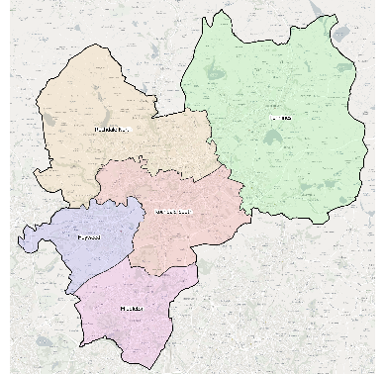NEIGHBOURHOODS

INGS LANE CLINIC

Phoenix Street, OL12 7DW

Tel: 0161 206 2906

[northhvteam@nca.nhs.uk](mailto:northhvteam@nca.nhs.uk)

HEYWOOD

NEIGHBOURHOODS

THE PHOENIX CENTRE

Church Street,Heywood,OL10 1LR

Tel: 0161 206 2906

[heywoodhvteam@nca.nhs.uk](mailto:heywoodhvteam@nca.nhs.uk)

MIDDLETON

NEIGHBOURHOODS

BROOK HOUSE

Middleton, M24 1AY

Tel: 0161 206 2906

[middletonhvteam@nca.nhs.uk](mailto:middletonhvteam@nca.nhs.uk)

ROCHDALE SOUTH

NEIGHBOURHOODS

CROFT SHIFA

Rochdale, OL16 2UP

Tel: 0161 206 2906

[southhvteam@nca.nhs.uk](mailto:southhvteam@nca.nhs.uk)

PENNINES

NEIGHBOURHOODS

MILNROW HEALTH CENTRE

Stonefield Street, Milnrow,

OL16 4HZ

Tel: 0161 206 2906

[penninehvteam@nca.nhs.uk](mailto:penninehvteam@nca.nhs.uk)

Pennine Team Profile

Eleanor Abrahams - Health Visitor and Team Lead

Cheryl Jowett Health Visitor Assessor and Supervisor

Margaret McLaughlin Health Visitor Assessor and Supervisor

Vanessa MacNae Health Visitor Assessor and Supervisor

Stephanie Brown Health Visitor (PEL) Assessor and Supervisor

Susan Hall Health Visitor Assessor and Supervisor

Victoria Holmes Health Visitor Assessor and Supervisor

Francesca Sharp Health Visitor Assessor and Supervisor

Emma Stott Staff Nurse Assessor and Supervisor

Sarah Brynes Community Nursery Nurse

Hazel McDonald Community Nursery Nurse

**HEALTH VISITING SERVICE**

The health visitors are qualified nurses who have completed their specialist community public health nursing qualification. This enables them to give the specialised care which supports their distinctive public health practice. They give advice and support for families with pre-school children in promoting the child’s potential in their health and development and in providing a positive environment for this to occur. This is completed through their ability to lead in the holistic assessment of families in their local area and their provision of a universal service using the healthy child programme.

The staff nurse working with the teams provide support, experience and time to families under the guidance of the health visitor and their plan of care for the individual child. The community nursery nurse has the qualification and experience in child development to offer packages of care to children and their families as requested by the health visitor. The clerical members of staff have a multifaceted role in supporting all members of the team in the office systems.

The team works together to deliver The Healthy Child Programme which offers every family an evidence-base programme of interventions, including screening tests, immunisations, developmental reviews, and information and guidance to support parenting and healthy choices. Health visitors utilise their clinical judgement and public health expertise to identify health needs early, determining potential risk, and providing early intervention to prevent issues escalating.

The Health Visiting Service Delivery model was updated in May 2021, it sets out details of a modernised health visiting model that is ‘**Universal in reach – Personalised in response’.**

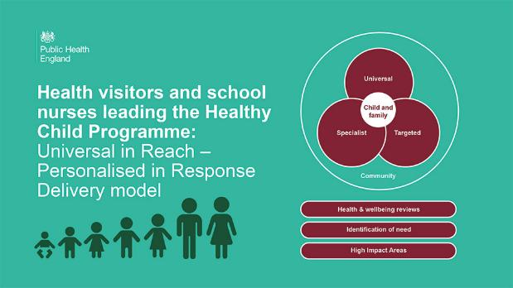

Health visitors lead the 0 – 5 years element of the HCP, which is from the antenatal period to school entry. There are 5 mandated contacts offered to all families but these are not the full extent of the Health Visiting service, some parents require additional support and safeguarding children is embedded throughout as Health Visitors have a vital role in keeping children safe and supporting local safeguarding arrangements.

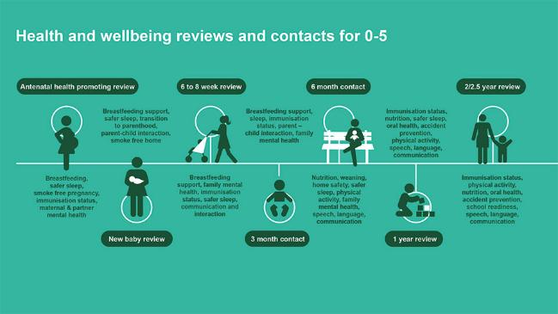

This shows the 5 mandated contacts plus two other suggested contacts at 3 and 6 months.

The Healthy Child Programme is personalised in response. All services and

Interventions need to be personalised to respond to families’ needs across time. For most families most of this will be met by the universal offer.

The service model is based on 4 levels of service – **community, universal, targeted and specialist,** depending on individual and family need. The use of community-based assetsis central to the universal offer, where health visitors are well placedto identify and signpost to local community support. Universal healthand wellbeing reviews can be utilised to identify needs and to develop a support offer or signpost to specialist services if required.

There are 6 high impact areas for early years and the diagram below shows how they relate to the 4 overarching aims for early years: which are

* focusing on preconceptual care and continuity of carer
* reducing vulnerability and inequalities
* improving resilience and promoting health literacy
* ensuring children are ready to learn at 2 and ready for school at 5

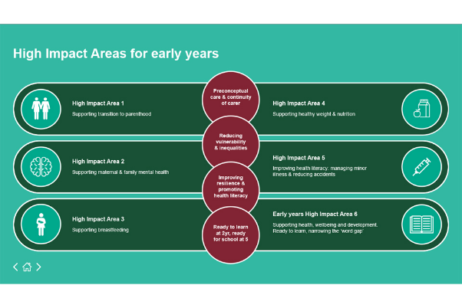

To learn more about The Healthy Child Programme you can access the following:

<https://www.e-lfh.org.uk/programmes/healthy-child-programme/>

**STUDENT PLACEMENT**

As a student you will be allocate a Practice Assessor and Supervisor for your placement.

Below gives an overview of their roles.

Student document is completed on the PARE system; please ensure that your Assessor and supervisor[s] complete the relevant documentation. If you are having any issues with this being completed, please speak to your assessor/supervisor/practice educator lead/academic assessor for support.

During your placement you will gain experiences in community health and other connected multi-agency services. You will see clients in both the clinic and home setting and will observe discussion, advice, action and plans of care on a variety of topics, issues and parental concerns. You will observe a wide range of families, parenting styles and home environments. You will see members of the team giving advice regarding a child’s development, health and social environment. There will be times when the focus of discussion and action will be on the parent’s needs.

There will be occasions when your supervisor will be writing in the child’s health records and during this time you will have the opportunity to complete the learning outcomes and reflection tools (adapted from Gibbs 1988) set out in this booklet. Each area will enable you to develop an understanding on a variety of common topics discussed regularly with parents. There are a variety of books and journals in the office to support your learning needs and you will have access to the computer when required. The reflections can assist discussions with your supervisor regarding any positive or negative experiences you may have had.

During your placement you may be requested to compile public health information on a notice board in the setting which should be informative, research based and visually interesting, a list of topics is included.

We hope you enjoy your placement and gain the experiences relevant in ascertaining a true understanding of the health visiting service.

**PROCEDURES AND OTHER INFORMATION**

* Fire regulations

The main fire exit in Milnrow Health centre is through the main door and into the car park. On hearing the alarm you will be required to congregate on the street opposite the building – ensuring the car park is not blocked in case the fire brigade need to attend. If this exit is unavailable, then follow the signs in the building to your nearest exit. A fire test will be held every week. The days do vary and staff are notified prior to a test.

If you discover a fire you are to press the nearest fire alarm and vacate the premises immediately. As a community team we also work in client’s homes, clinics and children’s centres, so you will need to observe their fire exits and evacuation purposes.

* Emergencies

In the case of an emergency dial 9-999.The nearest defibrillator is in reception. You are to commence life support as trained to do so, making sure help is called for prior to commencement.

* Health & safety

All Trust policies are available on the trust intranet site. These will be made available to you by your supervisor as required. Your supervisor will highlight this to you.

* Uniform

During your placement you are required to comply with Trust uniform policy and always wear your full uniform and university I.D. badge.

* Sickness and absence

If you are not able to attend due to sickness you are required to phone in person at your start time to inform your supervisor each day that you are absent. You are also required to inform university as arranged in your student guidance.

* Moving and handling

It is a requirement that all student nurses have completed their moving and handling training prior to practice. Although health visiting teams are not usually involved in moving and handling procedures, it is still necessary for students to inform their supervisor if they are not up to date with this training.

* Confidentiality

You will be aware of the guidelines stated in the NMC Code (2018). You are required to adhere to these guidelines during your placement.

* Your role as a student

Your primary role as a student is to learn and gain experiences of working in the community. You need to be aware of your development and limitations and discuss with your supervisor the learning needs and outcomes which need to be fulfilled on this placement.

* Complaints procedure

Whilst in placement if there are any complaints about your assessment, support or unacceptable learning opportunities please feel free to discuss these with your supervisor. If you feel this cannot be openly discussed with your supervisor, you can discuss this with another member of the team or with your university personal tutor. The PEF team can be contacted on [NEPEF.team@nca.nhs.uk](mailto:NEPEF.team@nca.nhs.uk) or [Suzanne.Kirkman@nca.nhs.uk](mailto:Suzanne.Kirkman@nca.nhs.uk)

**Reflection**

As Part of your experience, you are required to reflect on your experiences, you can use a model as below or another one if you prefer

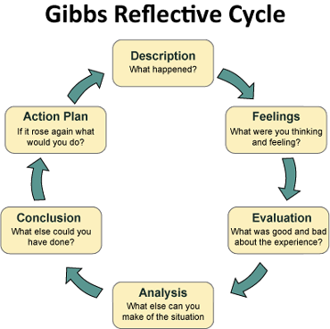

**Infant Feeding**

The latest research from the world health organisation shows that babies can get all the nutrients they need from breast milk or infant formula for the first 6 months of life. This gives babies digestive system time to develop so that they can cope fully with solid foods. Parents are provided with appropriate literature that enables them to make an informed choice about the way they choose to feed their babies.

**Breastfeeding**

Breastfeeding has many benefits not only to mother and baby but to also to the health of population. In order to protect this The World Health Organisation (WHO), following a decline in breastfeeding rates, introduced the baby friendly initiative in order to protect, promote and support breastfeeding as the optimal method of infant feeding. The international code of marketing of breastmilk substitutes was also developed as a global public health strategy and recommends restrictions on the marketing of breastmilk substitutes, such as infant formula, to ensure that mothers are not discouraged from breastfeeding and those substitutes are used safely if needed.

Breast milk is uniquely made for a growing baby. It is species specific and provides human baby’s with the appropriate ratio of fat and protein needed for their growth needs. This species specific element of breast milk makes it the most appropriate food for human babies. It is also packed full of antibodies, hormones and enzymes that work together to help the baby grow and develop. Due to this unique element of breast milk parents are encouraged to breastfeed exclusively for the first 6 months of a baby’s life and continue alongside appropriate weaning diet for two years and beyond.

Now read the ‘Off to the best start booklet’ that is given to parents and UNICEF ‘breastfeeding and relationship building workbook’ and then answer the following questions relating to breastfeeding.

1. Name 3 benefits of breastfeeding to the baby
2. Name 3 benefits of breastfeeding to the mother
3. Name 3 benefits of breastfeeding to the population
4. How does breastmilk differ from formula milk?
5. Why is skin to skin important following birth?
6. How do you know if breastfeeding is going well?
7. What are the key principles to effective positioning and attachment?
8. Describe a challenge with breastfeeding and how this can be overcome?
9. How can partners support breastfeeding
10. Where can families seek help with breastfeeding

Have a look at the following websites for further information relating to breast feeding

* [www.nhs.uk](http://www.nhs.uk)
* [www.nhs.uk/start4life](http://www.nhs.uk/start4life)
* [www.unicef.org.uk/BabyFriendly](http://www.unicef.org.uk/BabyFriendly)
* [www.breastfeedingnetwork.org.uk](http://www.breastfeedingnetwork.org.uk)
* <https://www.firststepsnutrition.org/>

There is a local breastfeeding support group within the Local children’s centre; you may wish to attend this session to speak to breastfeeding mothers and peer supporters.

The infant feeding co-ordinator within HMR is called – Amanda Hadlow.

The community infant feeding team lead is called – Alex Gibson.

**Immunisations**

Vaccines work by stimulating our immune system to produce antibodies (substances produced by the body to fight disease) without actually infecting us with the disease. They trigger the immune system to produce its own antibodies, as though the body has been infected with a disease. This is called "active immunity". If the vaccinated person then comes into contact with the disease itself, their immune system will recognise it and immediately produce the antibodies they need to fight it.

Newborn babies are already protected against several diseases, such as [measles](http://www.nhs.uk/conditions/Measles/Pages/Introduction.aspx), [mumps](http://www.nhs.uk/conditions/Mumps/Pages/Introduction.aspx) and [rubella](http://www.nhs.uk/conditions/Rubella/Pages/Introduction.aspx), because antibodies have passed into them from their mothers via the placenta. This is called "passive immunity". Passive immunity only lasts for a few weeks or months. In the case of measles, mumps and rubella, it may last up to one year (which is why the [MMR jab](http://www.nhs.uk/Conditions/vaccinations/Pages/mmr-vaccine.aspx) is given to children just after their first birthday).

Now read the immunisation booklet that is given to parents, then answer the following questions relating to immunisations.

1. Which immunisations will the baby have at 2, 3 and 4 months old?
2. which immunisations will be given between 12 and 13 months old
3. how do vaccines work
4. why do babies have more than one dose of the vaccines
5. what are some of the possible side effects of vaccines
6. what are possible reasons for not giving the vaccine

Have a look at the following web sites for more information on vaccines

Joint Committee on Vaccination and Immunisation

Public health England

Green book - vaccine updates

1. Look at three of the diseases that we vaccinate against and discuss what the disease is and find out what the vaccination uptake for each vaccine in the UK is and the incidents of that disease in the UK in the last year.

**Child Growth**

Growth Indicators are used to assess growth considering a child’s age and measurements together. In Health Visiting we use the UK-World Health Organisation 0 - 4 years growth charts. These charts have been developed by the Royal college of Paediatrics and Child Health, are based on the growth of breastfed infants.

In baby clinic and at home visits you will see the Health Visitor use the growth charts for plotting an infant’s/child growth and will have the opportunity to develop your skills in using and interpreting the growth charts as part of your practice.

In order to develop your knowledge around this area please complete HEE - <https://portal.e-lfh.org.uk/>

**Complimentary Feeding**

Introducing babies to solid foods, often called weaning onto foods, should start in accordance to WHO guidelines, when baby is around 6 months of age. This is when a baby is developmentally capable of feeding themselves proper food.

To develop your knowledge in this area

Read the weaning information

Visit [www.nhs.uk/start4life](http://www.nhs.uk/start4life)

[www.nhs.uk/weaning](http://www.nhs.uk/weaning)

[www.firststepsnutrition.org/](http://www.firststepsnutrition.org/)

You could also consider attending a session at one of the children’s centre.

**DEVELOPMENTAL ASSESSMENTS**

Children’s development is assessed using Ages and Stages [ASQ 3 and ASQ SE]. In the Greater Manchester area we are now all utilising a digital platform which parents are able to register on complete their child’s assessment on line before they have the appointment with the Health Visiting Service. Undertaking the assessment at the identified ages helps with timely identification of development problems so strategies can be put in place to help maximises the child’s development potential.

The ASQ is a low cost screening tool that relies on parents to complete simple and easy to understand questionnaires on their child. Psychometric studies based on more than 3000 questionnaires suggest that most parents and caregivers can use the ASQ SE and ASQ 3 accurately to provide initial screening information.

Assessments are completed by the Health visiting service at core contacts

1. 6 – 8 weeks
2. 8 – 12 months
3. 24 -30 months

Assessments can also be carried out at any age between 2 month and 5 years

During your placement you will be able to observe and participate in these assessments and increase your knowledge on children’s development at different ages. In order to help your understanding please read:

* Ages and Stages information folder
* Mary Sheridan Birth to Five book
* Department of Health [www.dh.gov.uk](http://www.dh.gov.uk)
* earlyyearshelp.greatermanchester.org.uk
* Complete HEE training - Ages and Stages Questionnaire course

Ask your supervisor about the assessments and discuss identified concerns with them after assessments have been completed to help your understanding.

**The Trio of Vulnerability.**

Mental Health

Substance misuse

Domestic Abuse

The term **Trio of Vulnerability** is used to describe the issues of domestic abuse, mental ill-health and substance misuse, identified as common features of families where harm to women, men and children has occurred. These issues rarely exist in isolation. They are viewed as indicators of increased risk of harm to children in isolation but when experienced as a group, are a potentially deadly combination.

What do the terms mean to you? Write down what thoughts, feelings, word associations you have for each of the components.

**Mental Health Substance Misuse Domestic Abuse**

**QUIZ**

* How many women are affected by domestic abuse in their lifetime?

a)1 in 10 b) 1 in 14 c) 1in 6 d) 1 in 4

* In the UK there is a call to the police on domestic violence every..?

1. 1 minute b) 5 minutes c) 9 minutes d) 13 minutes

* What % of domestic violence cases start or increase during pregnancy?

1. 10% b) 20% c) 30% d) 40%

* What number of children in England and Wales are affected by parental alcohol problems?

1. 3.3 million b) 705,000 c) 2.6 million d) 550,000

* What % of parents with a severe & enduring mental health disorder live with dependent children?

1. 8-15% b) 25-32% c) 50-66% d) 75-80%

* What % of children under 16 years in England and Wales have at least one parent with a serious drug problem?

1. 2-3% b) 3-4% c) 4-5% d) 5-6%

Parental mental health, substance misuse and domestic abuse can lead to unsafe, inconsistent and ineffective parenting. A disorganised lifestyle will have a differential impact on children depending on their age, development and temperament. High risk behaviours such as those associated with the toxic trio, will always leave children, regardless of their age, vulnerable to abuse and neglect.

Have a look at the Greater Manchester procedures. Choose one of the trio of vulnerabilities components and read the policy.

**http://greatermanchesterscb.proceduresonline.com/chapters/contents.html**

Have a think about how your chosen topic impacts on children?

Write down some thoughts for what signs / symptoms we might see as health visitors?

Ask one of the health visitors for an active case where the trio of vulnerabilities is evident? Read the notes and write down any thoughts / questions you might have that can then be discussed with your supervisor.

**NOTICE BOARD**

You may be asked to design research and compile information on a notice board in the setting which promotes health. Ideas for topics which could be used are listed below.

Burns and Scalds Bonfire night safety

Safety in the home Safety at Christmas

Immunisations Head Lice and Scabies

Sun Safety Positive Parenting

Weaning Asthma

Eczema Constipation

Potty Training Colic

**Learning Opportunities**

**ask your supervisor for contact numbers**

School Nurse Breastfeeding groups

Treatment room nurses Children centres

District nurses Orthoptists

Children’s community team Dieticians

Midwives Speech therapists

Diabetic nurses Family Planning

Asthma specialist nurse Community centres

**E- Learning : Consider undertaking some of these to enhance your learning whilst with the Health Visiting Service. They can be accessed via :**

<https://portal.e-lfh.org.uk/>

|  |  |  |
| --- | --- | --- |
| **Topic** | **Resource** | **Field** |
| Adolescent Health Programme | HEE e-LfH Hub | Child |
| ASQ 01 - Ages and Stages Questionnaire course | HEE e-LfH Hub | Child |
| All Our Health | HEE e-LfH Hub | All Fields |
| Asthma | HEE e-LfH Hub | All Fields |
| Autism Awareness | HEE e-LfH Hub | All Fields |
| Child Sexual Abuse Awareness | HEE e-LfH Hub | Child |
| Child Sexual Exploitation | HEE e-LfH Hub | All Fields |
| Children's Emotional and Additional Health Needs | HEE e-LfH Hub | Child |
| Children's Oral Health Advice | HEE e-LfH Hub | Child |
| Clinical Pathways for Sick Children | HEE e-LfH Hub | Child |
| Deprivation of Liberty Safeguards (DoLS) | HEE e-LfH Hub |  |
| Dermatology | HEE e-LfH Hub |  |
| Domestic Violence and Abuse | HEE e-LfH Hub | All Fields, AHPs |
| Early Developmental Support | HEE e-LfH Hub | Child |
| Female Genital Mutilation | HEE e-LfH Hub | Child, MW |
| Fetal Monitoring | HEE e-LfH Hub | Child, MW |
| Healthy Child programme (HCP) | HEE e-LfH Hub | Child |
| Infant feeding |  | Child |
| Immunisation | HEE e-LfH Hub | All Fields |
| Maternal Anaemia | HEE e-LfH Hub | MW |
| Mental Capacity Act | HEE e-LfH Hub | All Fields |
| Mental Health Awareness Programme - [Mental Health Awareness for Healthcare professionals](https://portal.e-lfh.org.uk/Catalogue/Index?HierarchyId=0_36974&programmeId=36974) | HEE e-LfH Hub | All Fields |
| National Child Measurement Programme | HEE e-LfH Hub | Child |
| NHS Antenatal and Newborn Screening Programmes: cross-programme learning | HEE e-LfH Hub | Child |
| NHS Newborn Blood Spot (NBS) Screening Programme | HEE e-LfH Hub | Child |
| NHS Newborn Infant Physical Examination (NIPE) Programme | HEE e-LfH Hub | Child |
| NHS Newborn Hearing Screening Programme (NHSP | HEE e-LfH Hub | Child |
| Perinatal Mental Health (PMH) | HEE e-LfH Hub | Child/MW |
| Saving Babies' Lives (SBL) | HEE e-LfH Hub | Child |
| Sepsis (SEP) >  Sepsis in Paediatrics | HEE e-LfH Hub | Child |

**TIMETABLE**

|  |  |  |  |  |  |
| --- | --- | --- | --- | --- | --- |
|  | Monday | Tuesday | Wednesday | Thursday | Friday |
| Date |  |  |  |  |  |
| a.m. |  |  |  |  |  |
| p.m. |  |  |  |  |  |

|  |  |  |  |  |  |
| --- | --- | --- | --- | --- | --- |
|  | Monday | Tuesday | Wednesday | Thursday | Friday |
| Date |  |  |  |  |  |
| a.m. |  |  |  |  |  |
| p.m. |  |  |  |  |  |

|  |  |  |  |  |  |
| --- | --- | --- | --- | --- | --- |
|  | Monday | Tuesday | Wednesday | Thursday | Friday |
| Date |  |  |  |  |  |
| a.m. |  |  |  |  |  |
| p.m. |  |  |  |  |  |

**TIMETABLE**

|  |  |  |  |  |  |
| --- | --- | --- | --- | --- | --- |
|  | Monday | Tuesday | Wednesday | Thursday | Friday |
| Date |  |  |  |  |  |
| a.m. |  |  |  |  |  |
| p.m. |  |  |  |  |  |

|  |  |  |  |  |  |
| --- | --- | --- | --- | --- | --- |
|  | Monday | Tuesday | Wednesday | Thursday | Friday |
| Date |  |  |  |  |  |
| a.m. |  |  |  |  |  |
| p.m. |  |  |  |  |  |

|  |  |  |  |  |  |
| --- | --- | --- | --- | --- | --- |
|  | Monday | Tuesday | Wednesday | Thursday | Friday |
| Date |  |  |  |  |  |
| a.m. |  |  |  |  |  |
| p.m. |  |  |  |  |  |