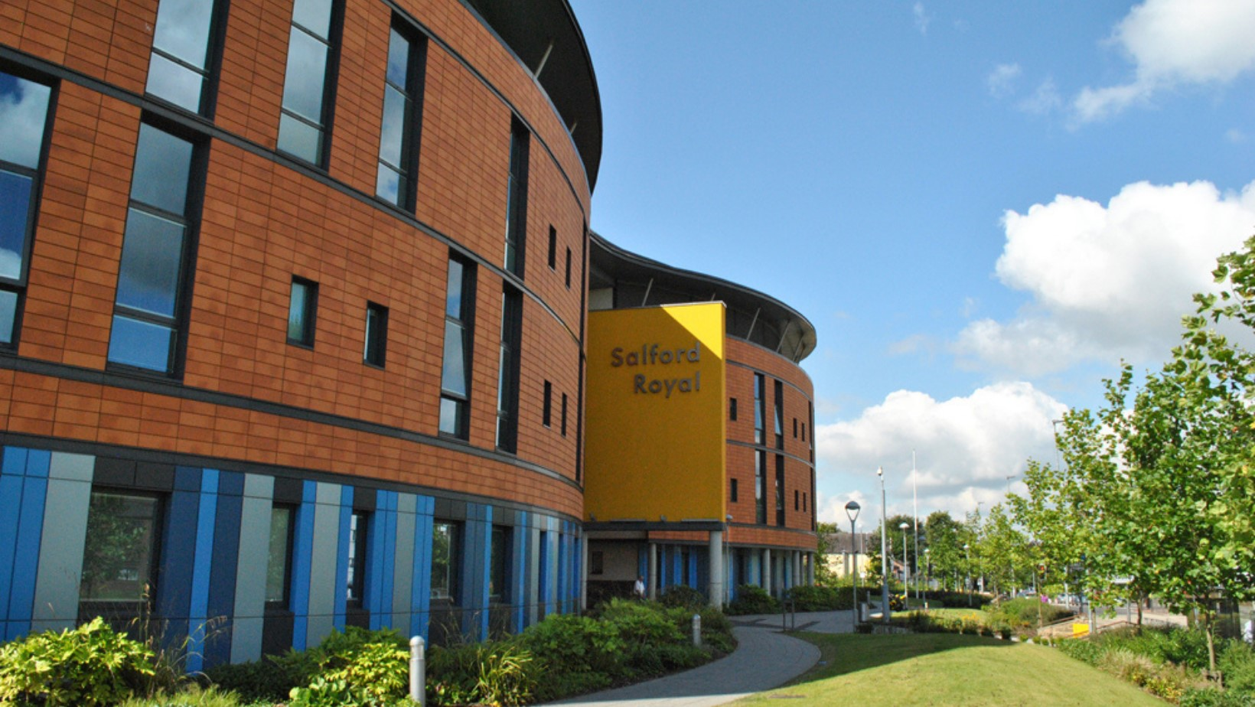**Learner Welcome Pack**

**Clinical Research Delivery**

**Learner Name: LEARNER NAME HERE**

**Assessor: NAME HERE**

**Supervisor: NAME HERE**

***Contact Number:* Add Team number Here**(Please phone usso we can give you your first two weeks shifts).  
 If you can’t find us on your first day, please phone us and we can meet you.

**Welcome!**



This is your welcome pack; it contains different aims and objectives that can be used as a guide throughout this placement + checklist of what you can expect to achieve throughout your placement with us in one of the clinical research teams. Regardless of which year you’re in on your nursing journey, there is a lot of experience to be gained, and this placement offers a completely new perspective of nursing, especially research nursing. Our advice is to have an open-minded approach, as this is very different to a day-to-day ward clinical placement.

At Salford Care Organisation we have 8 patient facing research delivery teams, 5 of which have student nurses joining them for placements. They all conduct research trials in specific disease areas. The team you are allocated to will be either Neurology, Renovascular, Musculoskeletal, Metabolic Medicine and Acute research. You will have the opportunity to have spoke placements with the Oncology, community, and core research teams.

As you know, you will have an array of competencies on PARE that are needing to be signed off for this placement. Therefore, it’s crucial to try and gain as much knowledge and experience as you can. Please be pro-active and let anyone you work with know, if you wish to aim to achieve or complete a certain competency. The team are enthusiastic and will actively encourage you to make the most out of your placement. Any suggestions or interests you may have and would like to explore, please just ask**.** The teams are all extremely helpful and eager for you to gain your full potential whilst being on placement.

There are lots of spoke opportunities and some of the spokes available are unique to research, we suggest making the most of the opportunities to gain a wide understanding of different areas of research, as it will enhance your understanding of research nursing.

**Useful info’**

* **Wear comfortable shoes!** (There is a lot of walking to and from the office & wards - so make sure they’re comfortable – within uniform policy).
* If you do not have EPR Access, please let us know **AS SOON AS POSSIBLE**, it’s essential for this placement, as we use the computer most of the day.

\

|  |  |
| --- | --- |
| **What to expect during each week of your placement with us (depending on length of placement this will vary).** | |
| **First Day of Placement** | * Orientation and complete PARE orientation paperwork * Gain access to EPR (authorised access via IT) * Gain access around the research building (FOB Access or door code) * Join in for Morning Handover + go through days list of jobs * Read up on different trials and the protocols (Learner Folder) * Shift Pattern Monday- Friday (no bank holidays) start/finish time varies depending on which team you are working with, your placement assessor will discuss this with you. |
| **Week 1 - 2 of Placement** | * Complete Good Clinical Practice (GCP) Training - NIHR * Familiarise yourself with the trials available * Familiarise yourself with the team’s daily routine (understanding the abbreviations, different sections etc.) * Look into different ways of consenting patients. * What is ethics and why is ethics important in research? * Research into capacity + lack of capacity + capacity assessments   + Research into national and local policies surrounding this (MHRA, NIHR, SCA). * Attend recruitment of patients with research nursing staff, observing to begin with and progress towards assisting in recruiting * Understand the screening process for screening patients. * Familiarise yourself with EPR & screening databases * Arrange lab training with Julie Oxton (2nd Floor labs in same building). * Initial meeting + assign shifts for rest of placement, any other PARE. |
| **Week 3 - 4 of Placement** | * Start to screen patients for the inclusion + exclusion criteria to trials, have this checked by senior member of staff (for each task assigned) * Safety check patients already recruited to trials for adverse events, alongside senior member of staff. * Lead a handover (AM/PM). (dependent on the team you are with) * Be the ‘Bleep Holder’ for the day. (Acute Research Delivery Team) * Assist recruitment of patients with senior staff and assist with randomisation/treatment delivery. * Work in link areas for trials (spoke opportunities – list below). * Complete mid-point meeting, review all progress/action plan + sign off hours so far. |
| **Week 5 – 6+ Onwards**  **of Placement** | * Screen patients allocated by your assessor or supervisor, working alongside senior member of staff. * Recruit a patient for a trial (under direct supervision).   + Randomise a patient for a particular trial.   + Administer/Guidance on treatment delivery for trial.   + Complete notes once recruitment successful. * Work in link areas for trials (spoke opportunities – list below). |
| **Final Week of Placement** | * Complete placement survey or answer any questions to aid the research team and progression for future learners (own preference for face-to-face or submit through PARE). * Complete all paperwork required for final meeting + sign off all hours. |

*The role of being a student nurse within clinical research is to gain an understanding and an insight into the role of ‘The Research Nurse’.*

*We hope to give you a flavour of our day to day running of our roles, and to gain an understanding in the guidance, governance and legislation concerning research in the NHS.*

*In addition to learning about research activity and trials within the team, we want you to gain a wider understanding of research within Salford Care Organisation and have an insight into the research pathways and how these links into clinical practice.*

**Spoke Opportunities + Departments**

There are many departments which support the research infrastructure within Salford.

A few are described below; The Research and Development website has more information on all the support available to researchers [www.ncaresearch.org.uk](http://www.ncaresearch.org.uk) .There are many different spokes you can experience for a day or week depending on what you’re most interested in completing.

**Barnes Clinical Research Facility**

The Barnes CRF is situated in the **pink** area (refer to the site map at the back of this pack). The Unit is used predominantly for outpatient research by all our teams with occasional overnight patient stays. You will have the opportunity to attend patient visits to observe the patient assessment and treatments provided there.

**Clinical Trials Pharmacy**There is a dedicated clinical trials pharmacy which includes aseptic services for clinical trials, if you are interested in trials that include medicinal products and think it would benefit you then a visit is a must. The pharmacist to contact who works closely with the research team

is Claire Keatley on [claire.keatley@sfrt.nhs.uk](mailto:claire.keatley@sfrt.nhs.uk).The clinical trials pharmacy team are in the Irving Building (**Blue** area on the site map).

**Clinically Based Spokes:**

* ED/A&E – Emergency Department/Accident & Emergency
* EAU – Emergency Assessment Unit
* Intestinal Failure Unit (H8)
* Neurosurgery theatre and wards.
* Renal Satellite Units at Wigan, Bolton & Oldham.
* Out-patient clinics
* CCU/ICU – Critical Care Unit/Intensive Care Unit
* H1 – Medical High Dependency Unit
* H2 – Respiratory Medicine
* L3 – Complex & Elderly Medicine
* L7 – Complex & Elderly Medicine
* Hyper Acute Stroke Unit (HASU)

***To arrange any Spoke placements, please speak with your assessor***

**Useful Research Abbreviations List**

|  |  |
| --- | --- |
| **A&E** | Accident & Emergency |
| **ADR** | Adverse Drug Reaction |
| **AE** | Adverse Event |
| **SAE** | Serious Adverse Event |
| **SAR** | Service Adverse Reaction |
| **SUSAR** | Suspected Unexpected Serious Adverse Reaction |
| **APACHE** | Acute Physiology, Age, Chronic Health Scoring System |
| **BIBA** | Brought in By Ambulance |
| **BNF** | British National Formulary |
| **CI** | Chief Investigator |
| **PI** | Principal Investigator |
| **CRF** | Case Report Form |
| **DSMC** | Data Safety & Monitor Comity |
| **GCP** | Good Clinical Practice |
| **GCS** | Glasgow Coma Scale |
| **HE** | Health Economy/Economist |
| **HFNO** | High Flow Nasal Cannula |
| **HRH** | Human Resources for Health |
| **I&V** | Intubated & Ventilated |
| **MAU** | Multi-Attribute Utility |
| **MCID** | Minimal Clinical Importance Difference |
| **MHRA** | Medicines & Healthcare Products Regulatory Agency |
| **NRES** | National Research Ethics Service |
| **PACS** | Picture, Achieving and Communications System |
| **PIL/PIS** | Patient Information Leaflet/Sheet |
| **PSS** | Personal Social Services |
| **PSSRU** | Personal Social Services Research Unit |
| **QA** | Quality Assurance |
| **QALY** | Quality Adjusted Life Year |
| **RCT** | Randomised Controlled Trail |
| **REC** | Research Ethics Committee |
| **SAP** | Statistical Analysis Plan |
| **SD** | Standard Deviation |
| **SOP** | Standard Operating Procedures |
| **TMG** | Trail Management Group |
| **TOC** | Trial Oversight Committee |
|  |  |
|  |  |
|  |  |
|  |  |

*Intentionally Left blank for you to enter any extra’s you come across*

|  |  |  |  |  |  |  |  |
| --- | --- | --- | --- | --- | --- | --- | --- |
| **Day** | **Week 1 – w/c XX/XX/2025** | **Week 2 – w/c XX/XX/2025** | **Week 3 – w/c XX/XX/2025** | **Week 4 – w/c XX/XX/2025** | **Week 5 – w/c XX/XX/2025** | **Week 6 – w/c XX/XX/2025** | **Week 7 – w/c XX/XX/2025** |
| **Monday** |  |  |  |  |  |  |  |
| **Tuesday** |  |  |  |  |  |  |  |
| **Wednesday** |  |  |  |  |  |  |  |
| **Thursday** |  |  |  |  |  |  |  |
| **Friday** |  |  |  |  |  |  |  |
| **Saturday** |  |  |  |  |  |  |  |
| **Sunday** |  |  |  |  |  |  |  |

|  |  |  |  |  |  |  |  |
| --- | --- | --- | --- | --- | --- | --- | --- |
| **Day** | **Week 8 – w/c**  **XX/XX/2025** | **Week 9 – w/c**  **XX/XX/2025** | **Week 10 – w/c**  **XX/XX/2025** | **Week 11 – w/c**  **XX/XX/2025** | **Week 12 – w/c**  **XX/XX/2025** | **Week 13 – w/c**  **XX/XX/2025** | **Week 14 – w/c**  **XX/XX/2025** |
| **Monday** |  |  |  |  |  |  |  |
| **Tuesday** |  |  |  |  |  |  |  |
| **Wednesday** |  |  |  |  |  |  |  |
| **Thursday** |  |  |  |  |  |  |  |
| **Friday** |  |  |  |  |  |  |  |
| **Saturday** |  |  |  |  |  |  |  |
| **Sunday** |  |  |  |  |  |  |  |

Learner Rota – LEARNER NAME HERE

**Shift Pattern is:**

**You are based here in the beige building (Research)**

**Clinical Research Delivery Placement Contact Information**

**Acute Research Delivery Team-**

**PEL-** Team Lead Reece Doonan

**Contact-** [Reece.Doonan@nca.nhs.uk](mailto:Reece.Doonan@nca.nhs.uk) 0161 206 2188  
**Location-** Clinical Sciences Building (Next to A&E and Greater Manchester Major Trauma Hospital)

**Metabolic Medicine Research Team**

**PEL-** Research Nurse Louise Winter

**Contact-** [Louise.Winter@nca.nhs.uk](mailto:Louise.Winter@nca.nhs.uk) 0161 206 7294   
**Location-** Clinical Research Facility (Barnes building, next to staff multi storey car park and opposite Meadowbrook)

**Neurology Research Team**

**PEL-** Team Lead Kathryn Slevin

**Contact –** [Kathryn.Slevin@nca.nhs.uk](mailto:Kathryn.Slevin@nca.nhs.uk) 0161 206 4276  
**Location –** 1st Floor Summerfield House, Eccles New Rd (on the corner of Stott Lane, just a five-minute walk from the main site)

**Musculoskeletal Research Team**

**PEL-** Team Lead Kathryn Slevin

**Contact –** [Kathryn.Slevin@nca.nhs.uk](mailto:Kathryn.Slevin@nca.nhs.uk) 0161 206 4276  
**Location –** 1st Floor Summerfield House, Eccles New Rd (on the corner of Stott Lane, just a five-minute walk from the main site)

**Renovascular Research Team**

**PEL –** Team Lead Christina Summersgill

**Contact –** [Christina.Summersgill@nca.nhs.uk](mailto:Christina.Summersgill@nca.nhs.uk) 0161 206 4211  
**Location –** 1st Floor Summerfield House, Eccles New Rd (on the corner of Stott Lane, just a five-minute walk from the main site

**Clinical Research Delivery Hub**

