
Ward T5/T6:
Surgical Triage Unit
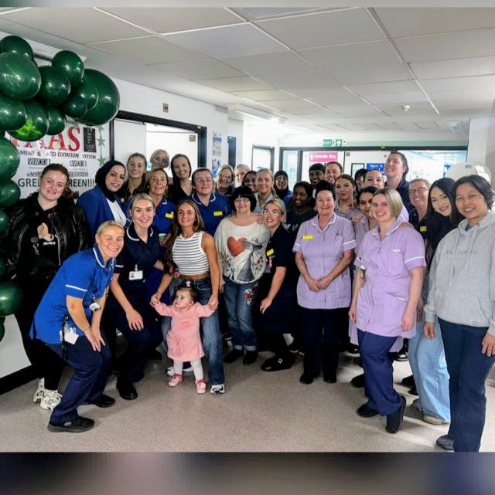

STUDENT WELCOME PACK

Contents
Welcome | Page 3
Ward philosophy / Contact numbers | Page 4
Useful contacts | Page 5
Surgical ward area | Page 6
Physiological Observations | Page 7
Surgical terms and abbreviations | Page 8 - 9
Urology and abbreviations | Pages 10 -11
Expectations | Page 12-14
Spoke opportunities inc IV Access team | Page 15-16

Welcome
Firstly, a warm welcome to Ward T5 /T6 - Surgical Triage Unit. Ward T5/T6, is a multi-specialty, emergency, surgical ward that takes admissions direct from A&E, GP referrals, and clinics.
We are also a 35 bedded unit which is attached to our Surgical Triage Unit.
Ward T6 STU
This is the Surgical triage unit where most of our referrals are admitted via this route.
Ward T5/T6
These wards are a short stay ward with a fast turnaround. Sometimes we need to move patients around the ward to accommodate the activity in STU and A&E.
We are committed to developing and supporting students to ensure a positive experience on the ward which would contribute to your future aspiration.
We value and acknowledge that essential learning takes place by ensuring you are provided with support throughout your placement.
During your placement, you will be supernumerary, and an assessor/ supervisor will be allocated, however you will experience working with a wide range of colleagues to enable every learning opportunity is provided at all levels. We do ask that you are proactive and seek these opportunities.
Please don’t be afraid to ask, as no question is a trivial question. Answers provided could potentially lead to a positive patient experience.
We hope you take advantage of the support offered to you to allow you to have a positive student experience.
Kinds regard,
Lewisa Walker – Ward Manager
Dawn Humphreys – Practice Educator Lead

Ward Philosophy
We aim to work towards a high-quality multidisciplinary service, for patients who require Surgical, Vascular, Urology treatment. On occasions we may have other specialities including medical patients and gynae patients.
We are a hard-working & motivated ward at TROH. We expect everyone to work as a team and support when and where needed.
Patient centred approaches are used to ensure patients are treated with respect and dignity.
We expect every staff member including students to encourage:
#EndPJParalysis - Get Dressed, Get Up, Get Moving! We encourage patients to be dressed and mobile whilst in our care as their condition allows. Our hospital participates in the national #EndPJParalysis campaign.

Useful Contacts:
Lead Nurse – Alison Birkett
Ward Manager – Lewisa Walker
Ward Sisters – Alex Robb, Amy Steenson, Dawn Humphreys, Hannah Plunkett, Hannah Rivett, Laura Cain, Amy Humphries, Louise Walthou

Work numbers: Email: ward.stu@nca.nhs.uk
T6/ STU – 0161 627 8253 /
0161 627 8252
T5- 0161 627 8429

Please phone in if you are sick and take note who you spoke to!

Surgical Ward Area
SKILLS
You will be shown many skills that are transferable throughout your training. These include medication rounds, obtaining observations, venepuncture, cannulation (when NCA training completed), documentation, handing over and admitting patients. Also, if you have anything you’re really interested in please let your mentor know then they can guide you in achieving it.
Medications:
On the ward you will come across many drugs that we use on a day-to-day
basis. Most common ones you will see are:
Analgesics: Paracetamol, codeine, Morphine, oromorph, Diclofenac, Buscopan
Anti-emetic (anti-nausea): Cyclizine, Ondansetron, Metoclopramide
Anticoagulants: Clexane, Heparin, Apixaban
Concerns/Complaints
We expect you to treat all patients with dignity and respect and communicate well with them and the team. Any concerns about anything on placement should be escalated promptly to the nurse in charge so we can help you and keep everyone safe.
Emergency Process
Everyone who has a placement with us needs to know the emergency process. In an emergency, you must shout for help and pull an emergency buzzer if it is safe to do so. Staff may ask you to put a call out, which is 2222 on any phone within the hospital.

Physiological Observations
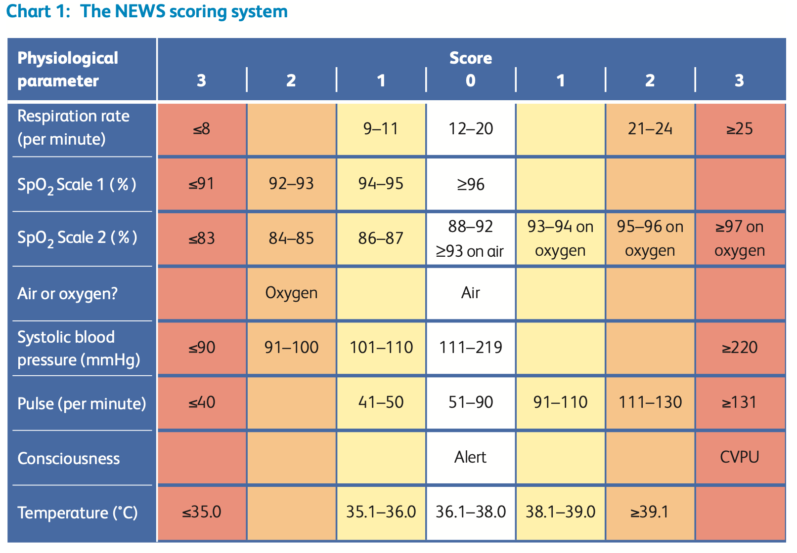

!! NB Please let your nurse know of patients News Score as this an early warning sign to patient deterioration!!

Surgical terminology

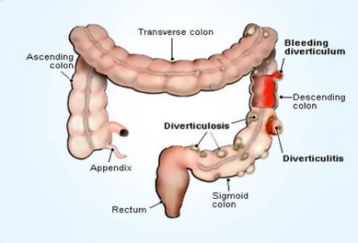
Pancreatitis occurs when digestive enzymes become activated while still in the pancreas, irritating the cells of your pancreas and causing inflammation.
Diverticular disease and diverticulitis are related digestive conditions that affect the large intestine (colon). In diverticular disease, small bulges or pockets (diverticula) develop in the lining of the intestine. Diverticulitis is when these pockets become inflamed or infected.

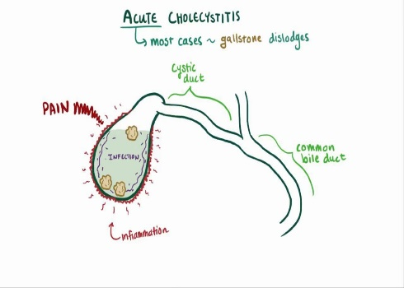
Cholecystitis is when your gallbladder is inflamed. Gallbladder inflammation can be caused by: Gallstones. Most often, cholecystitis is the result of hard particles that develop in your gallbladder (gallstones). Gallstones can block the tube (cystic duct) through which bile flows when it leaves the gallbladder.

Abbreviations | Terms
FF | Free Fluids
CF | Clear Fluids
NBM | Nil By Mouth
USS | Ultrasound scan
MRI | Magnetic Resonance Imaging
Lap | Laparoscopic (keyhole surgery)
OGD | Gastroscopy – to see the stomach and upper part of the small intestines
Flexi sig | Flexible sigmoidoscopy. Camera examination of the rectum and the lower part of the large bowel
Colonoscopy | Camera examination of the large bowel and the distal part of the small bowel.
NWB | Non-Weight Bearing
IV | Intravenous (drug administration route)
IM | Intra- Muscular (drug administration route)
SC | Subcutaneous
IVF | Intravenous Fluid
SBO | Small Bowel Obstruction
CTAP | Computerised Tomography Abdo pelvis
EUA | Examination Under Anaesthetic
Urology Meaning...
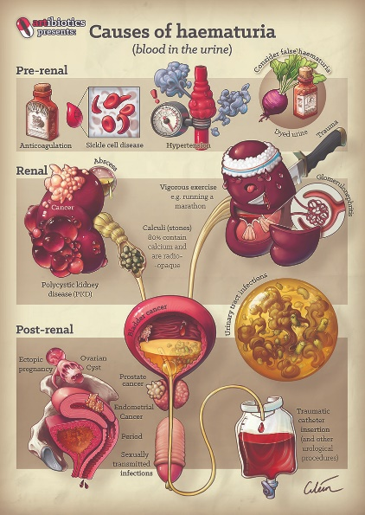
Haematuria is when there is blood in the urine.
You may need to complete a urine test called urinalysis.

Nephrostomy

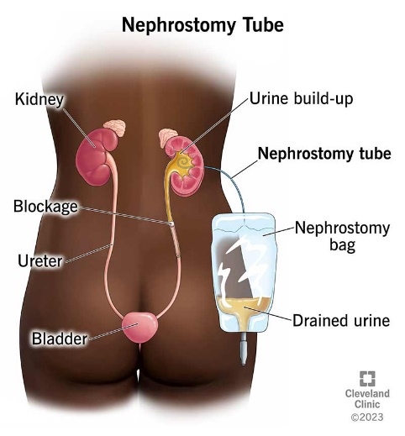
A nephrostomy tube allows a tube to drain from the back of the kidney into a bag.
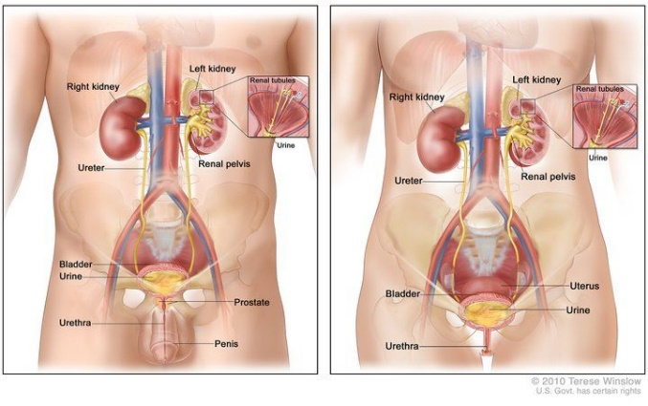

Abbreviations | Urology Terminology
EGFR | Estimated Glomerular filtration rate
KUB | Kidney Ureter bladder-
TURP | Transurethral Resection Prostrate
TURBT | Transurethral Resection Bladder Tumour
CT Urogram | Computerised Tomography to visualise Kidney Ureter bladder
CBD | Common Bile Duct Stone
TWOC | Trail Without Catheter
MSU | Mid-stream Urine
CSU | Catheter stream Urine

Expectations
This pack will provide you with the information that will be helpful throughout your placement with us. Please become familiar with it. You will receive an induction into the work area to ensure you are familiar with the environment and are able to practice safely.

Our aim is to develop your confidence, and interpersonal communication. We will expect you to have your goals set out for the day.

- Please leave your contact details with the ward at the beginning of your placement should we need to contact you or alternatively ensure your PARE details are completed.

- You are expected to work a variety of shifts including weekends and nights. Your rota will be allocated to you. If you have any requests, please speak to your assessor/ supervisor/ PEL. Please do not self-rota as you will be asked to leave the ward and return on your allocated shift.

Shift Patterns:
Long Day:
07:30 – 20:00
Break – 1 hour

NB: you will owe 1.5 hours per week as you are contracted to 37.5 hours per week. This will be your responsibility to make up.

Night Shift:
20:00- 08:00
Break – 1 hour

- We expect you to arrive on time for your planned shifts ensuring uniform policy is adhered to. If you do not wear the correct uniform, do not have an ID badge or are wearing false nails you will be asked to leave to correct the issues. It is your responsibility to familiarise yourself with Salford University uniform policy.

- If there is any sickness, please inform the ward at the earliest convenience / opportunity. You will also need to tell them when you think you may be returning to work.

We expect you to make your assessor/ supervisor aware of your leaning outcomes and specific needs at the beginning of your placement. In return we will provide a conducive environment to support your learning goals. You can expect your assessor/ supervisor to provide regular feedback and supervision to help develop your skills in the clinical environment.

Patients meals times:
Breakfast-8am-8.45am
Lunch-12noon-1pm
Tea - 5pm – 6pm

- You are expected to support in all aspect of Activities of daily living (ADL’s) including personal care. You are expected to complete skin checks and learn about pressure areas, complete accurate fluid balances, and understand cannulas and VIP scoring.

- Including with this you are expected to write clear documentation and keep accurate records for patients in their notes. If you are unsure how to complete documentation, please ask the staff nurse. Your documentation could be used in any future court cases.

- We suggest you use the following format in your writing:

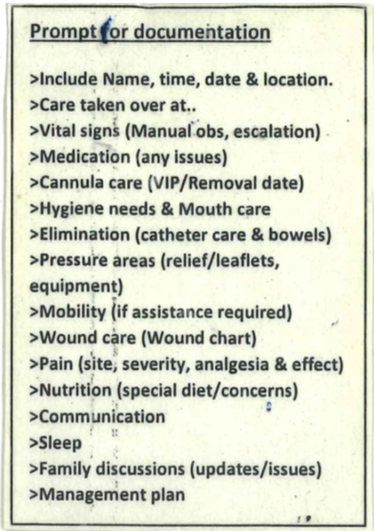

Please do provide feedback about your placement; any issues raised will be dealt with in a confidential and sensitive manner. It is always better to raise worries or queries sooner rather than later. If you are unable to raise concerns with the placement, please do contact the PEF team or you academic tutors.

We expect you to always maintain and respect confidentiality. This applies to patients, their records and your discussions with your assessor/ supervisor.

And finally, we expect you to enjoy this placement with us!

Many Thanks
Dawn Humphreys
Practice Educational Lead
Spoke Opportunities
Possible spoke opportunities could include:

Colorectal Specialist Nurses | 71450
Palliative Care Team – | 75918 or bleep 7707
Pain Management Team | bleep 7608
Tissue Viability Nurses – | 78701
Physio/ OT | 78972 or bleep 7623
Theatre | 78810/ 78827
Bed managers (usually 3rd yrs) | 75291 /75115
Critical Care Outreach (usually 3rd years) | bleep 7744
Diabetes (usually 3rd years) | 78268 or bleep 7842

Please arrange your possible spoke placement with your assessor/ supervisors.
Spoke placements will need to sign your timesheet.

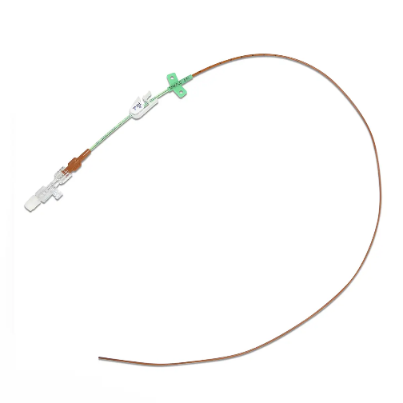
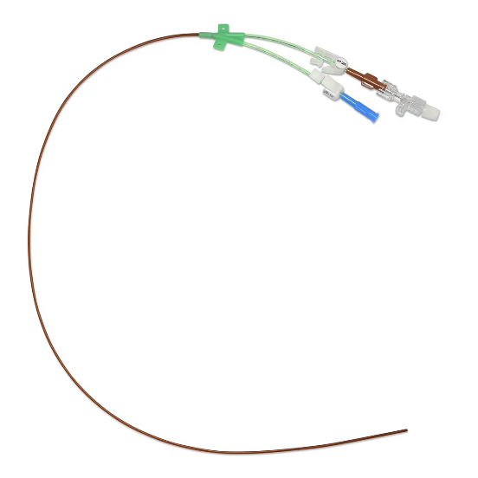
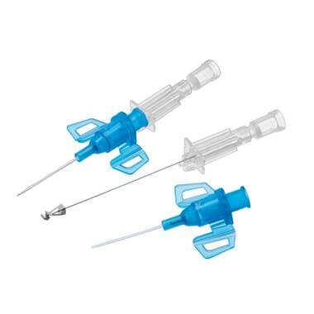
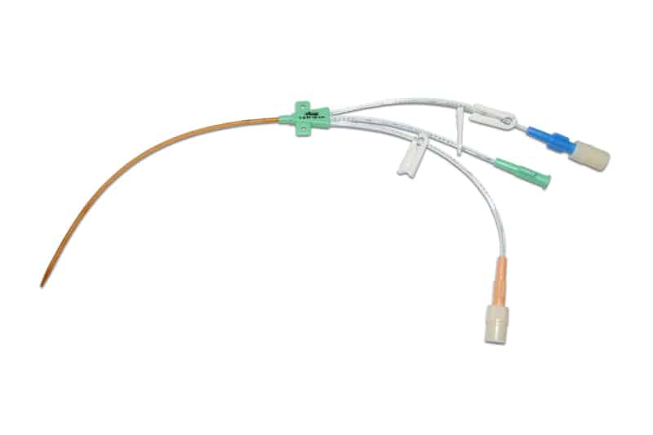
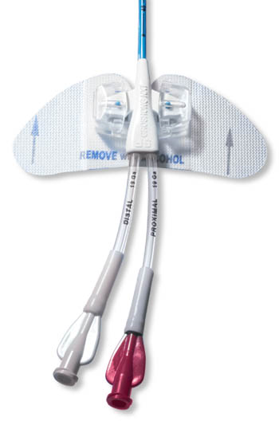
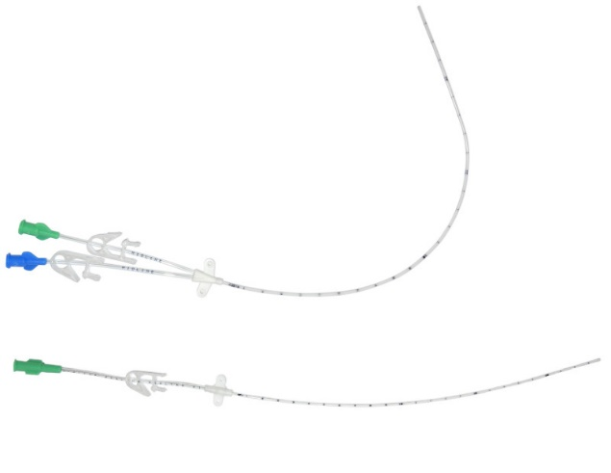



Spoke placements available
with the
IV Access Service!
Learning opportunities:
- Observe and assist for PICC/Midline insertions
- Observe PICC/Midline weekly care
- Observe Portacath access
- Observe Standard and Surgical ANTT
- Observe and assist with long line troubleshooting
- Bespoke learning package and resources
- Opportunity to use ultrasound for assessment
- Opportunity to ask questions
Salford:
E-Mail: SalfordIVTeam@nca.nhs.uk
Telephone: 01612060459
(if no answer, please leave a message with your name and contact details)
Oldham:
E-Mail: IVAccessService@nca.nhs.uk

Calling all
STUDENTS

